A.S.D GOVERNMENT DEGREE COLLEGE FOR WOMEN (A), KAKINADA
DEPARTMENT OF COMMERCE
Detailed Report on Activities for 2024-2025
1. A Faculty Exchange Programme was organized on 28-07-2024 between A.S.D. Government Degree College for Women (Autonomous), Kakinada and P.R. Government Degree College, Kakinada with the objective of promoting academic collaboration and enriching student learning. As part of this initiative, Dr. G. Sowjanya delivered an engaging lecture on Business Organization and Management to around 60 first-year B.Com students. The session covered fundamental concepts of business organization, forms of business, and the essential functions of management, linking theory with practical examples from the contemporary business environment. The interactive nature of the lecture encouraged student participation, clarified key concepts, and provided valuable exposure to expert teaching, making the programme highly beneficial for academic enhancement.
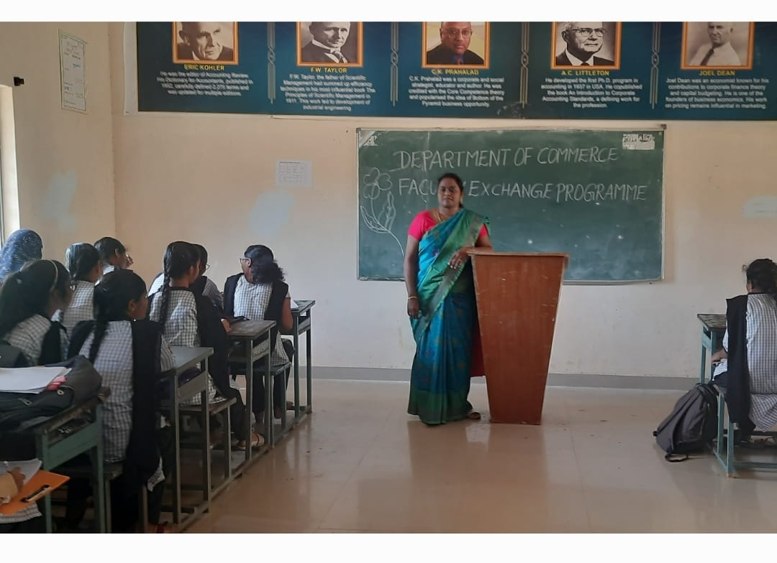
2. A Guest lecture was conducted at A.S.D. Government Degree College for Women (Autonomous), Kakinada, in which S. Srinivasa Rao, Incharge of the Department of Commerce from Pitapuram Government Degree College, participated as the resource person on 15-7-24 and delivered an informative session on Income Tax e-Filing. The lecture provided practical insights into the process of online tax filing, including procedures, documentation, and recent updates, helping students understand its real-time application. Around 100 second-year students attended the session and actively participated, gaining valuable knowledge and awareness about digital tax compliance and its importance.
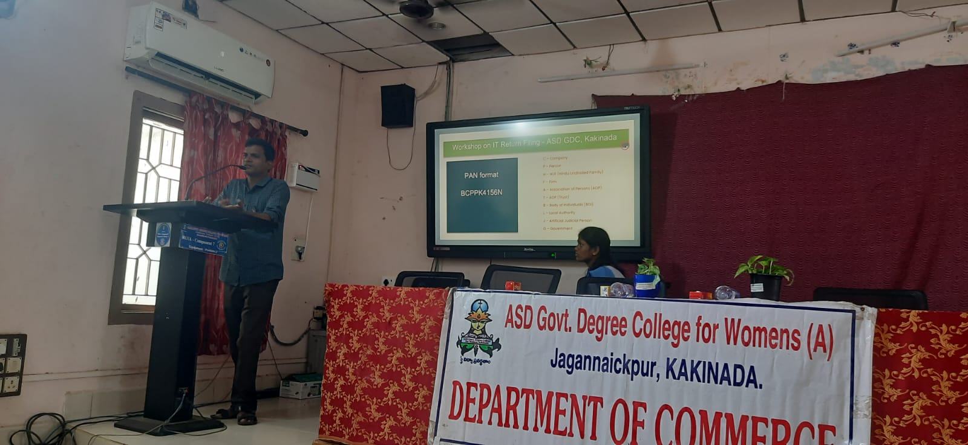
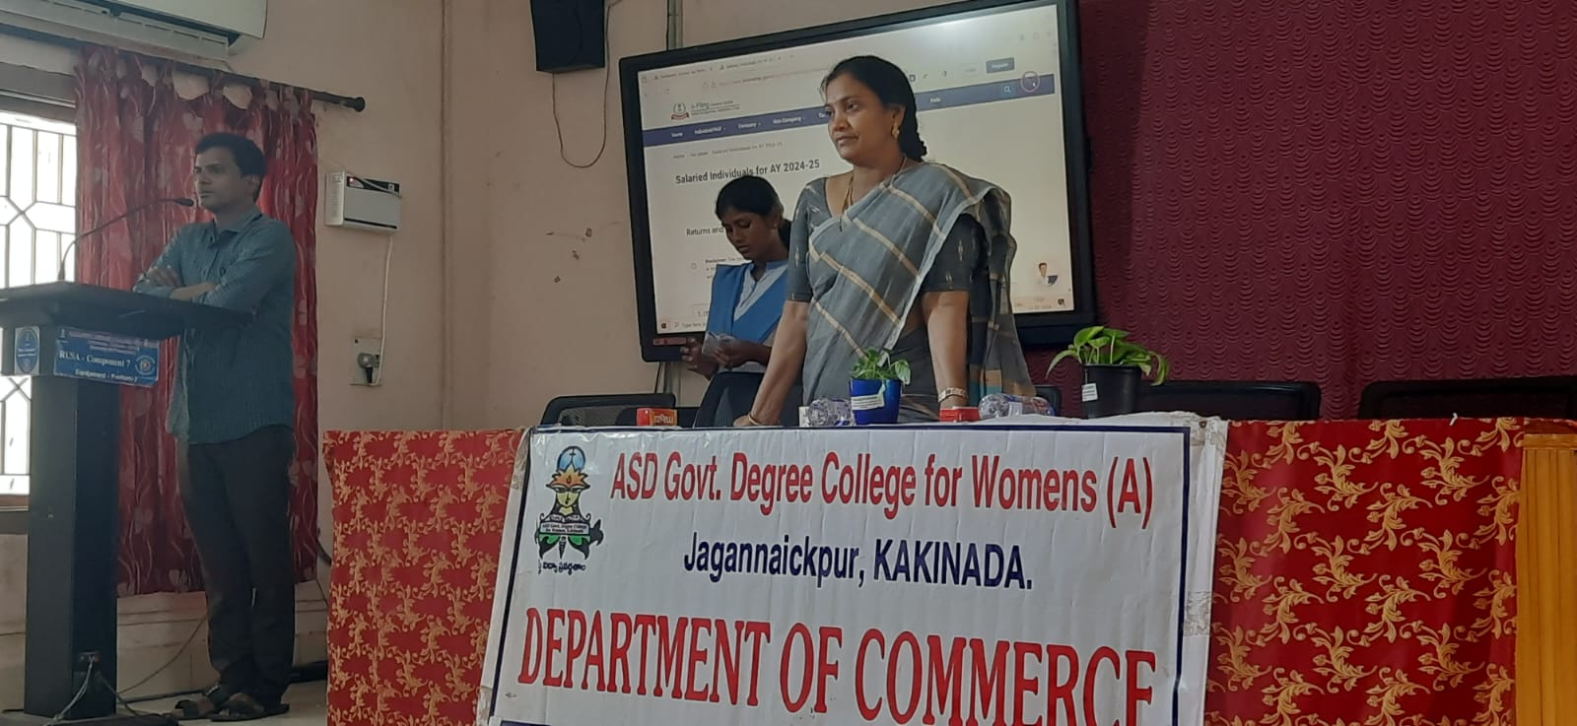
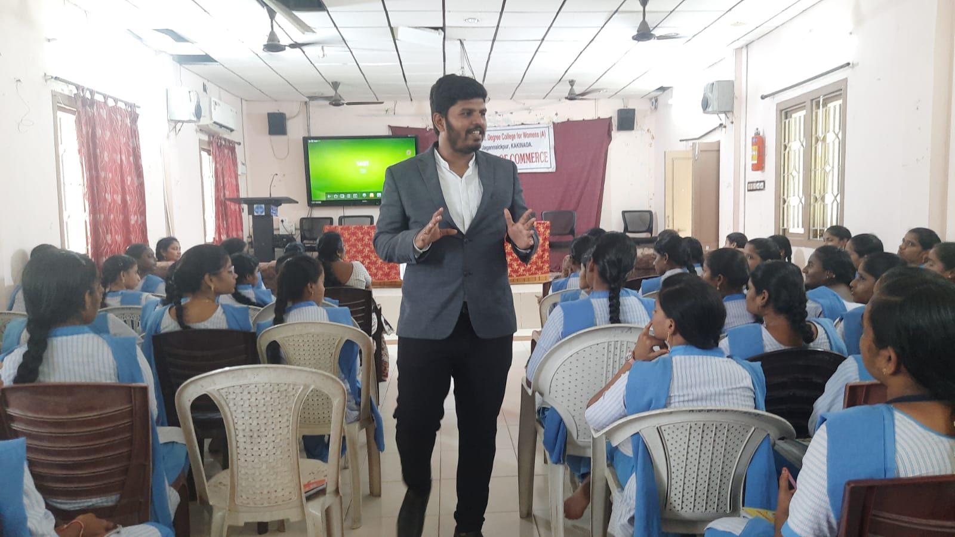
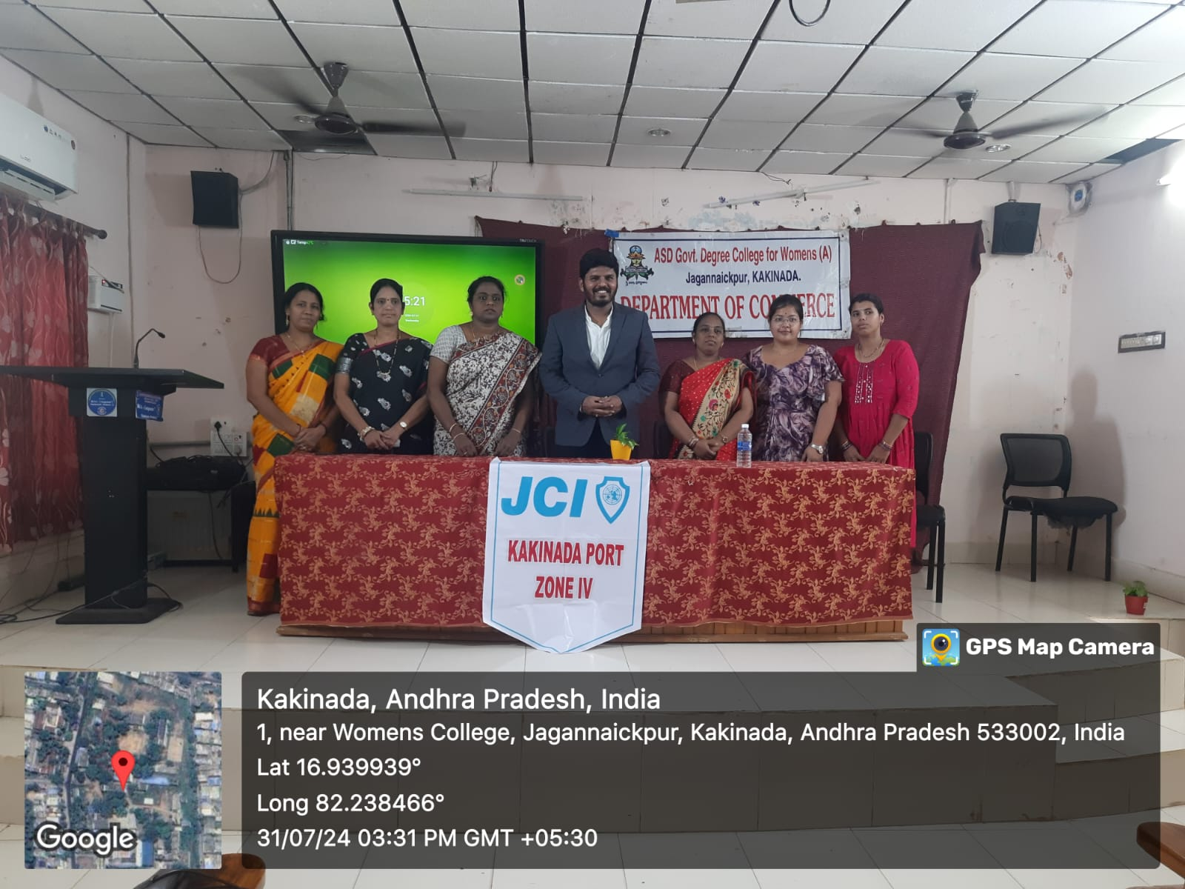
3. A Guest lecture was conducted by the Department of Commerce on 31-07-2024, in which around 100 final-year students participated. The resource person for the programme was A. Santosh from Kakinada Port. He delivered an informative session on Career Guidance in Chartered Accountancy, explaining the pathway to pursue CA after graduation, the stages involved in the course, and the skills required to succeed in the profession. He also guided students on how to set clear career goals, plan systematically, and build a strong professional future in the field of accountancy. The session motivated students to explore career opportunities in Chartered Accountancy with confidence and clarity.

4. A guest lecture was organized by the Department of Commerce on 13-08-2024, in which D. Prasad, a PD Trainer from Rajahmundry, participated as the resource person. He delivered an insightful session on Time Management, emphasizing the importance of planning, prioritizing tasks, and maintaining a balance between academic responsibilities and daily activities. The lecture highlighted practical techniques to manage time effectively according to one’s routine schedule and studies. Around 100 students participated in the programme and gained valuable guidance on improving productivity, avoiding procrastination, and developing disciplined study habits.
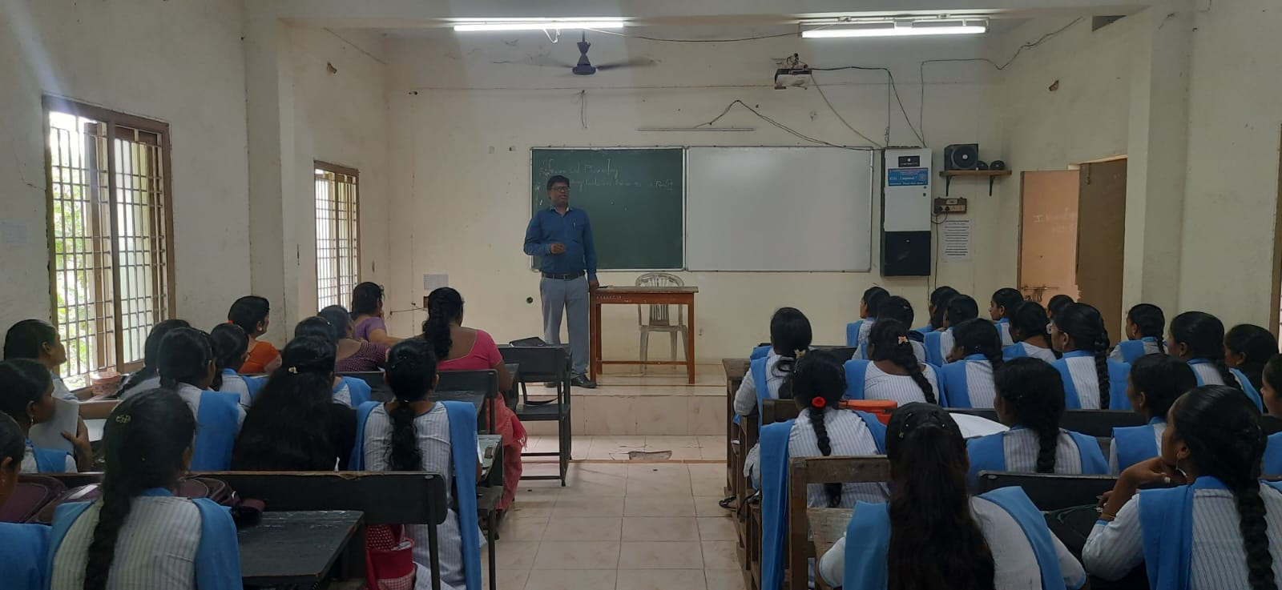
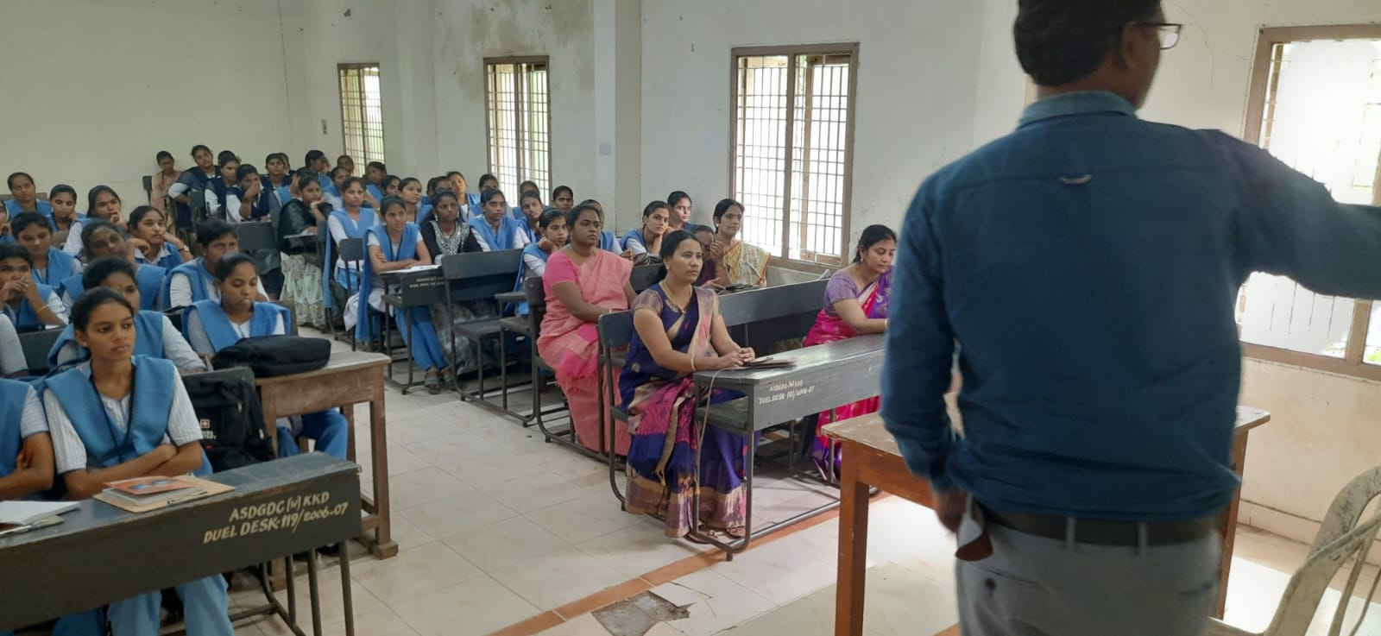

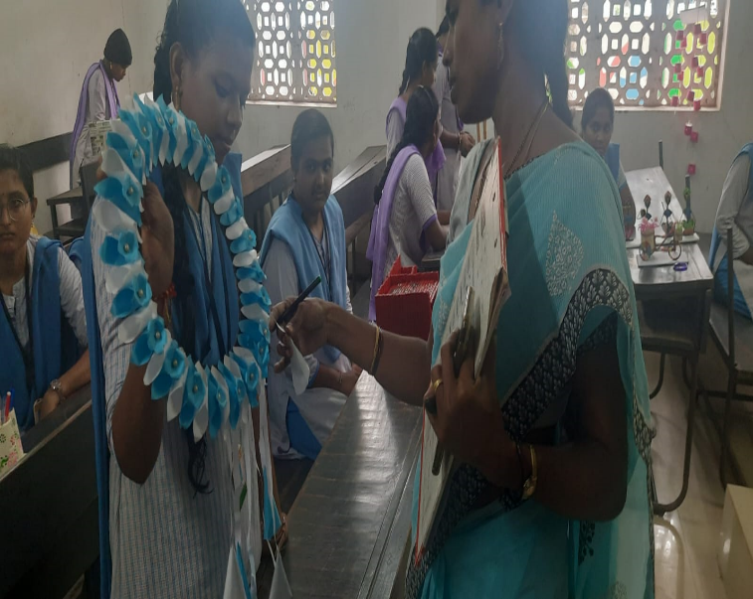
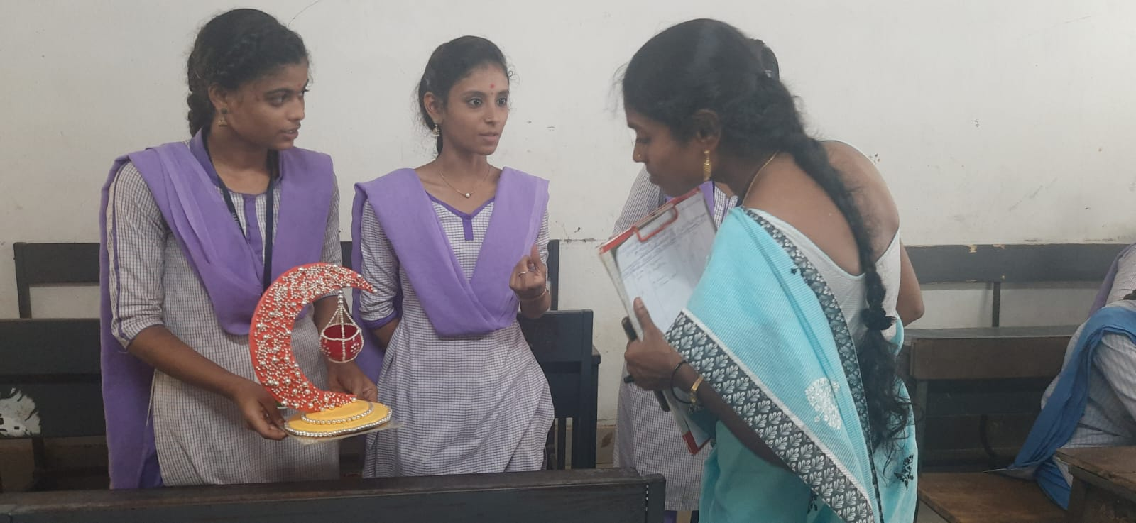
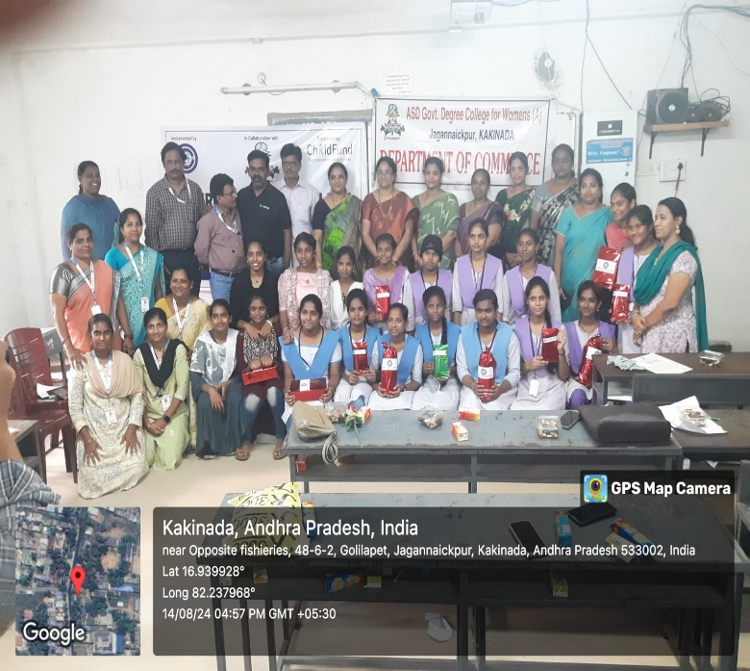
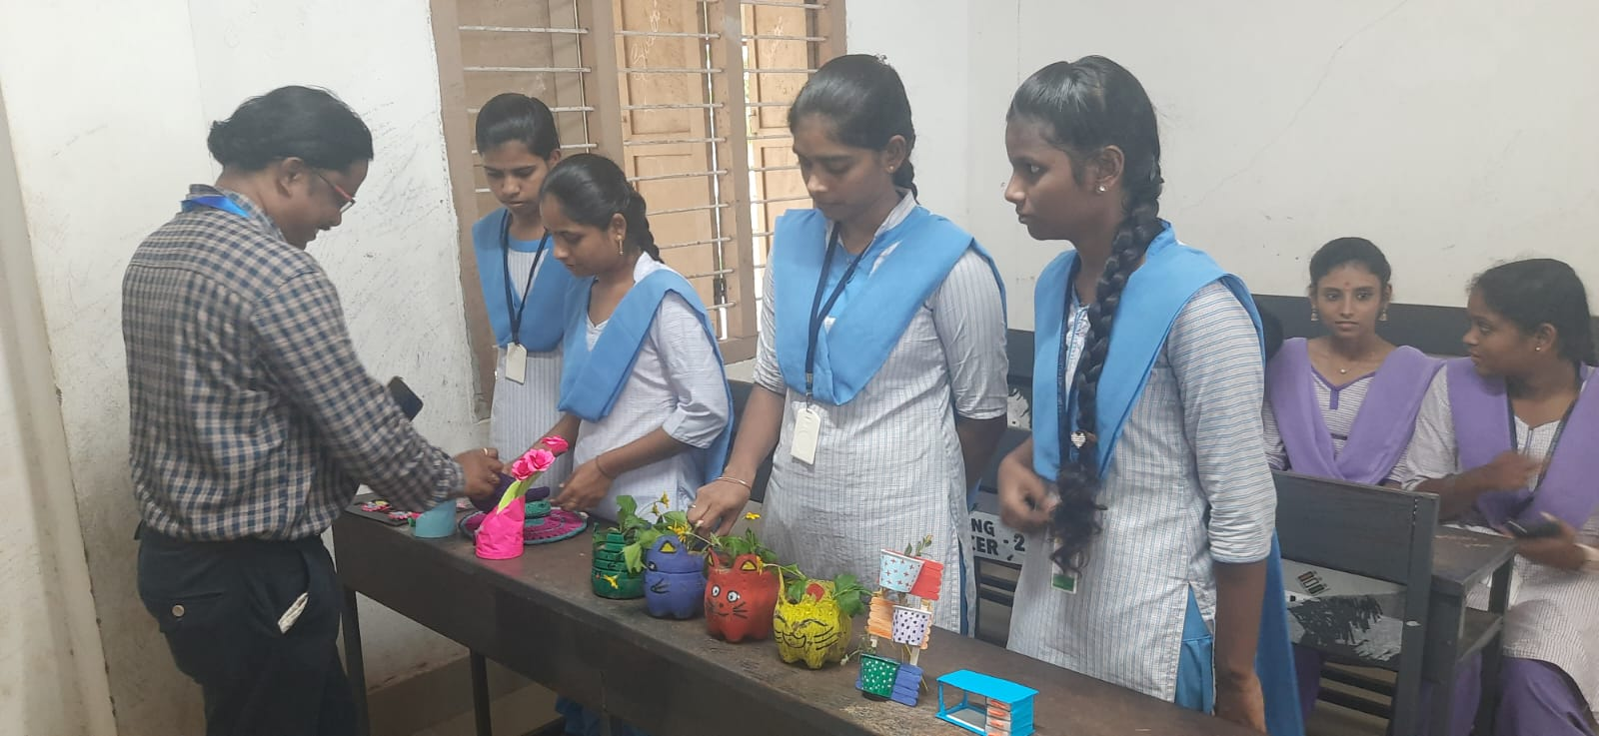
5. The Department of Commerce, in collaboration with CWS, organized a Best Out of Waste Programme on 14-08-2024 at A.S.D. Government Degree College for Women (Autonomous), Kakinada. 100 Students across the college actively participated in various activities such as role-play, photography, and creative recycling, where they collected waste materials and transformed them into useful and innovative products, promoting environmental awareness and sustainability. D. Ravikumar from CWS attended the event and served as the judge for the skit Programme. The event was vibrant and impactful, highlighting students’ creativity and social responsibility, and all participants were appreciated with prizes and participation certificates.

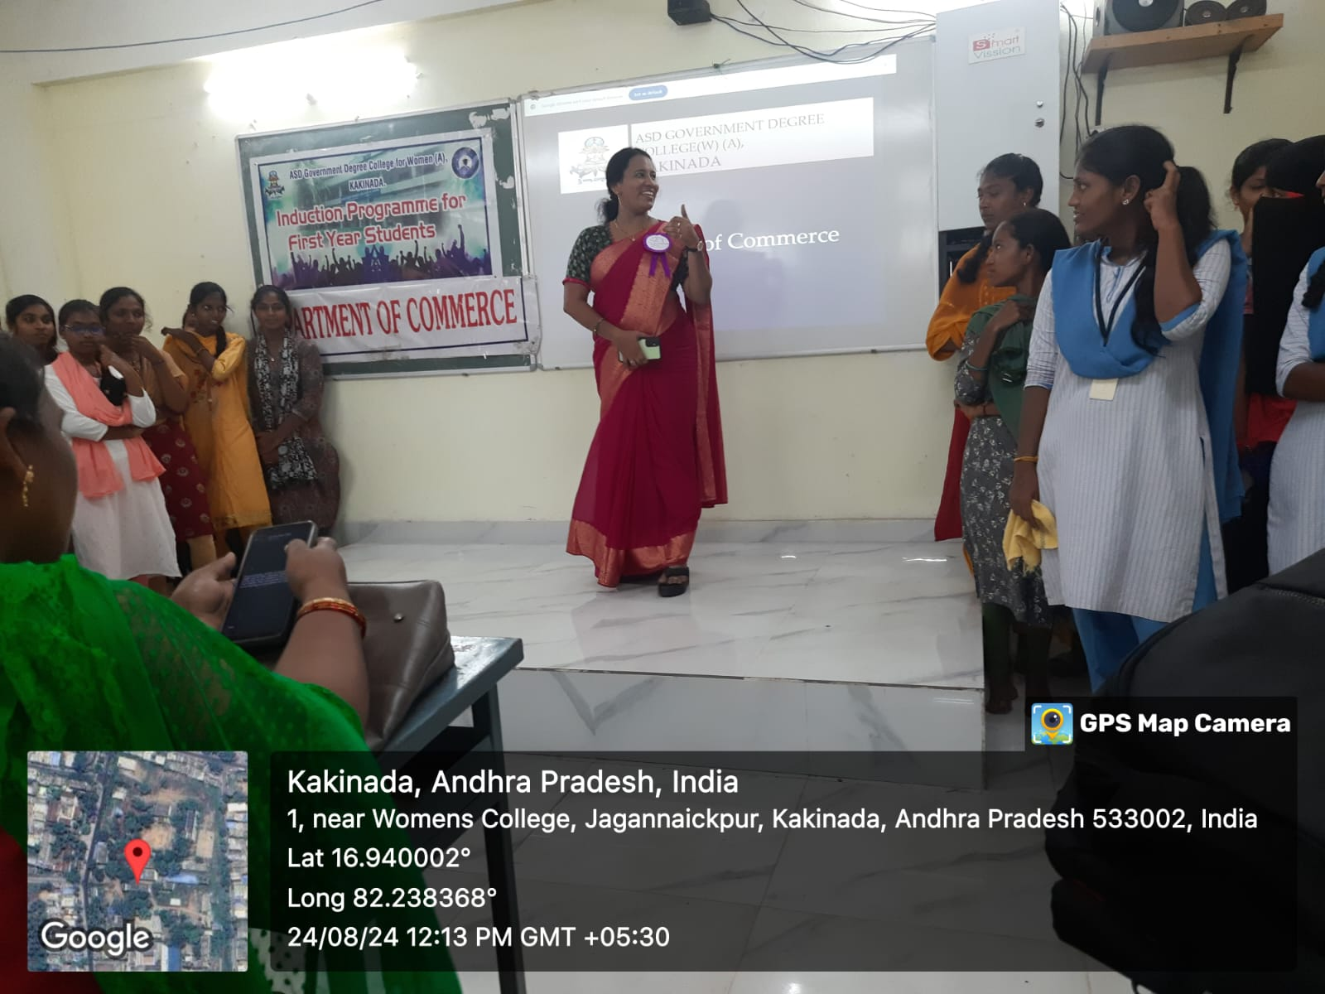
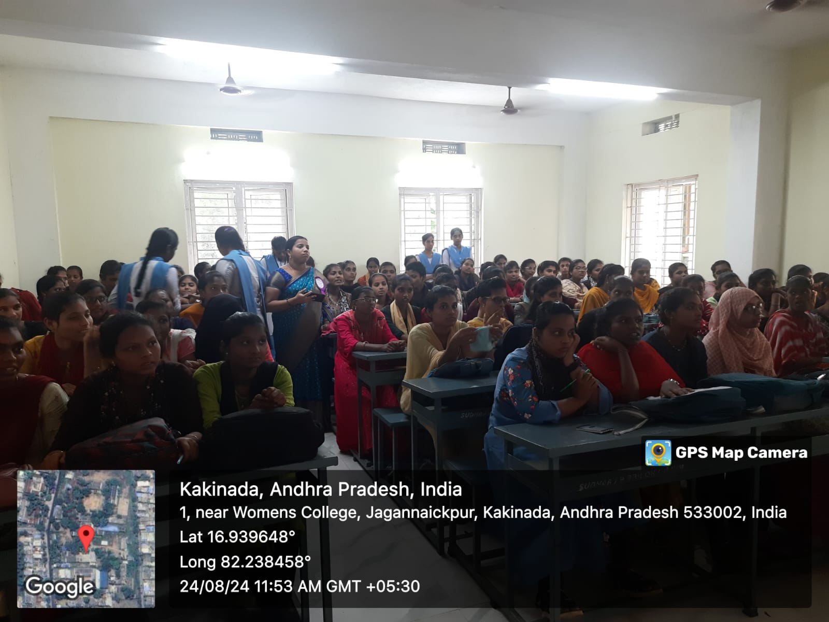
6. The Department of Commerce conducted an Induction Programme for the newly admitted first-year students of the 2024–2025 batch on 24-08-2024 at A.S.D. Government Degree College for Women (Autonomous), Kakinada. The programme included several skill-oriented activities and interactive games designed to develop students’ time management and communication skills. Around 110 students actively participated in the event. All the Commerce faculty members were involved and addressed the students, introducing them to the history and significance of the Department of Commerce, its academic structure, and the various opportunities available for developing knowledge and professional skills. The session aimed to motivate students and guide them on how to effectively utilize their three-year degree programme for academic growth and career development.

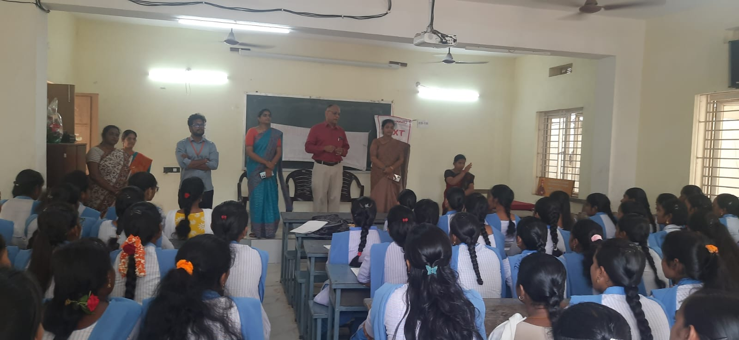
7. The Department of Commerce, in collaboration with the Career Guidance Cell, organized a certificate course in association with Unnati Foundation for final-year students to enhance their employability skills. The resource person, Trinath Tilakoti, conducted 40 Days Certificate course for III B.Com CA and General students on soft skills and the effective use of grammar in daily academic and professional communication. A total of 80 students were selected in two batches, with 40 students in each batch, and the course was conducted daily from 3:00 PM to 6:00 PM. The programme provided valuable guidance on personality development and workplace readiness, while the Unnati Foundation management also interacted with students and explained how such certificate courses can help them improve their career prospects and succeed in their future professional journeys.

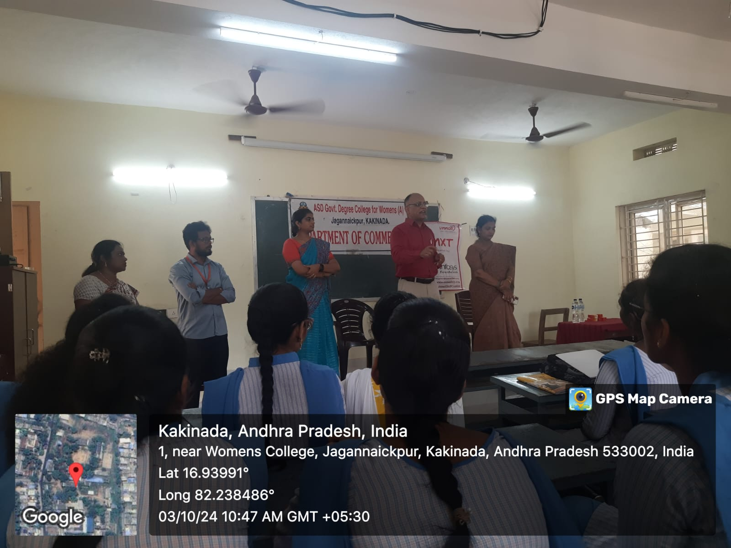

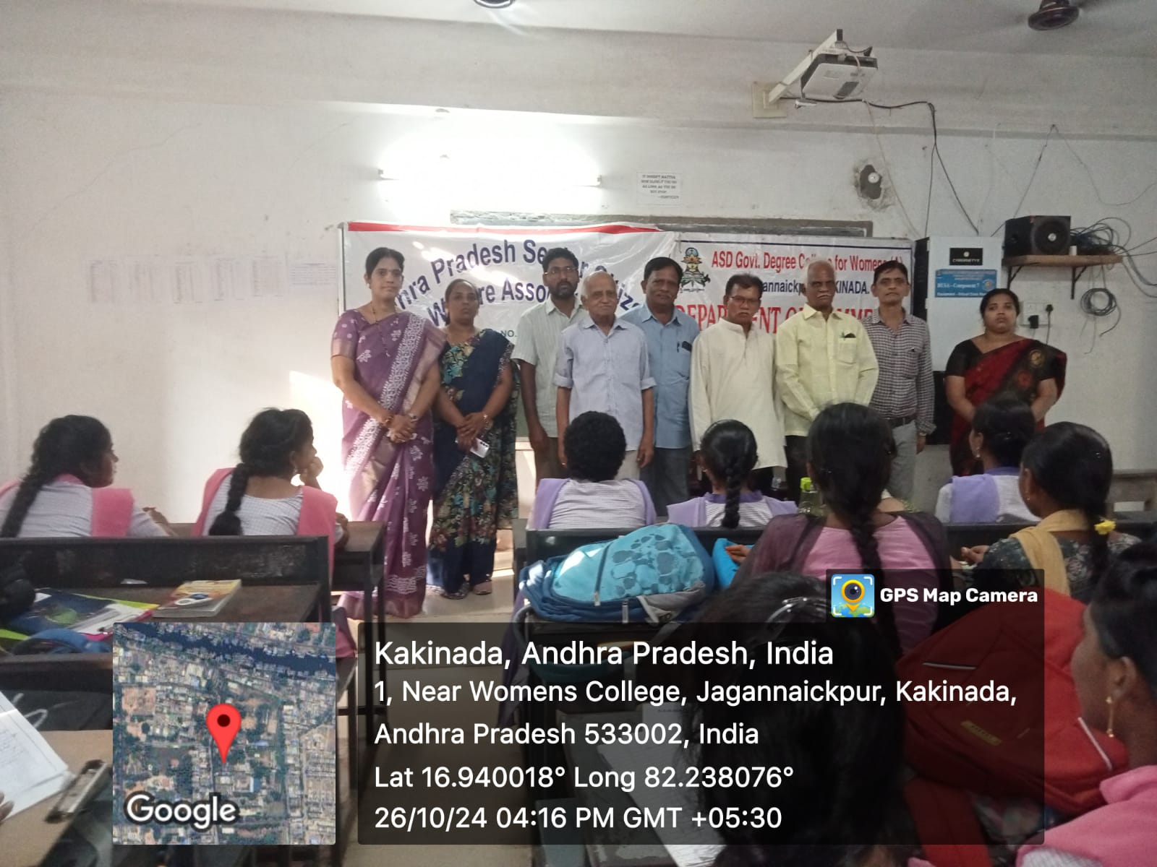
8. An Awareness Programme was organized by Department of Commerce in collaboration with f the Andhra Pradesh Senior Citizens Welfare Association to sensitize students about the importance of respecting and caring for the elderly in families and society. A total of 100 students actively participated in the programme. The distinguished senior citizens, Sri Surya Narayana Murthy and Sri J. Satyanarayana, addressed the gathering and shared valuable insights drawn from their life experiences. They emphasized the moral responsibility of younger generations to treat senior citizens whether parents, grandparents, or other elders in the community with dignity, patience, and compassion. The speakers highlighted the need to understand the emotional, social, and health-related challenges faced by the elderly and encouraged students to develop empathy, offer support, and foster intergenerational harmony. The session served as an eye-opening experience, instilling values of respect, gratitude, and social responsibility among the students.

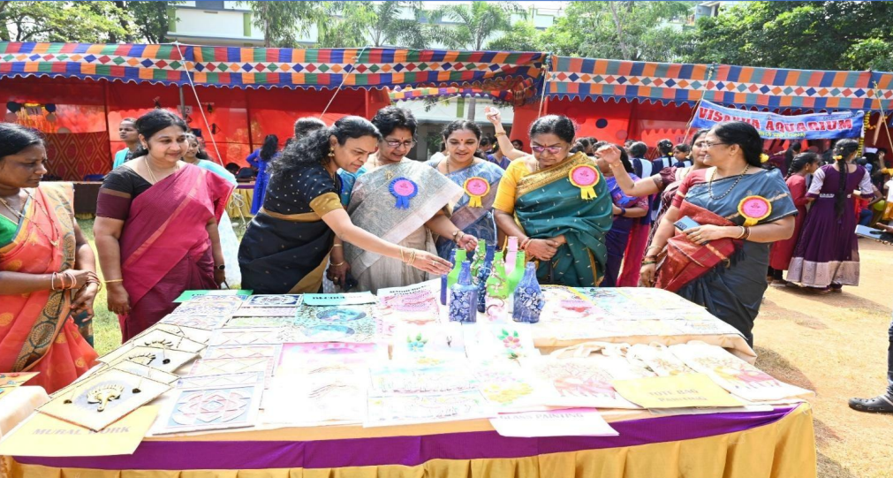
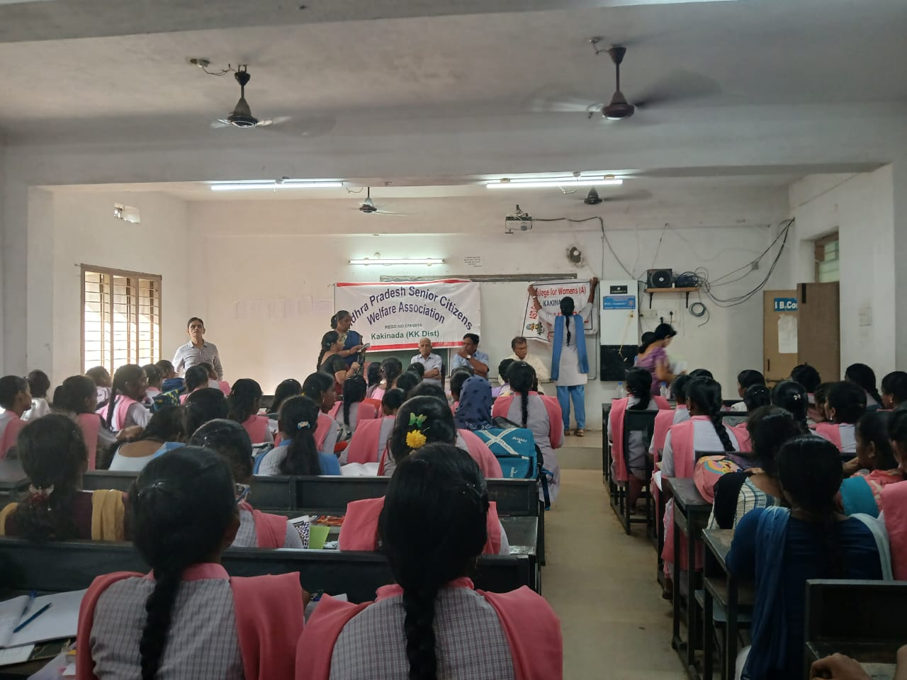
9. SAMANA – A Student Fair, organized by the Department of Commerce on November 2, 2024, stands as one of the best practices of our college. The program was graced by Chief Guest Sri Vanampadi Kondababu, City MLA, who encouraged students to explore their entrepreneurial potential. The fest aimed at empowering students by providing a vibrant platform to showcase their entrepreneurial skills and talents through cultural, academic, and extracurricular activities. Around 800 students actively participated, setting up 34 stalls, making the event both educational and celebratory. It fostered teamwork, creativity, and leadership while enabling meaningful interaction among students and faculty in a dynamic and competitive environment.

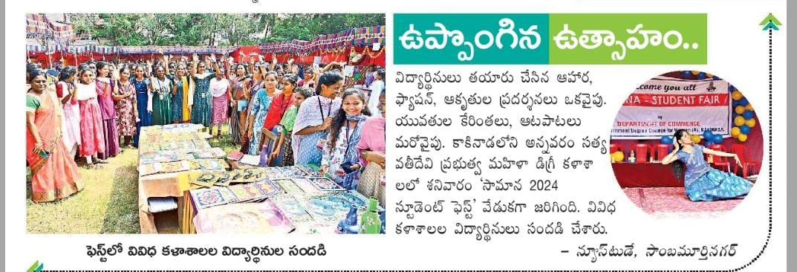
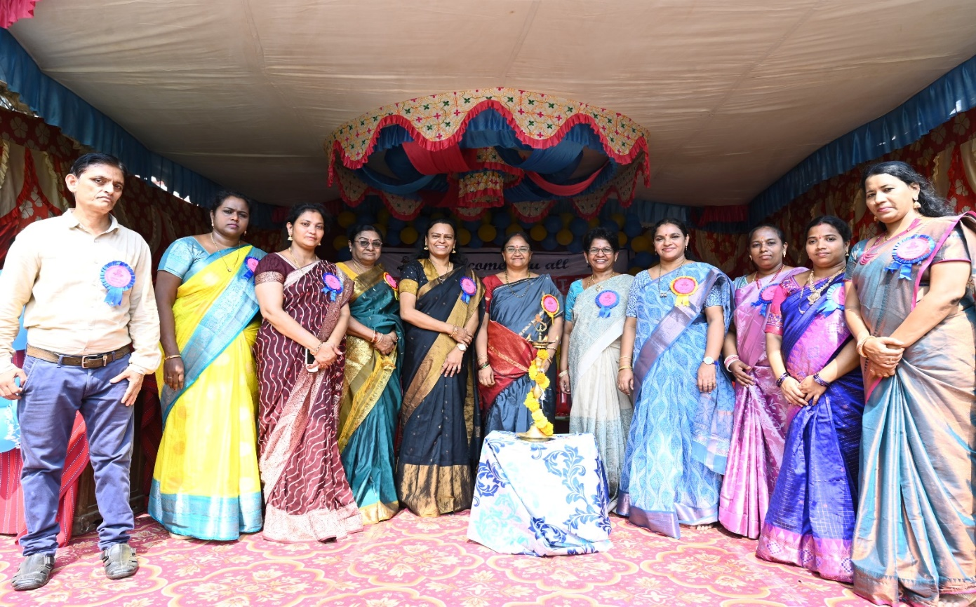

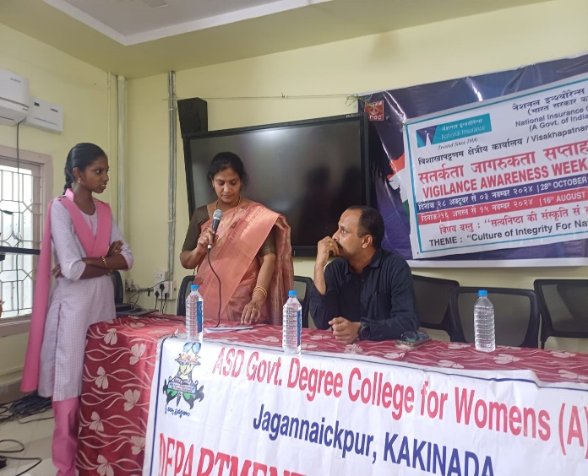
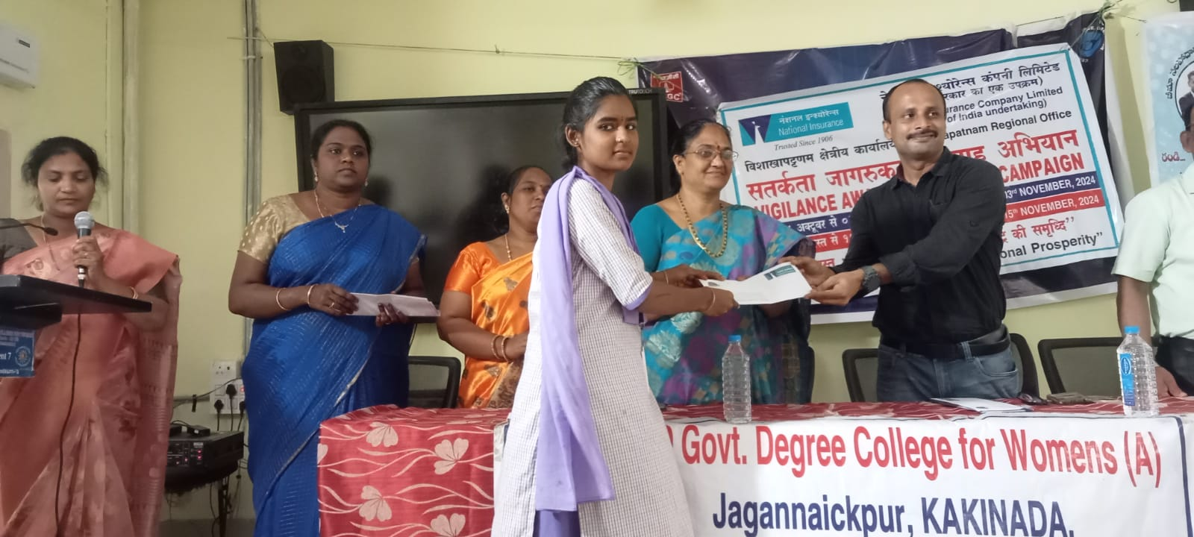
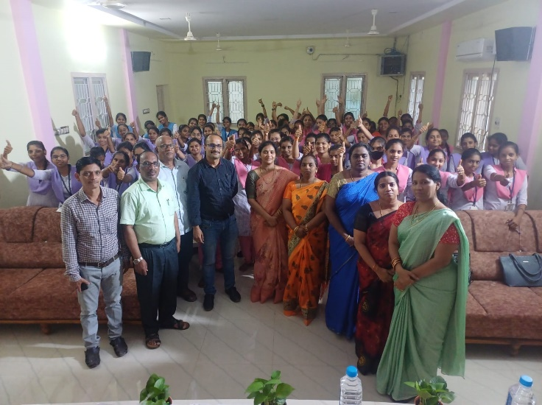
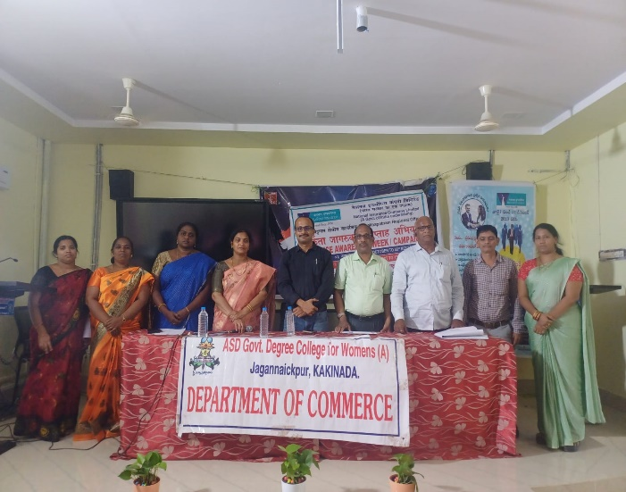
10. In collaboration with National Insurance Company Limited, a workshop on “Essence of Insurance” was organized on 4-11-2024 at Visakhapatnam. Sri CH Ramesh, Manager (Vigilance), addressed the students on the importance of insurance awareness, risk management, and ethical practices in the insurance sector, while V. Chandra Shekar Rao, Divisional Manager from Kakinada, delivered an insightful session on career opportunities and practical aspects of insurance services. Around 100 final-year B. Com students actively participated in the program, gaining valuable knowledge about insurance principles and their relevance in today’s financial environment. After the completion of the workshop, a few students were shortlisted for internship opportunities with the company. The event also included activities such as essay writing and elocution competitions, in which students enthusiastically expressed their ideas and reflections, followed by a feedback session that highlighted the program’s effectiveness and learning outcomes.

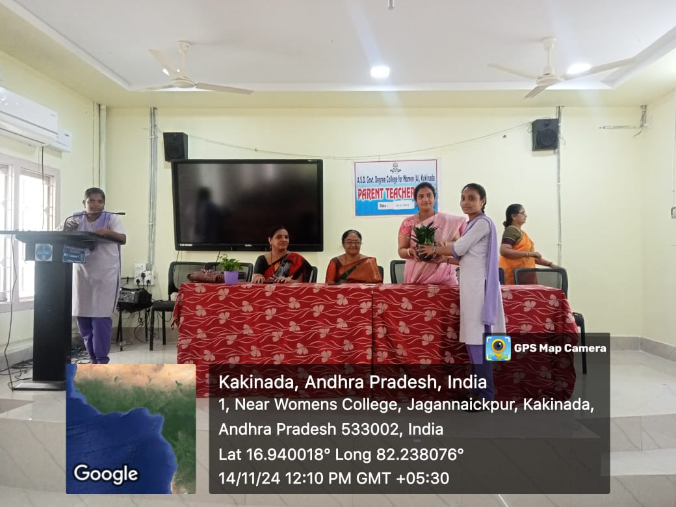
11. The Department of Commerce organized a Parent–Teacher Meeting to inform parents about the academic progress and overall development of their children. Faculty members discussed students’ performance, attendance, and areas for improvement, while also guiding parents on how to support their children in planning future career paths. Parents were briefed on students’ performance, career planning, and the importance of Primary Internship Courses and other internship opportunities, including guidance on where students should pursue their internships. Parents interacted with faculty, clarified their doubts, and shared feedback. A total of 108 students along with their parents participated in the program.

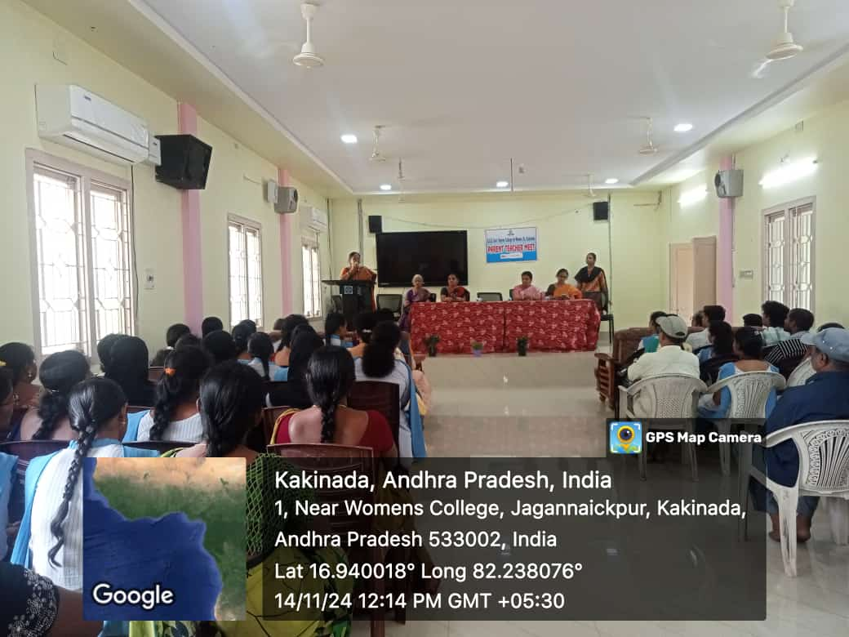

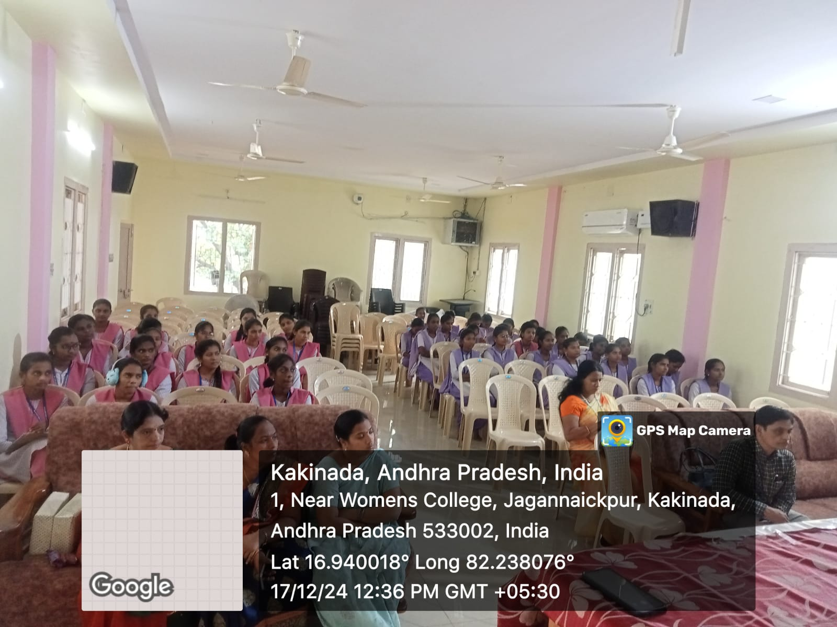
12. The Department of Commerce organized a Career Guidance Program on 17-12-2024 to create awareness about professional courses such as CA and ICWA. The resource person, Sri Gangadhar Rao.CA, addressed the students and explained the procedure for enrolling in CA courses, the scope of Chartered Accountancy, and the importance of pursuing ICWA after graduation. He also highlighted career opportunities, required skills, and the benefits of choosing professional education in the commerce field. 100 final-year students participated in the program and gained valuable guidance for planning their future careers.

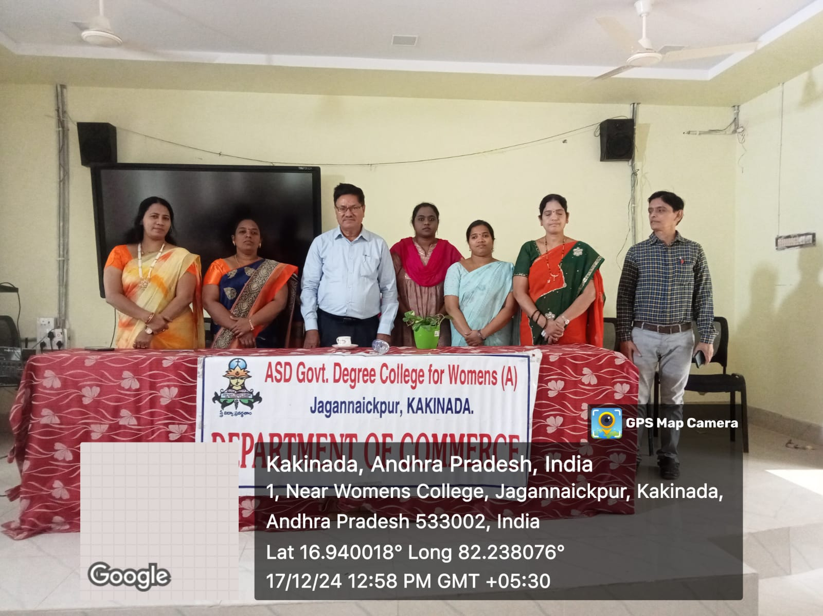

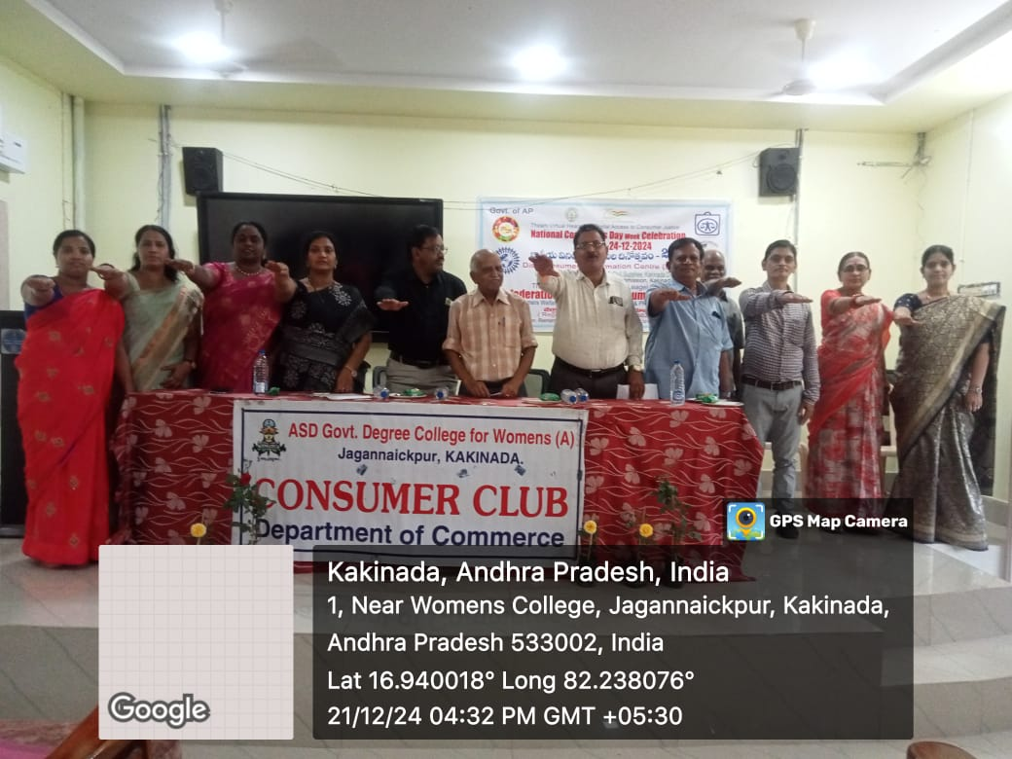
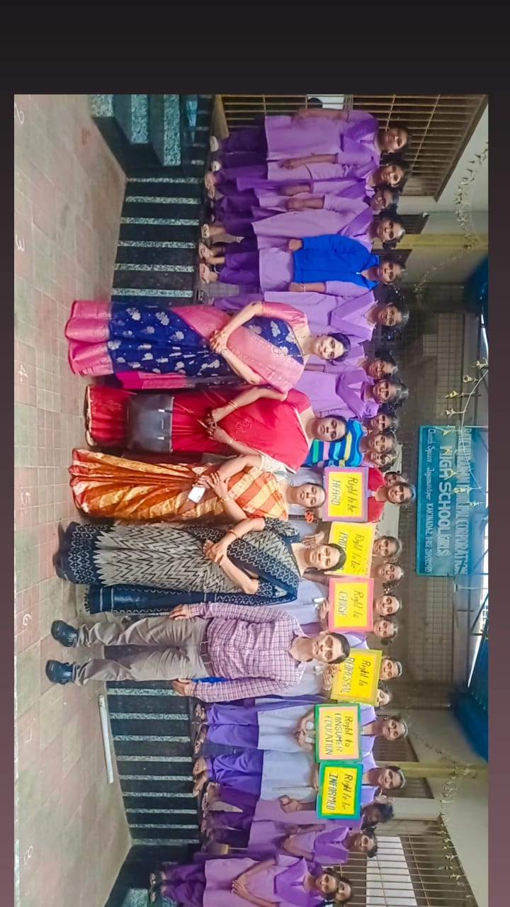
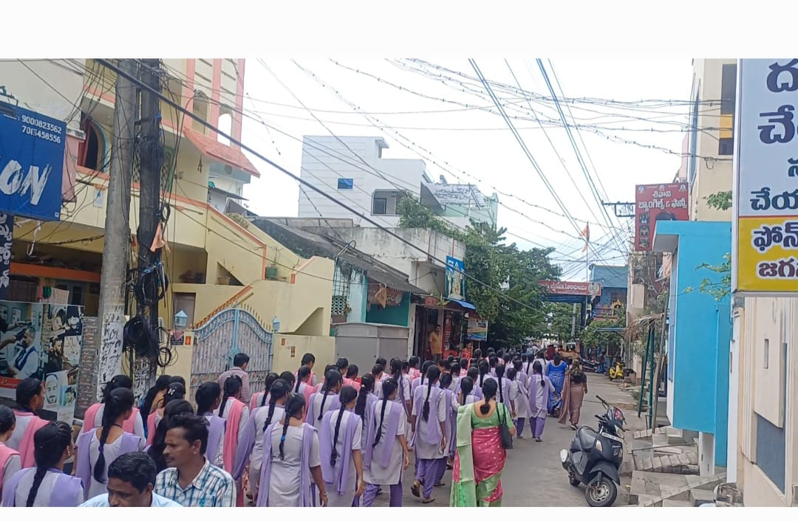
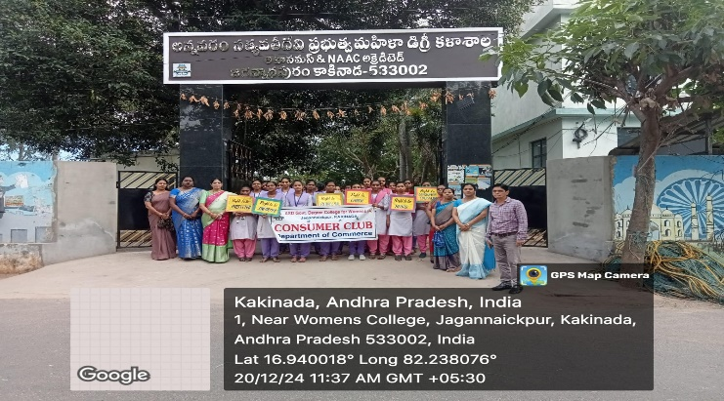
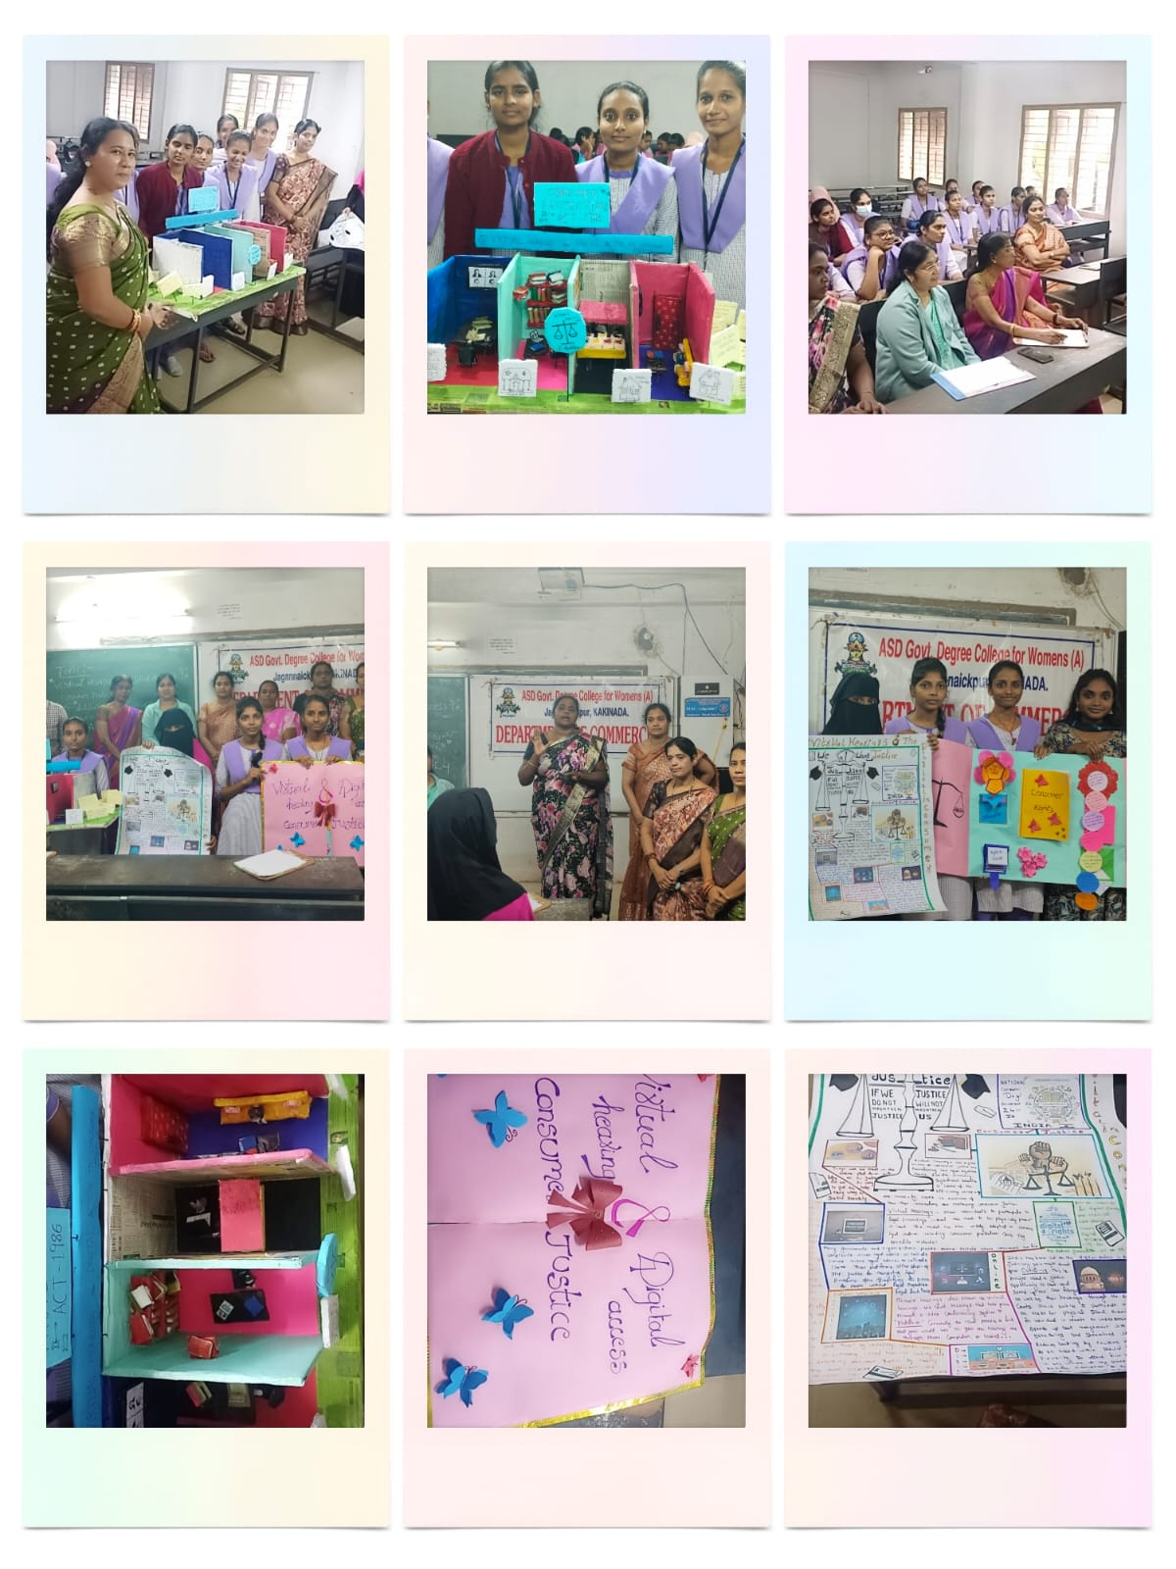
13. The Consumer Club of the Department of Commerce organized Consumer Week Celebrations with the participation of 100 students, in connection with National Consumer Day on 24th December. Activities included an Elocution Competition (16-12-2024), Essay Writing (17-12-2024), Extension Program (18-12-2024), Poster Presentation (19-12-2024), Rally and Flash Mob (20-12-2024) to promote awareness of consumer rights and responsibilities. Faculty and students actively participated and conducted outreach programs in nearby junior colleges and government schools around Jagannaikpur. A Guest lecture by the District Consumer Forum on 21-12-2026 further educated students on consumer laws and prizes, certificates were distributed to active participants.
14. The Department of Commerce organized a workshop on 5th January 2025 on the topic “Income Tax Slabs: Old Regime vs New Regime.” The program was conducted for both teaching and non-teaching staff to enhance their understanding of income tax provisions. The resource person, Sri Aditya Sharma, Chartered Accountant, along with his associates, explained the latest income tax slab rates, key differences between the old and new tax regimes, and guided participants on how to choose the most suitable option while filing their income tax returns. The session created awareness among the staff and helped them make informed financial decisions.
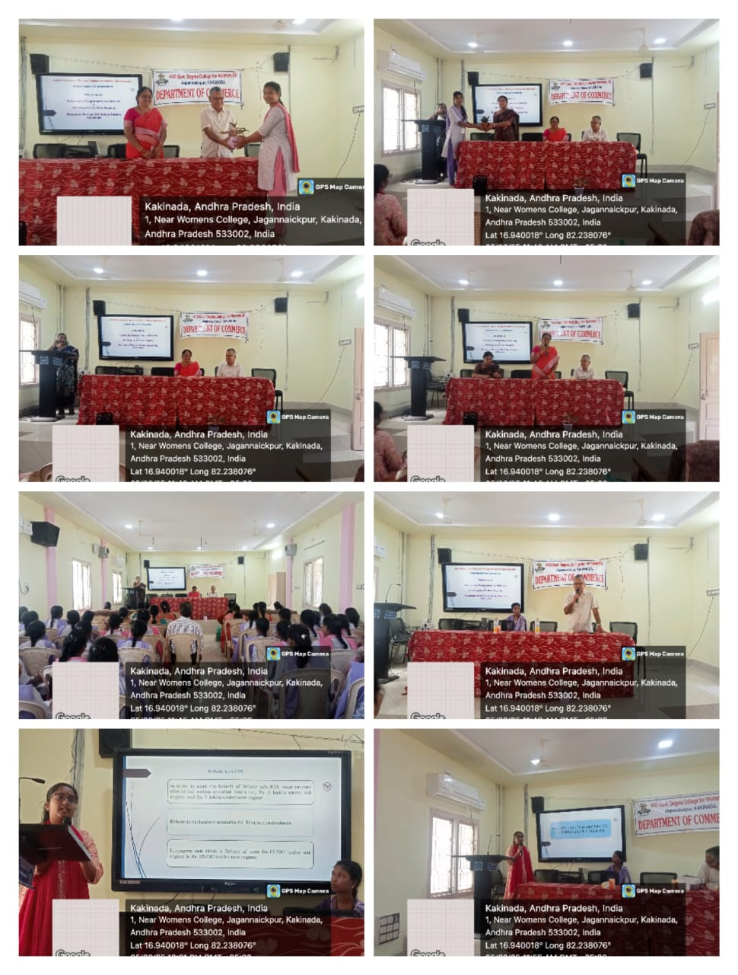
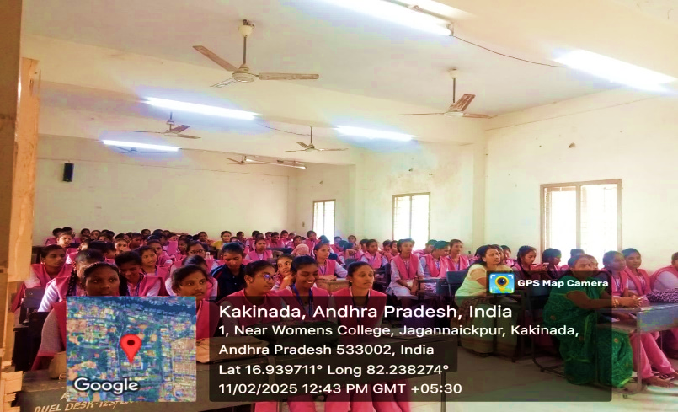
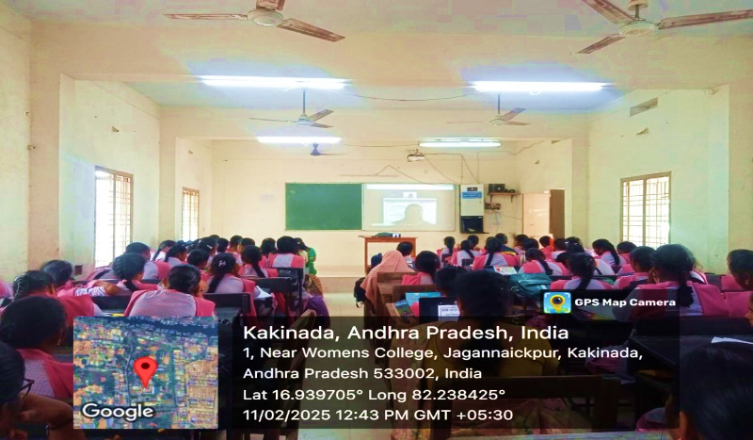
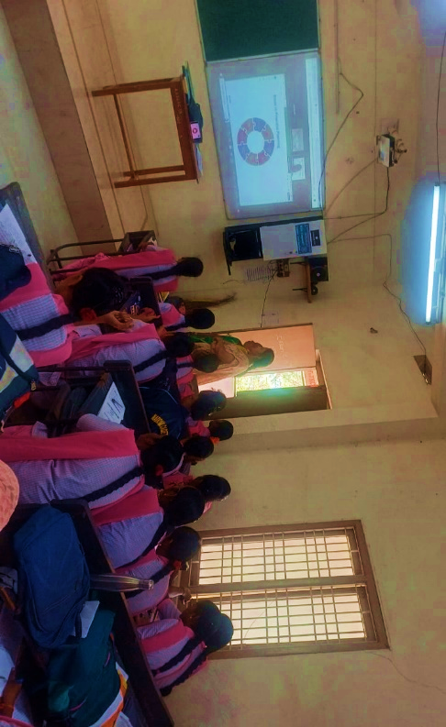
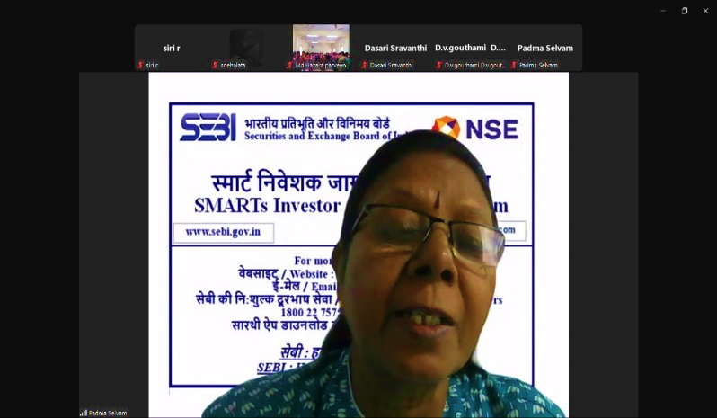
15. The Department of Commerce organized a National Webinar on 11th February 2025 on the topic “Financial Planning” in collaboration with the Securities and Exchange Board of India (SEBI) under the SMARTs Investor initiative and Edufin Welfare Organization. The resource person, Srimati Padma Syalvian from Tamil Nadu, delivered an insightful session,100 students from first, second, and final years. She explained the importance of financial well-being, methods of making sound financial decisions, and the role of SEBI in strengthening the Indian economic system. The program was highly informative, and feedback was collected from the students to support the further improvement of such initiatives.

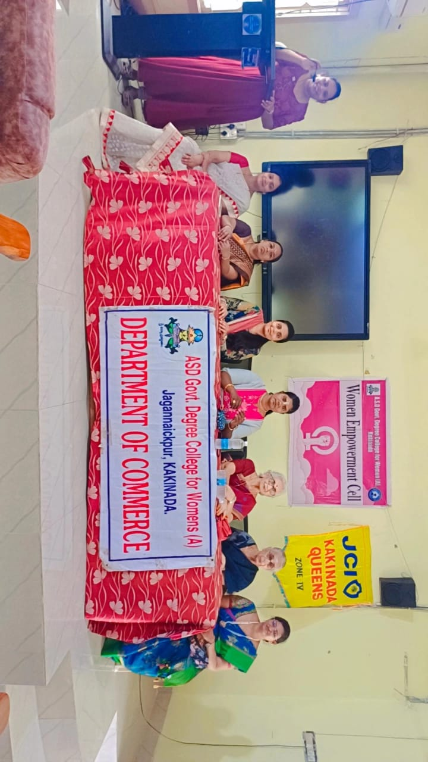
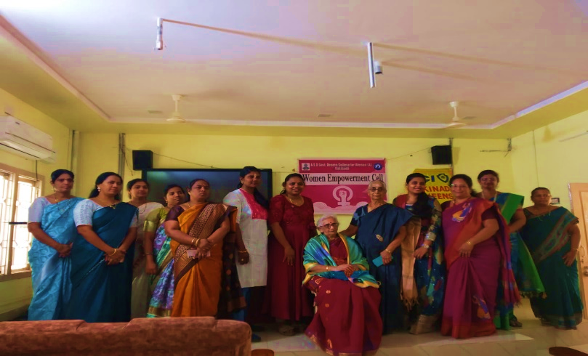
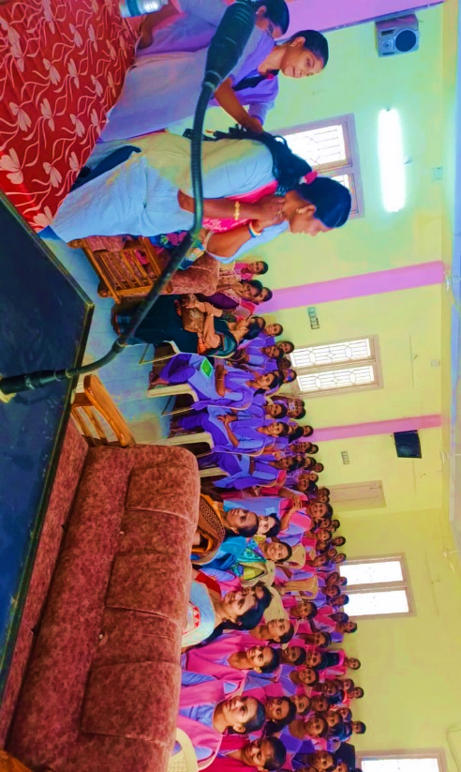
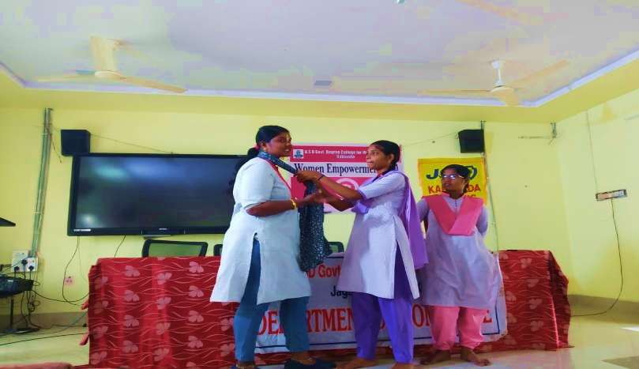
16. The Department of Commerce and Women Empowerment Cell of ASD Government Degree College, in collaboration with JCI Kakinada Queens, organized a special program on 7th March 2025 to empower and celebrate women through self-defense awareness. The session focused on teaching practical techniques to help women protect themselves and build confidence in challenging situations. It was highly informative and enlightening for the students, emphasizing personal safety and empowerment. Following the session, a felicitation ceremony was conducted, and a speech training program guided participants on how to speak confidently in public, interact effectively with audiences, and present themselves assertively.

17. The Department of Commerce organized a National Webinar on 13th March 2025 titled “Navigating the IPR Landscape Patents, Trademarks, and Copyrights” in collaboration with the Institution’s Innovation Council (IIC). 100 students were participated in the program, which provided valuable insights into intellectual property rights, their significance, and procedures for protecting innovations. The webinar was conducted successfully, enhancing students’ awareness of IPR concepts, and feedback was collected to further improve future programs.

