A. S. D. Government Degree College for Women (A)
(Re-Accredited by NAAC with ‘B’)
Kakinada 533002, East Godavari, Andhra Pradesh
Department of English

Student Progression to Higher Education

S.No | Name of the Student | Group | Year of Study | Hall Ticket No. | Subject | Rank | Category | Photo
1 | Madhavapuri Manipriya | MPC | 2019-2022 | 10120220311 | MA  English | 72 | BC -D | 
2 | Virodhula Swathi | B. Com | 2019-2022 | 10120220677 | MA  English | 387 | OC | 

3 | Linda Manga Devi | B. Com | 2019-2022 | 10120220271 | MA  English | 579 | SC | 
4 | Sirisha Padala | B. Com | 2019-2022 | 10120220400 | MA  English | 391 | SC | 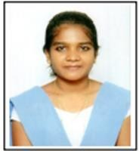
5 | Palivela Devi Sri | III CBZ | 2021-2024 | 10120230349 | M.A. English | 408 | BC-B | 