**BEST PRACICE-II – ITR e-filling**

On every year department of commerce conducing a workshop by inviting a guest to create awareness on income tax e-filling to staff and students. e-file is sometimes restricted to certain professionals and/or businesses with a minimum annual income. whether individuals, small businesses, and other professionals are allowed to e-file depends from country to country, and sometimes depending on the tax regulations and government rules.

Electronic filing is becoming increasingly popular because of the wide array of benefits it brings to the table:

**1. Convenient and flexible**

e-filing has brought about increased flexibility in the filing of taxes and is a lot more convenient since one’s taxes can now be filed from the comfort of their home or workspace at their own time. They can do it whenever they wish to, as it no longer serves to be a 9 to 5 task.

**2. Saves time and money**

e-filing also reduces time and effort for both the tax agency and the taxpayer because it is generally much easier and faster to process e-file tax returns than paper returns, thereby saving a lot of time on both ends.

**3. Increased accuracy**

Since transmission errors and the like can be avoided through e-filing, it leads to increased data records accuracy and the overall tax filing process.

**4. Less room for manipulation of records and window dressing**

E-filing leaves less room for manipulation of data records and window dressing. With e-filing, online data availability and interconnectivity are much more profound, and linking or tracing data back to a tax-paying unit is made much easier and faster with e-filing.

**5. Increased authenticity and accountability**

E-filing has also led to increased authenticity to the process of tax filing and increased accountability on both the tax agency and the taxpayer. Paper filing is slightly more ambiguous because there is high ambiguity on the receipt of tax papers and tax records.

**Workshop on e-filling 2025**

Sri Adhitya Sharma**.,** charted acconttent and his members gave PPT presentation to staff and students.

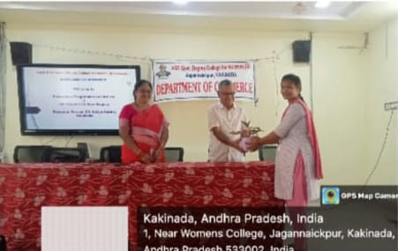

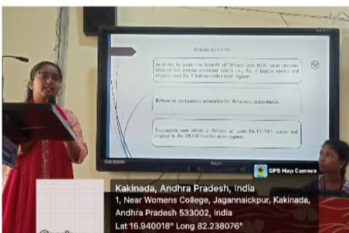

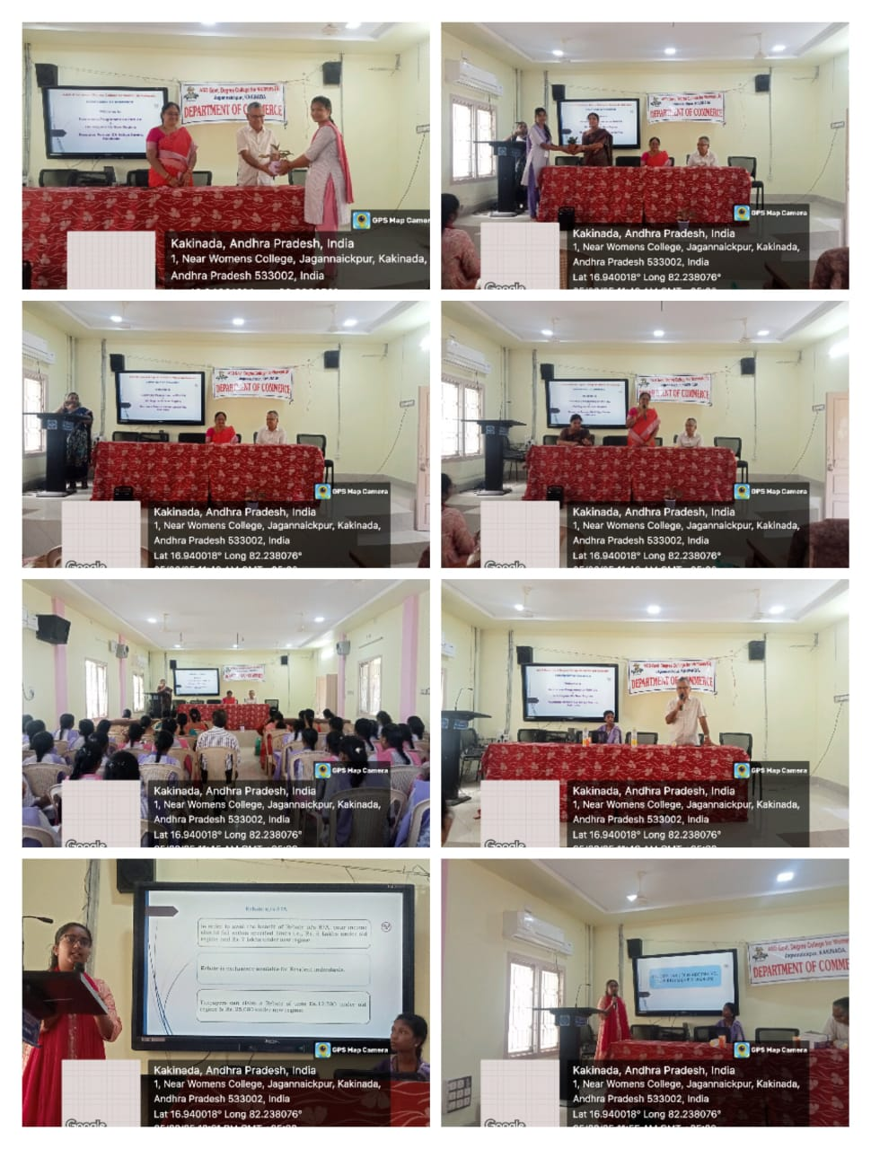

**Workshop on e-filling 2024**

Sri. M.Srinivas., Lecturer in Commerce gave PPT presentation to staff and students.

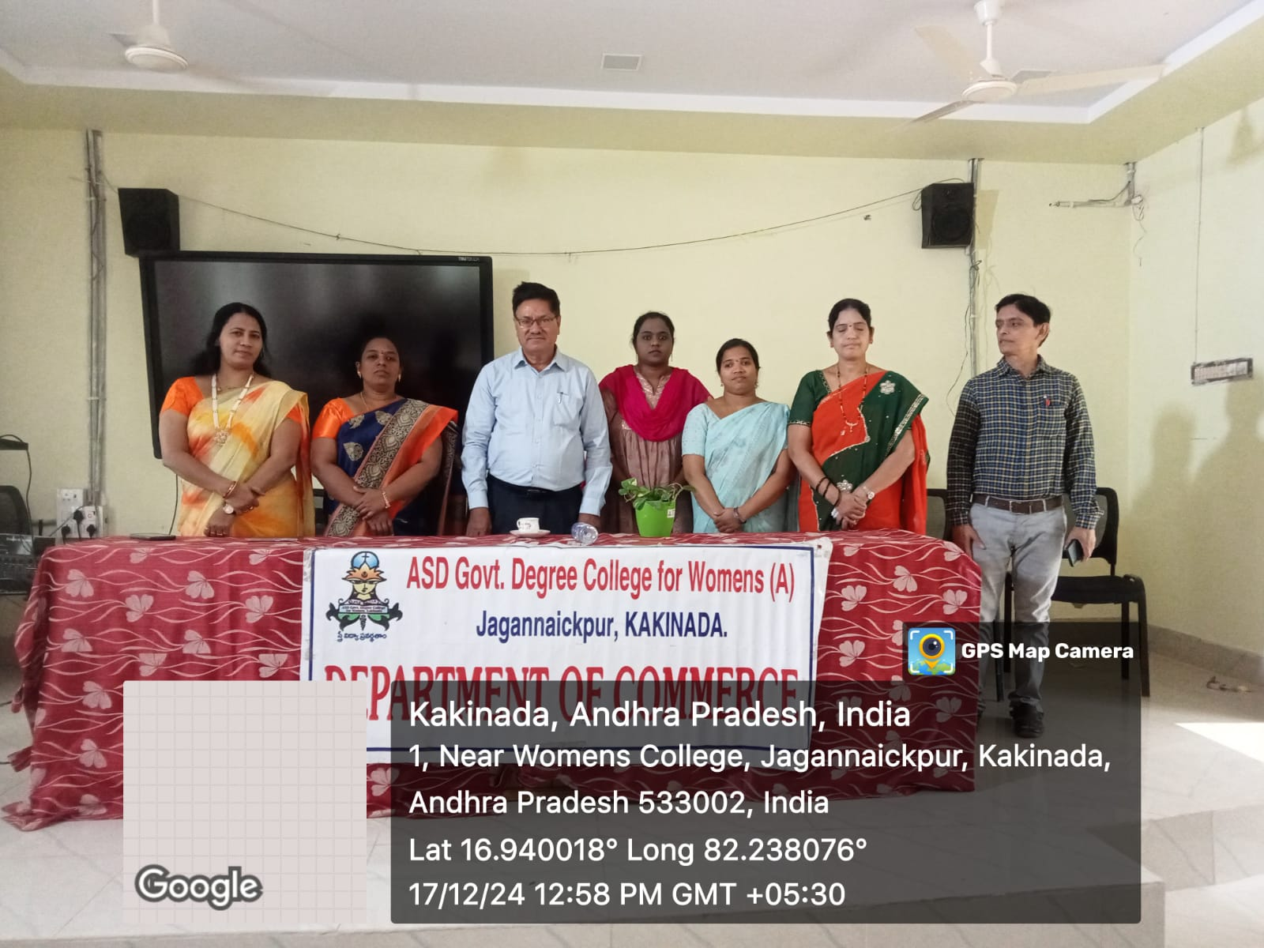

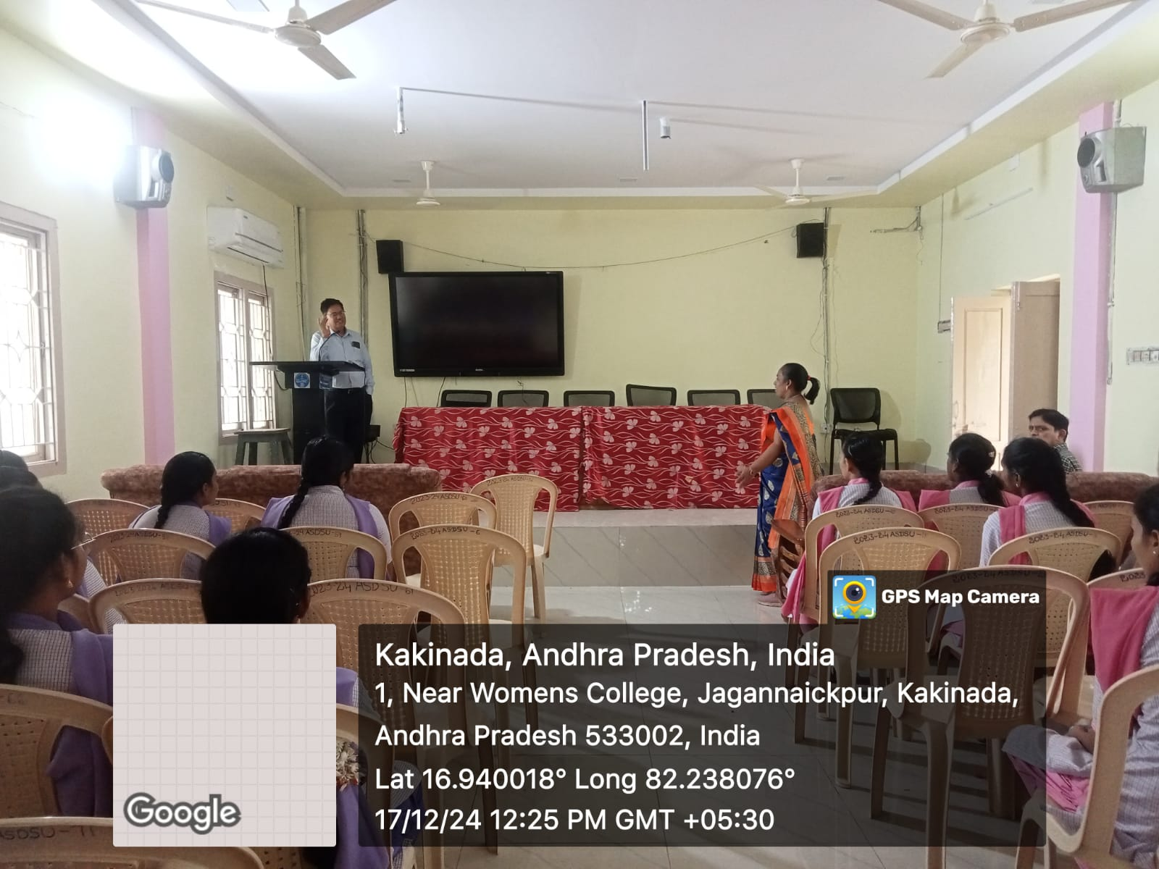

**Workshop on e-filling 2024**

Sri. M.Srinivas., Lecturer in Commerce gave PPT presentation to staff and students.

