A. S.D.Govt.Degree College for Women(A), Kakinada Department of Chemistry
Student Progression to Higher Education 2023-2024

S.NO | NAME OF THE STUDENT | HALL TICKET NUMBER | SUBJECT | RANK OBTAINED | PROOF
1. | Bunga Sujitha | 2139002 | Chemical Sciences | 26350  S.V.University of College, Tirupathi | 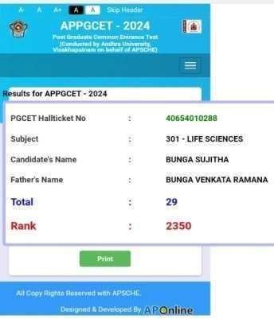
2. | Isukapatla Anusha Jyothi | 2139012 | Chemical Sciences | S.V.Univeristy of College, Tirupathi | 