A.S.D. Government Degree College for Women (A), Kakinada

Department of Commerce

Detailed Report on Activities Conducted by the Department of Commerce for the year 2023-24
- Remedial Coaching - Business Statistics (6th July 2023) On the 6th of July, 2023, the Department of Commerce organized a remedial coaching session focusing on the subject of Business Statistics. The coaching session, led by Smt. K.N.B. Kumari, was designed to provide additional academic support to students struggling with statistical concepts. The lecturer in Commerce M. Pusphalatha, provided valuable insights, ensuring that students gained a deeper understanding of the subject. With 40 students in attendance, the session aimed to bridge the gaps in their knowledge, making it easier for them to cope with the regular coursework. The initiative was well-received, with students appreciating the focused attention they received.
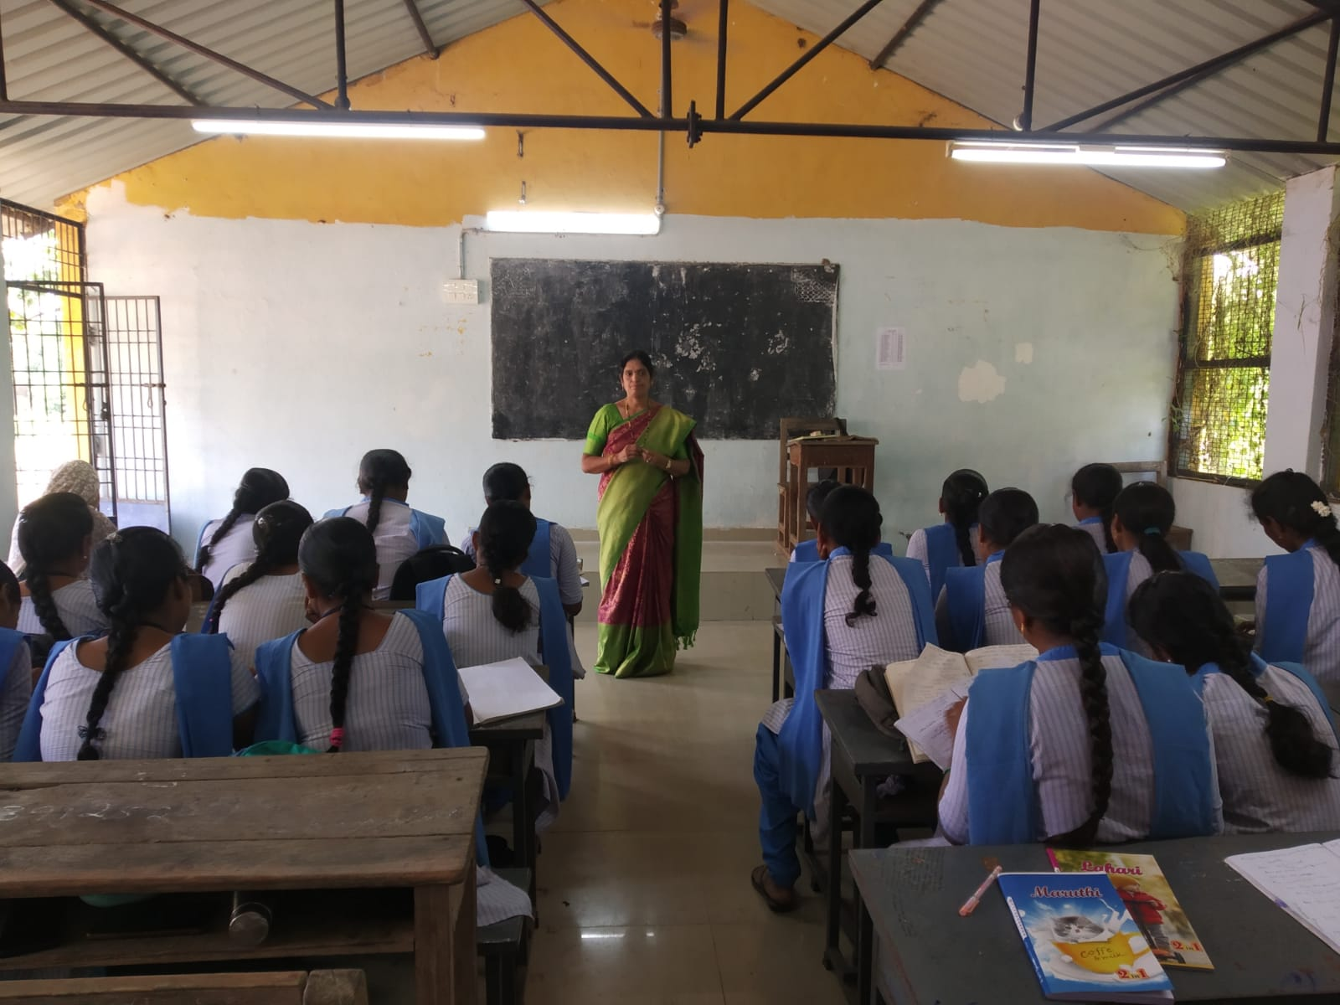
- International Youth Day – Elocution & Essay Writing (10th August 2023) To commemorate International Youth Day, the Department of Commerce organized an Elocution and Essay Writing competition on 10th August 2023. The event focused on engaging students in activities that would enhance their public speaking and writing abilities. Smt. Ragireddy Chandrakala Deepthi, the Chairperson of KUDA attended as Chief Guest. The event witnessed the enthusiastic participation of 80 students, who presented their ideas on youth-related issues. The competition not only encouraged the students to think critically about their role in society but also fostered a healthy sense of competition and creativity. Winners awarded with prizes and certificates.
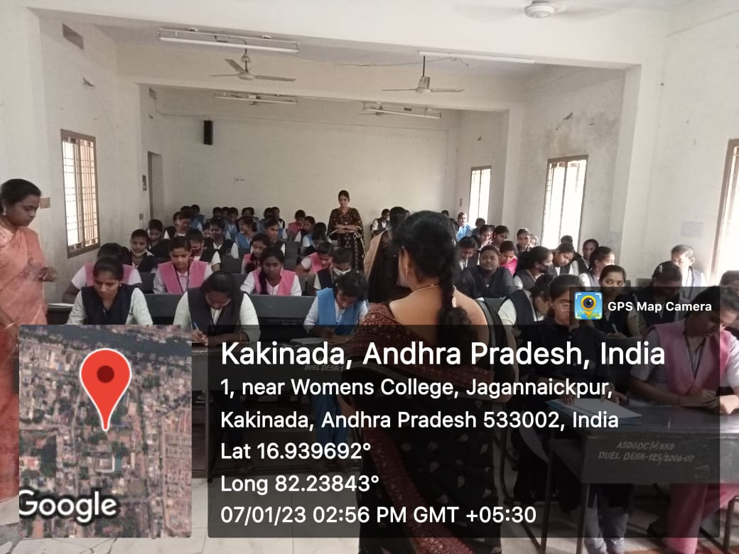
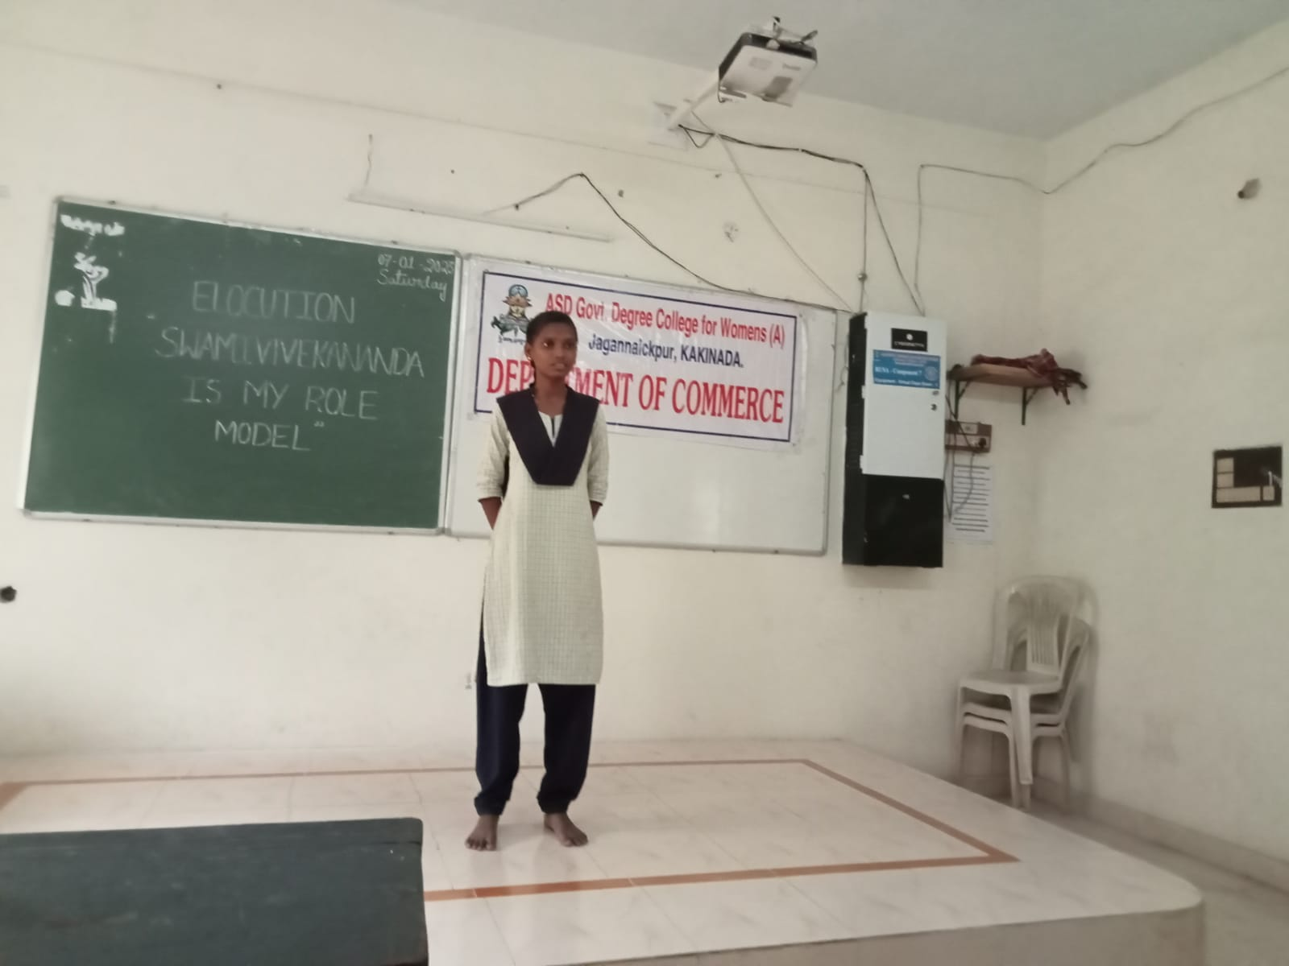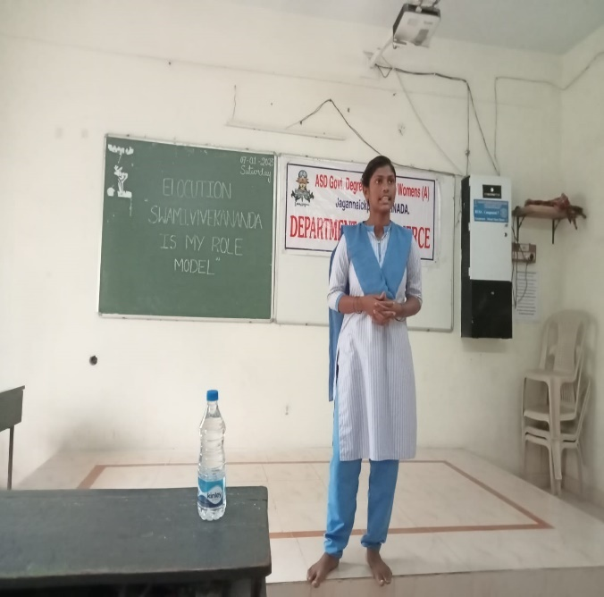
- Best Out of Waste – National Youth Skill Day (11th August 2023) As part of the National Youth Skill Day celebrations on 11th August 2023, the Department of Commerce hosted a unique "Best Out of Waste" competition. The aim was to promote innovative thinking and sustainable practices among students. Radha, Chairman of ICAI, Kakinada, was invited as the resource person. The event encouraged students to use waste materials creatively, transforming them into useful items. This competition not only sparked creativity but also raised awareness about the importance of recycling and environmental sustainability. Faculty of department of Commerce has taken special care and prizes and certificates are given to Winners.
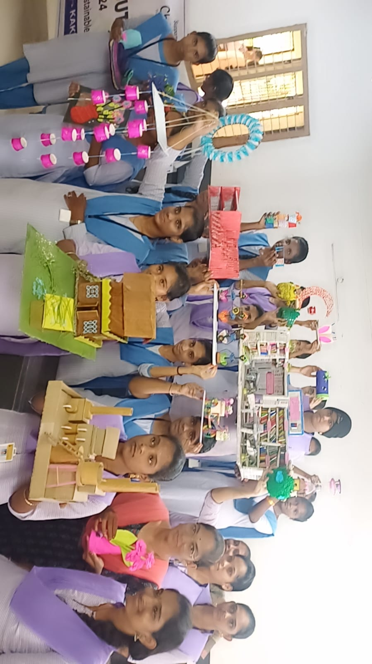
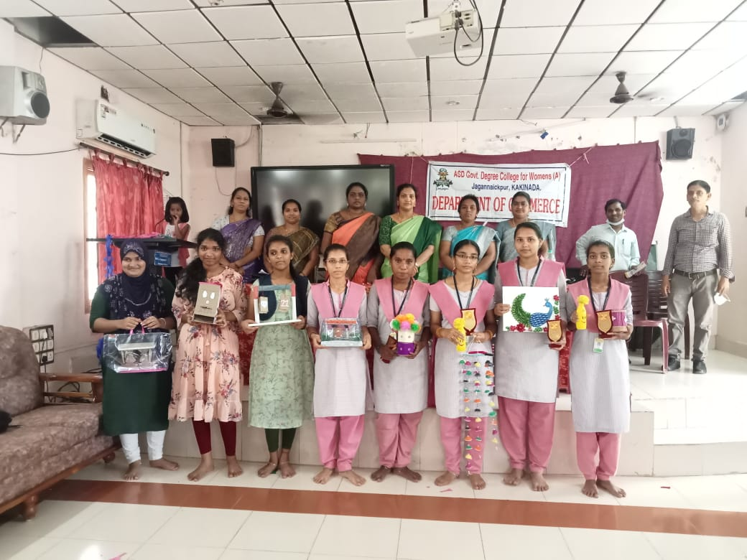
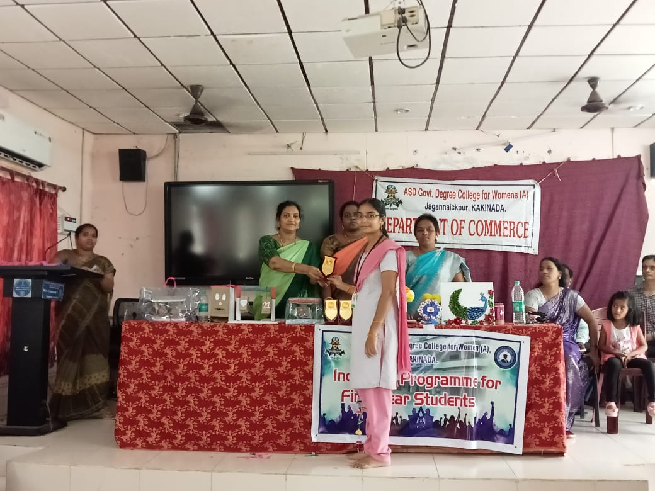
- SAMANA 2023 – Student Fest (11th August 2023) SAMANA 2023, the annual student fest of the Department of Commerce, was held on the same day, 11th August 2023. The fest provided a platform for students to showcase their entrepreneurial skills and talents across various cultural, academic, and extracurricular activities. It was a day of celebration and learning, where students interacted with their peers and faculty in a relaxed yet competitive environment. The event was a huge success, with students actively participating in various activities that fostered a spirit of teamwork, creativity, and leadership.
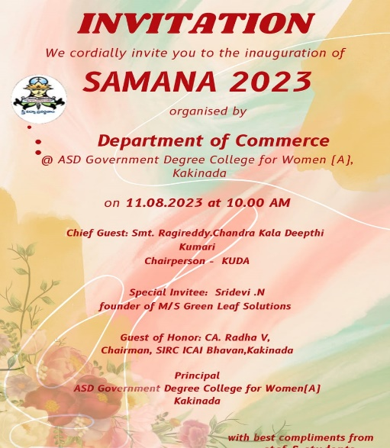
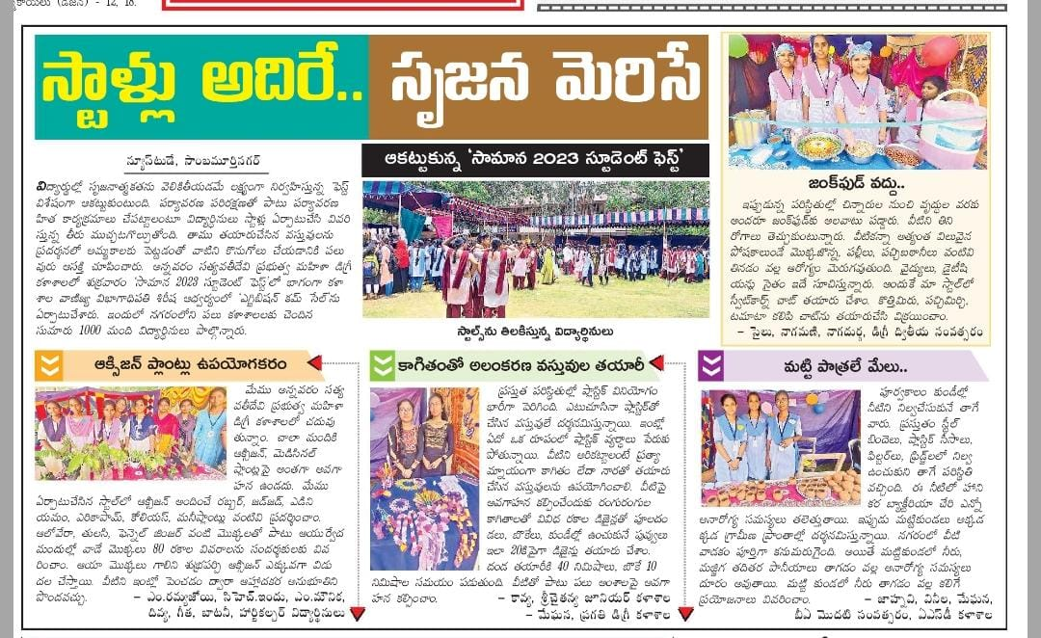
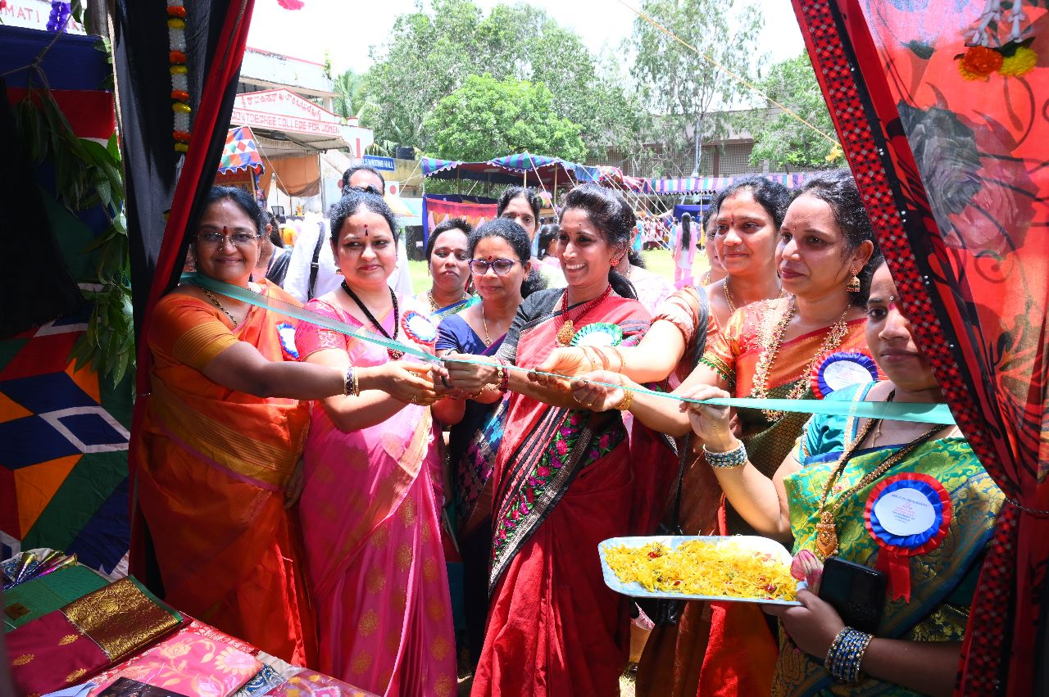
- Induction Programme 2023 (18th August 2023) The Department of Commerce organized an Induction Programme for newly admitted students on 18th August 2023. The induction program aimed to familiarize the first-year students with the department, its faculty, and the academic environment. With the participation of 90 students, the program covered topics such as course structure, academic expectations, and the role of faculty in mentoring students. The induction served as a crucial step in helping students acclimatize to their new academic journey, ensuring a smooth transition from school to college life.
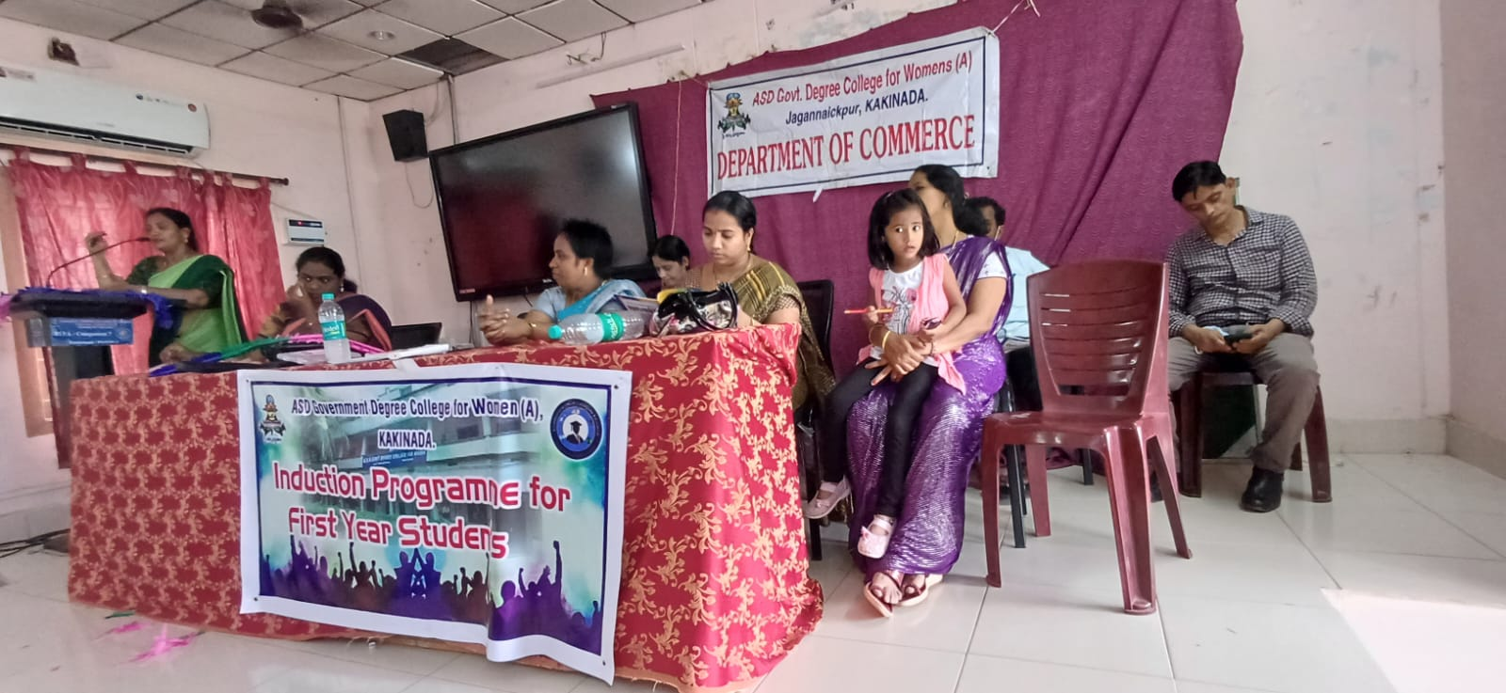
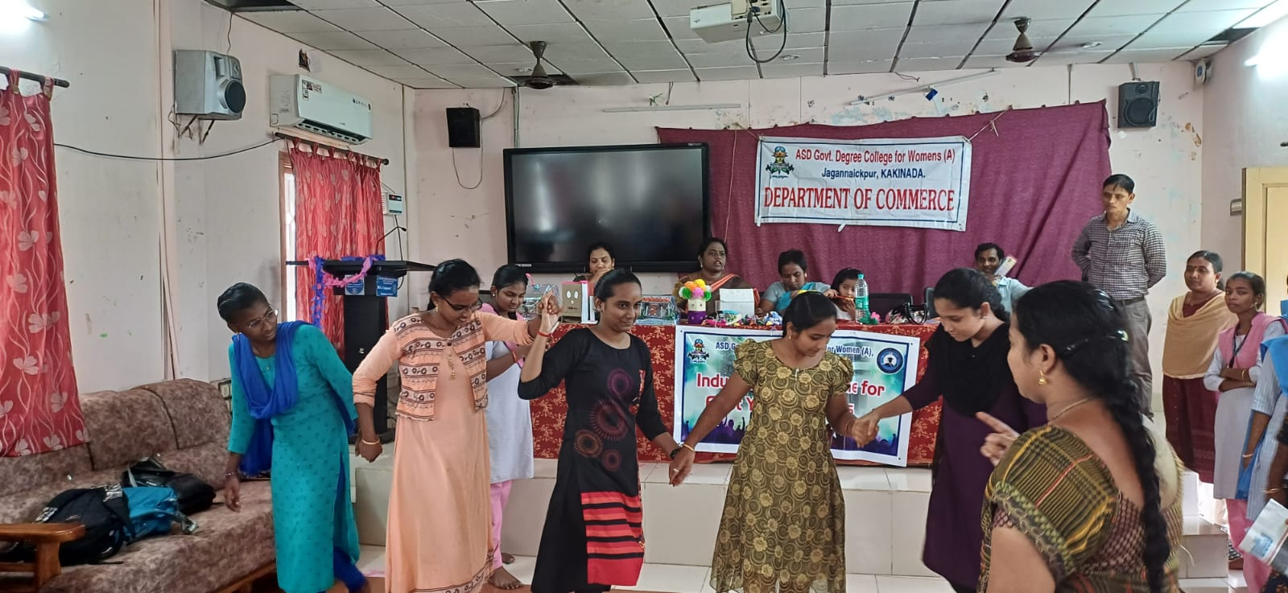
- Bridge Course for First-Year Students (30th August to 10th September 2023) From 30th August to 10th September 2023, the Department of Commerce conducted a Bridge Course for first-year students. This course was designed to help students transition into the college's academic rigor by revisiting fundamental concepts they had learned in their previous studies. Faculty members from the department led the course, covering basic subjects that would form the foundation for more advanced topics in their curriculum. This course helped ease students into their new academic environment and provided them with the necessary tools to excel in their future studies.
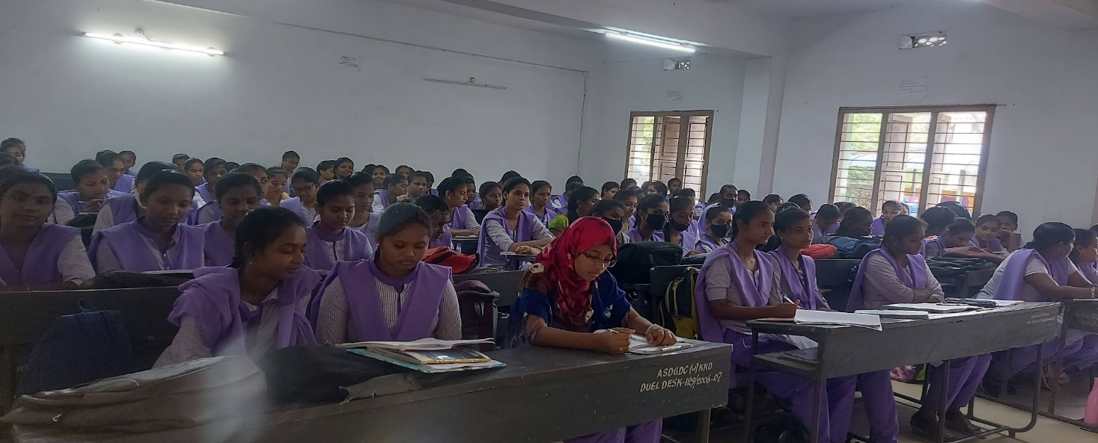
- Career Guidance Programme for Newly Admitted Batch (23rd September 2023) A Career Guidance Programme was conducted on 23rd September 2023 for the newly admitted students of the Department of Commerce. Dr. P. Uma Maheswari, Associate Professor at AKNU, Rajamahendravaram, who provided valuable insights into career opportunities available to commerce graduates as a Resource person. With 100 students in attendance, the program offered guidance on career planning, skill development, and industry expectations. It was an eye-opening experience for the students, helping them make informed decisions about their future career paths.
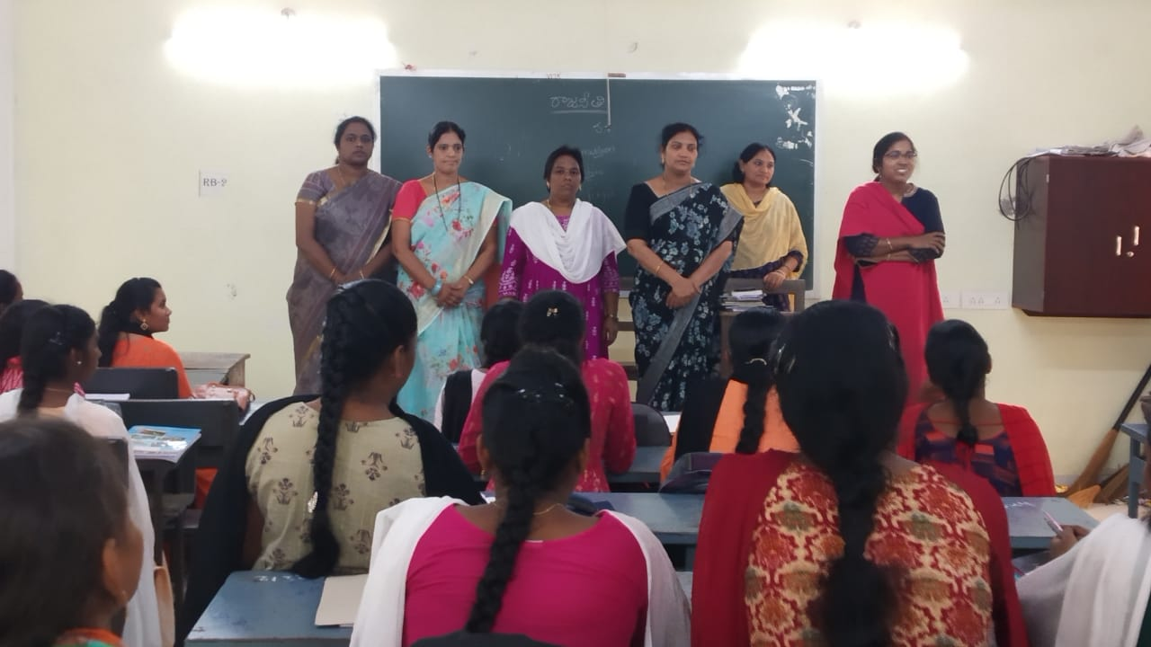
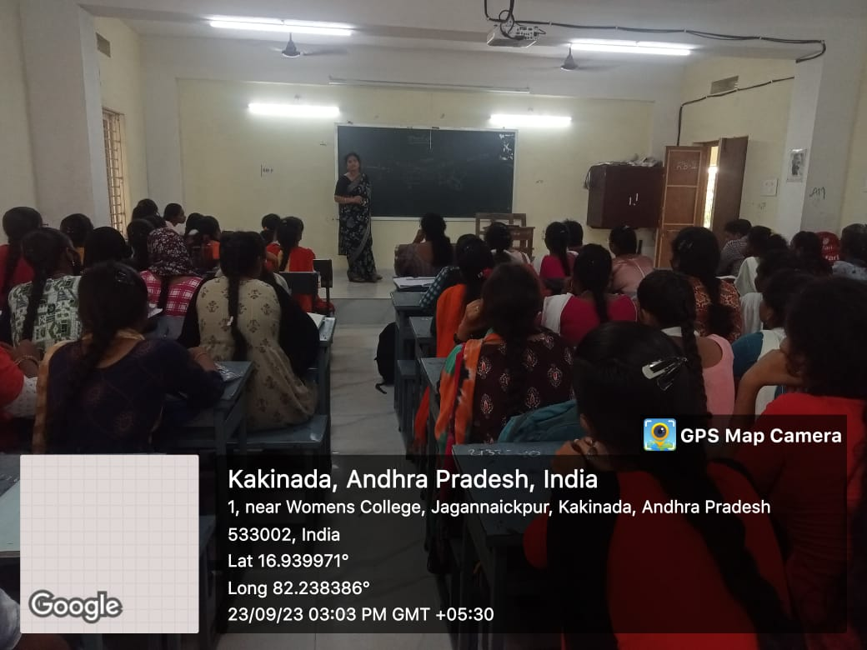
- Management Games under Commerce Club (30th September 2023) On 30th September 2023, the Commerce Club organized a series of management games for first-year students. The games were designed to enhance skills such as teamwork, problem-solving, decision-making, and leadership. Faculty members, including R. R. D. Sirisha,, I/C Department of Commerce, N. P. V. Lakshmi Devi, Dr. Sowjanya, and others, facilitated the event. A total of 70 students participated in the event, which provided a hands-on learning experience in managing real-world business scenarios. The event was both fun and educational, helping students to apply theoretical knowledge in practical situations.
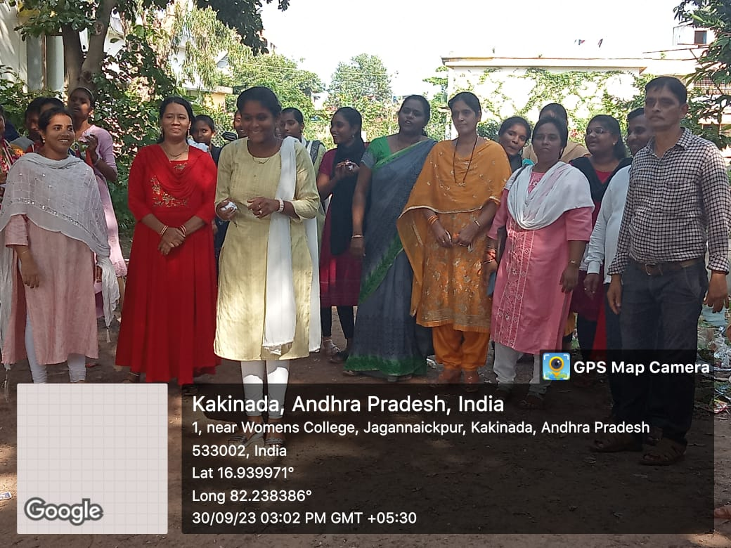
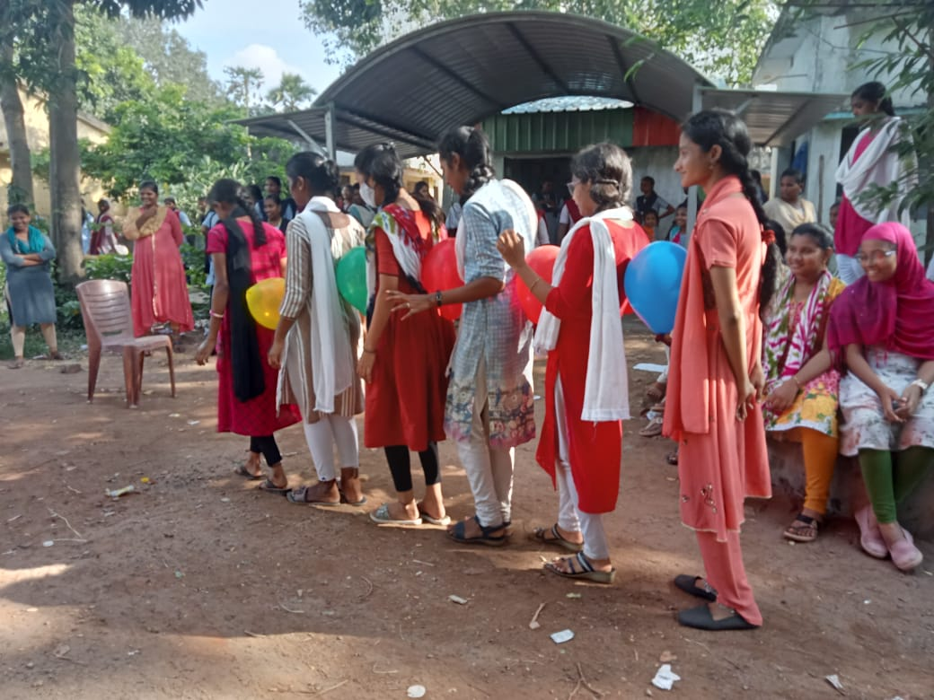
- Faculty Exchange Programme conducted under MOU between PR Government Degree College, Kakinada and A.S.D. government Degree College for Women (A), Kakinada (3rd November 2023 and 18th November 2023) The faculty of both Colleges underwent faculty Exchange Programme as per Memorandum of Understanding between both Colleges. NPVL Devi, Dr. G Sowjanya, K.N.B Kumari, V. Srinivas visited the PR Government Degree College, Kakinada and extended their teaching service to the students there, In the same way Dr. Madhu, Rajeswari, Hema Visited this College and taught II and IV SEM students.
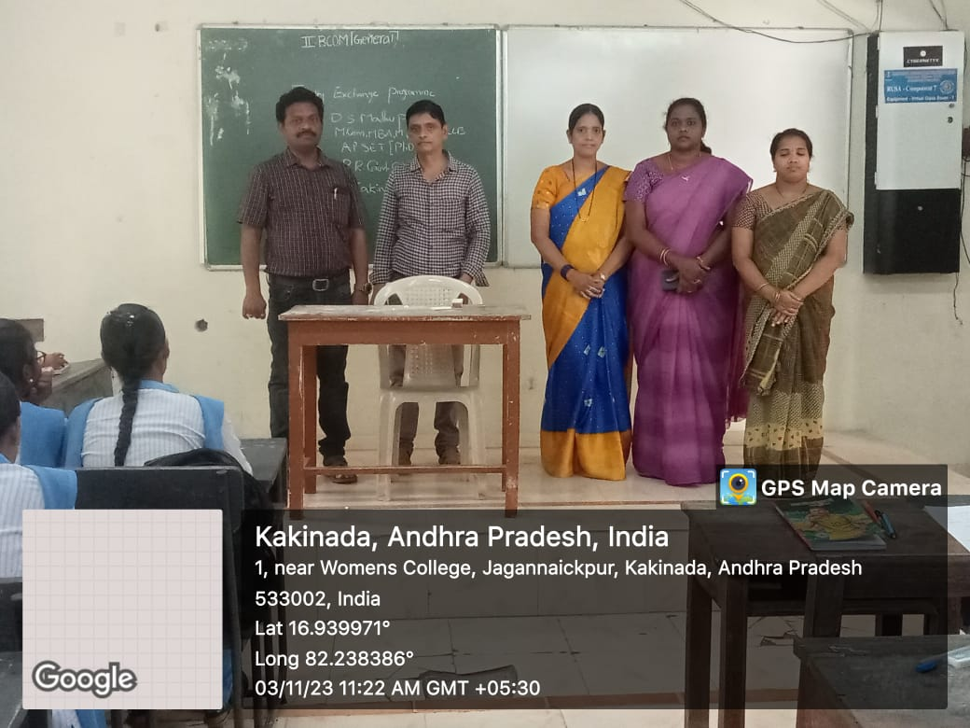

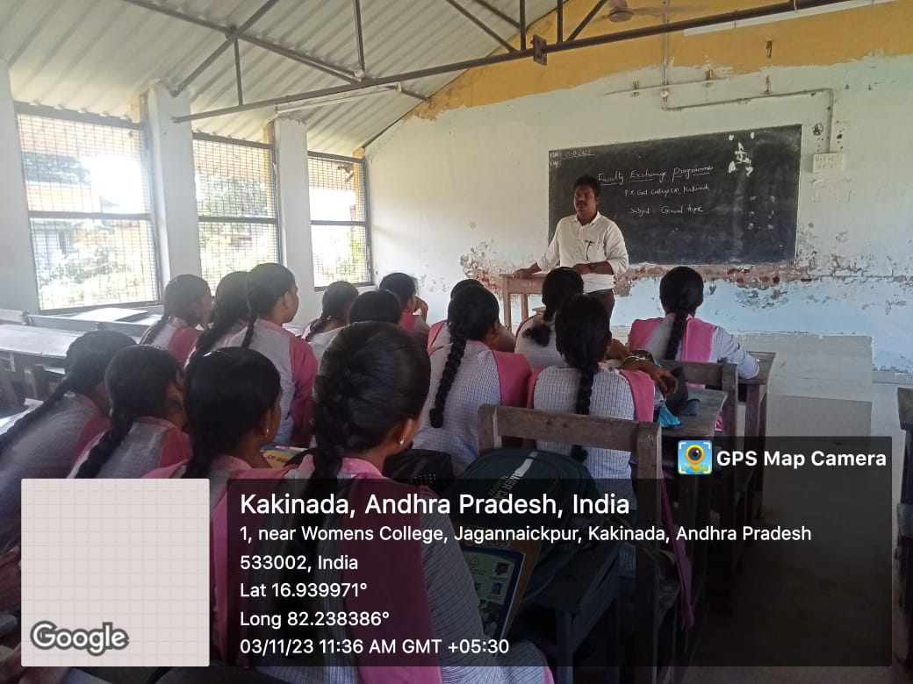
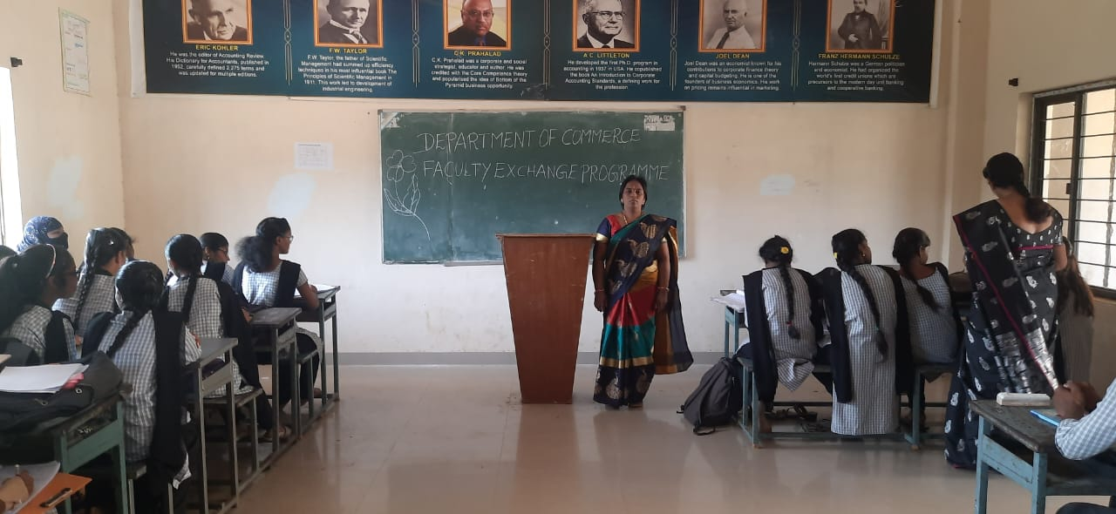
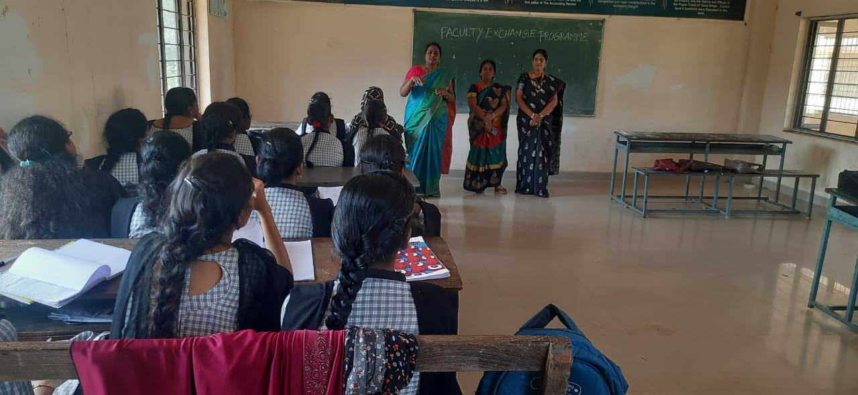
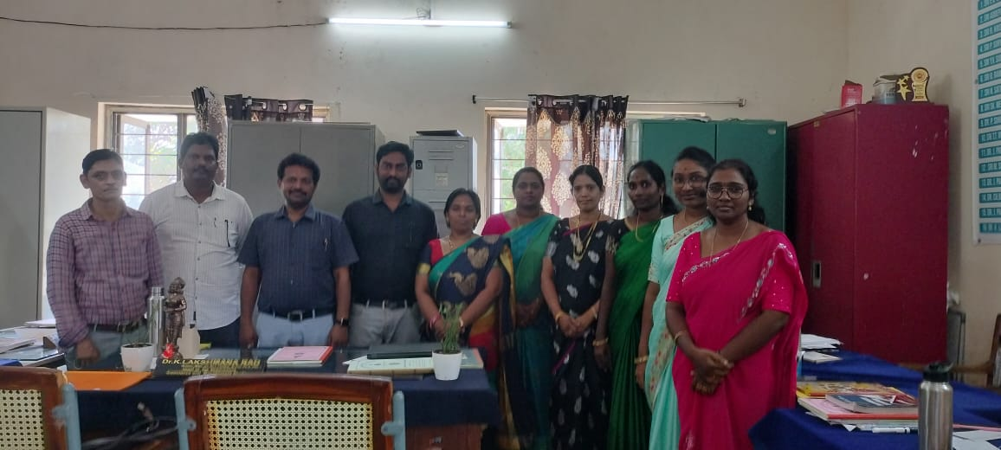
- Guest Lecture on Global Accounting Trends (9th November 2023) A guest lecture on "Global Accounting Trends, Changes, and Opportunities in the 21st Century" was held on 9th November 2023. The lecture, led by CA Ganga Ram Garu, Chairman of ICAI, and CA Rama Subba Rao Garu, provided 100 students with a comprehensive overview of the changes and developments in the field of accounting. The speakers discussed the evolving nature of accounting practices and how students can prepare themselves for future challenges in the industry. This insightful lecture was highly appreciated by the students as it connected classroom learning with real-world accounting scenarios.
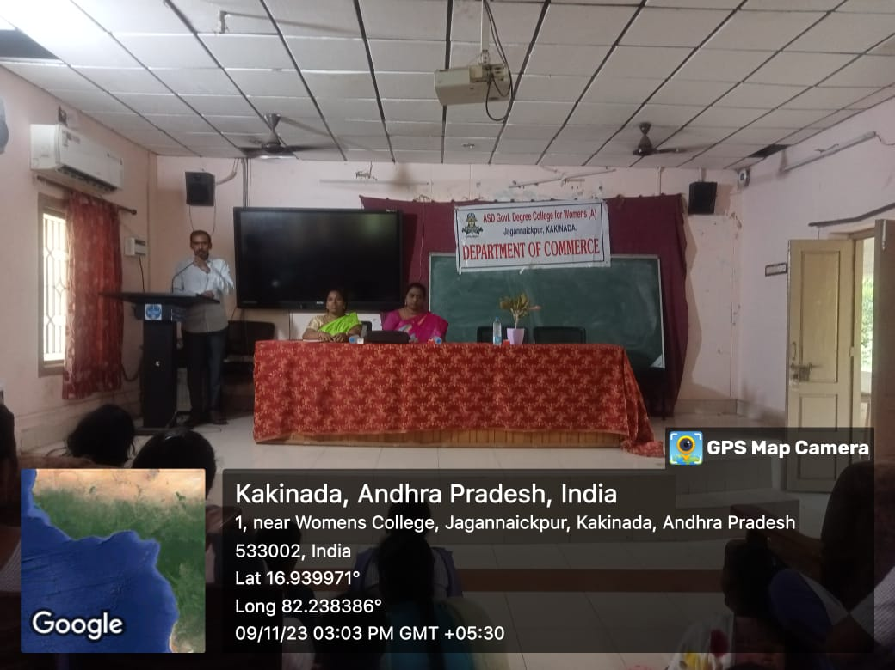
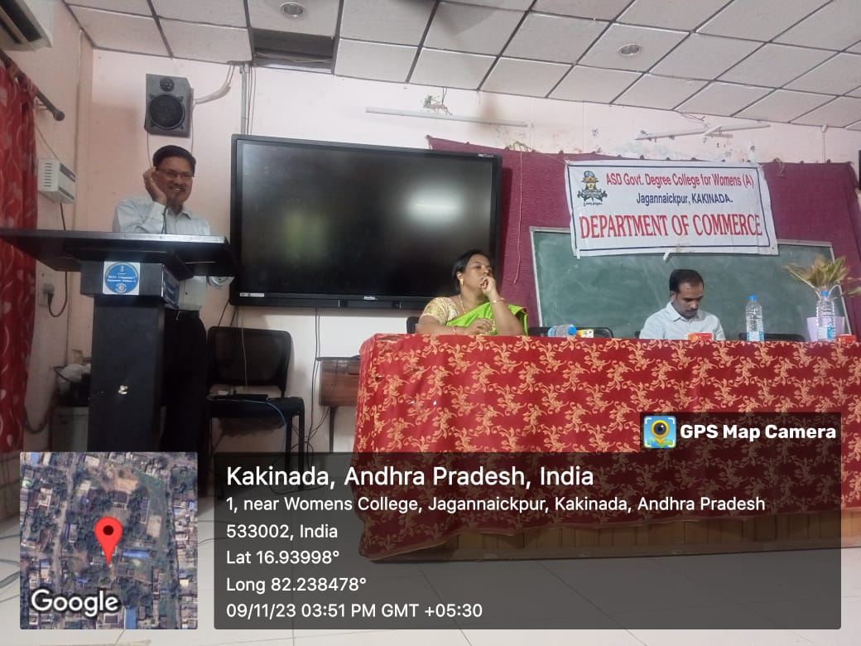
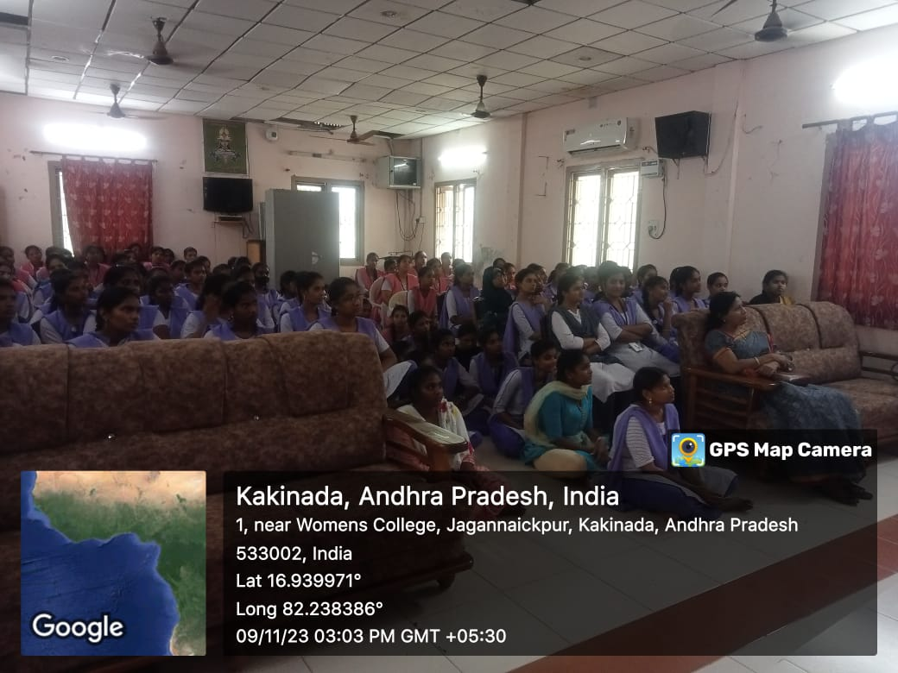
- Parent-Teacher Meeting (28th November 2023) On 28th November 2023, the Department of Commerce organized a Parent-Teacher Meeting, which saw the participation of 200 parents and students. The meeting provided a platform for parents to interact with faculty members and discuss their children's academic progress and challenges. Faculty members shared insights into the students' performance, behaviour, and potential areas of improvement. The meeting strengthened the relationship between parents and the college, ensuring that parents were actively involved in their children's education.
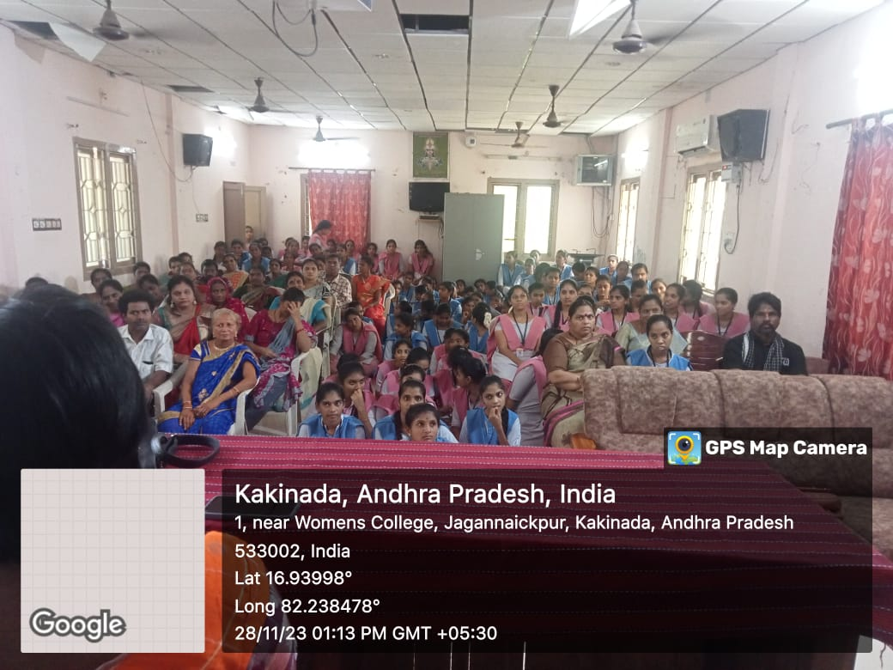
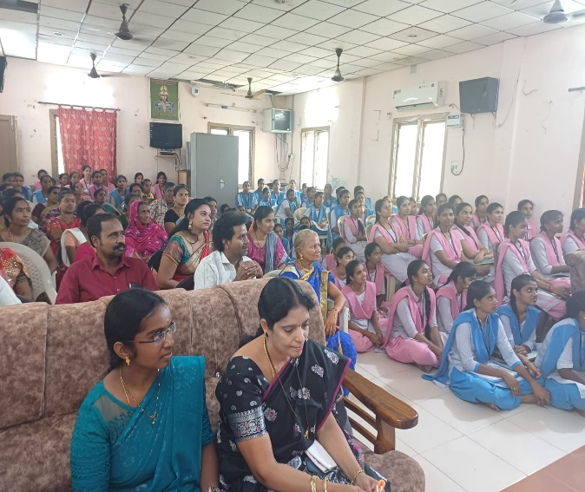
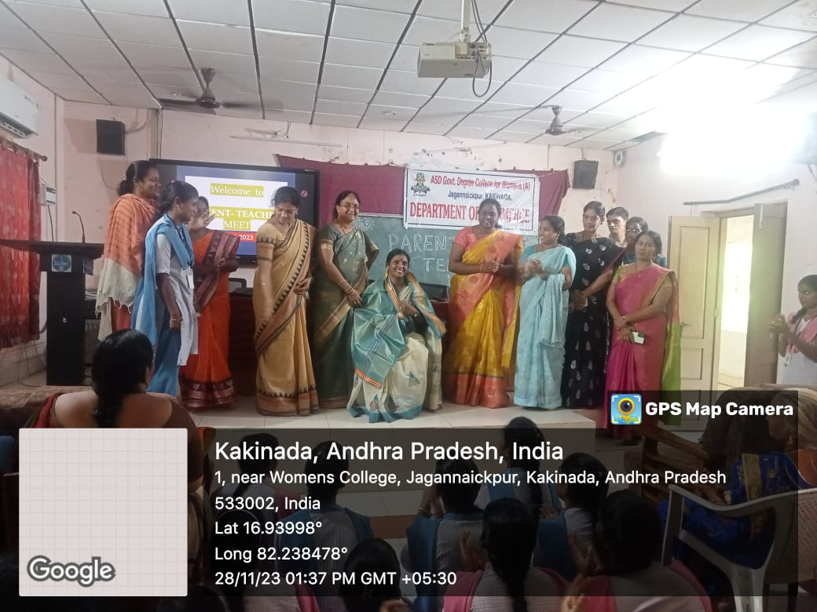
- Poster presentation on the occasion of Constitution Day (25 November 2023) On 25th November 2023, the Department of Commerce organized a Poster Presentation to celebrate Constitution Day, also known as Samvidhan Divas, which commemorates the adoption of the Indian Constitution. The event aimed to raise awareness about the significance of the Constitution and the values it upholds, such as democracy, equality, justice, and liberty. Students were encouraged to create posters that visually represented the fundamental rights and duties enshrined in the Constitution, key articles, and the contributions of prominent leaders like Dr. B.R. Ambedkar, the principal architect of the Constitution. The posters also highlighted the relevance of constitutional values in today’s society, focusing on issues such as social justice, individual freedoms, and the rule of law. The presentation offered a platform for students to express their creativity while deepening their understanding of the Constitution's role in shaping India's democracy. Faculty members and students discussed the importance of constitutional principles in ensuring a fair and just society, making the event an educational and engaging celebration of India's democratic foundation.
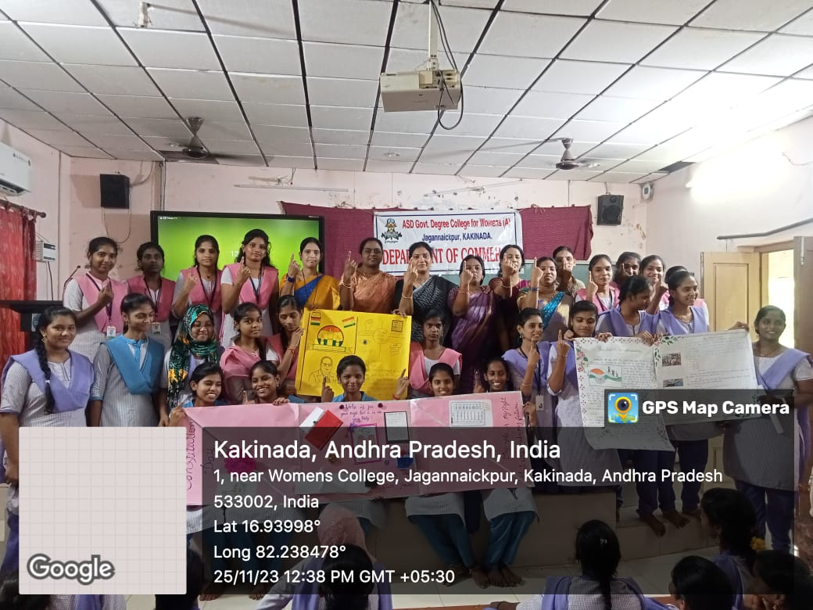
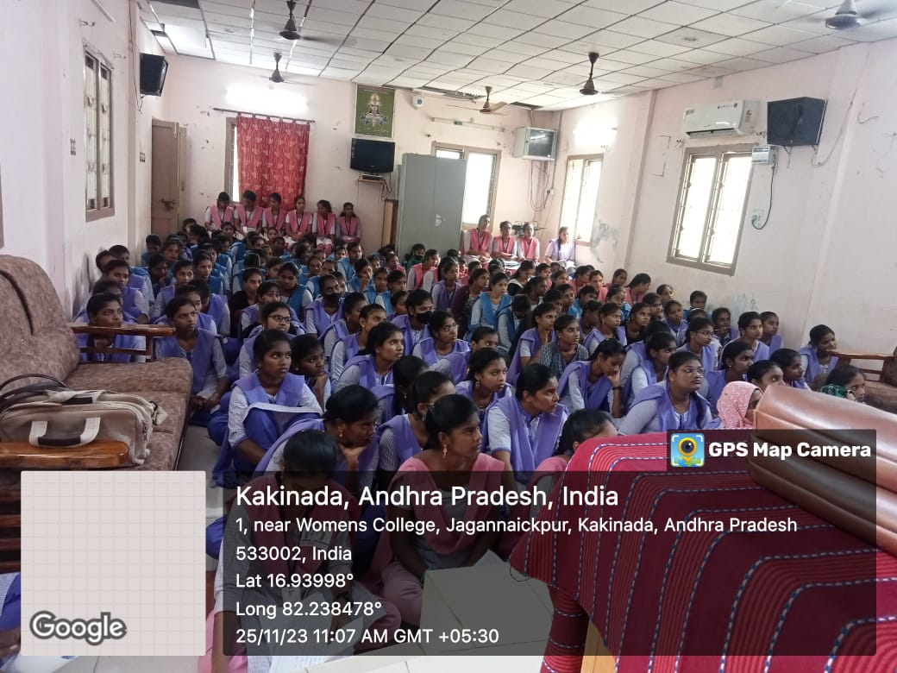
- MOU Between A.S.D. Government Degree College for Women and GDC, Pithapuram (29th November 2023) On 29th November 2023, the Department of Commerce facilitated the signing of a Memorandum of Understanding (MOU) between A.S.D. Government Degree College for Women, Kakinada, and GDC, Pithapuram. This MOU aims to foster academic collaboration between the two institutions, allowing for faculty exchange, joint research initiatives, and student development programs. The collaboration is expected to open new avenues for students and faculty members, enhancing the overall academic environment.
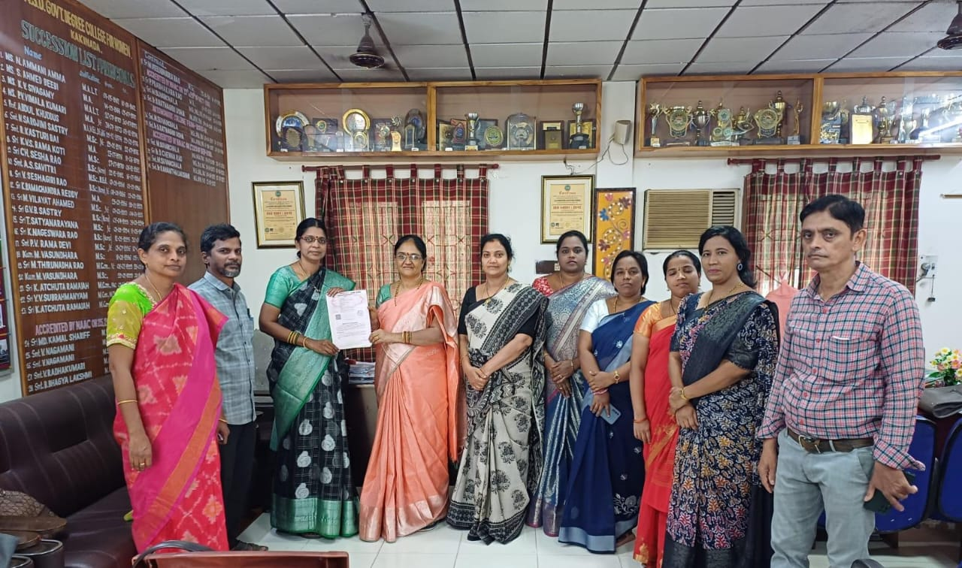
- Inauguration of PGCET Coaching ((29th November 2023) On 29th November 2023, the Department of Commerce launched a specialized PGCET Coaching Program to prepare students for postgraduate entrance exams. The program covers key subjects like business management, accounting, economics, and quantitative aptitude, offering in-depth lectures, problem-solving sessions, and regular assessments. Personalized attention through doubt-clearing sessions and mock exams ensures comprehensive preparation. The initiative aims to equip students with the necessary skills, knowledge, and strategies to excel in the highly competitive PGCET exam. This coaching program is part of the department’s commitment to supporting students’ academic growth and career aspirations. Faculty members, including Smt. R. R. D. Sirisha and others, guided the students throughout coaching.
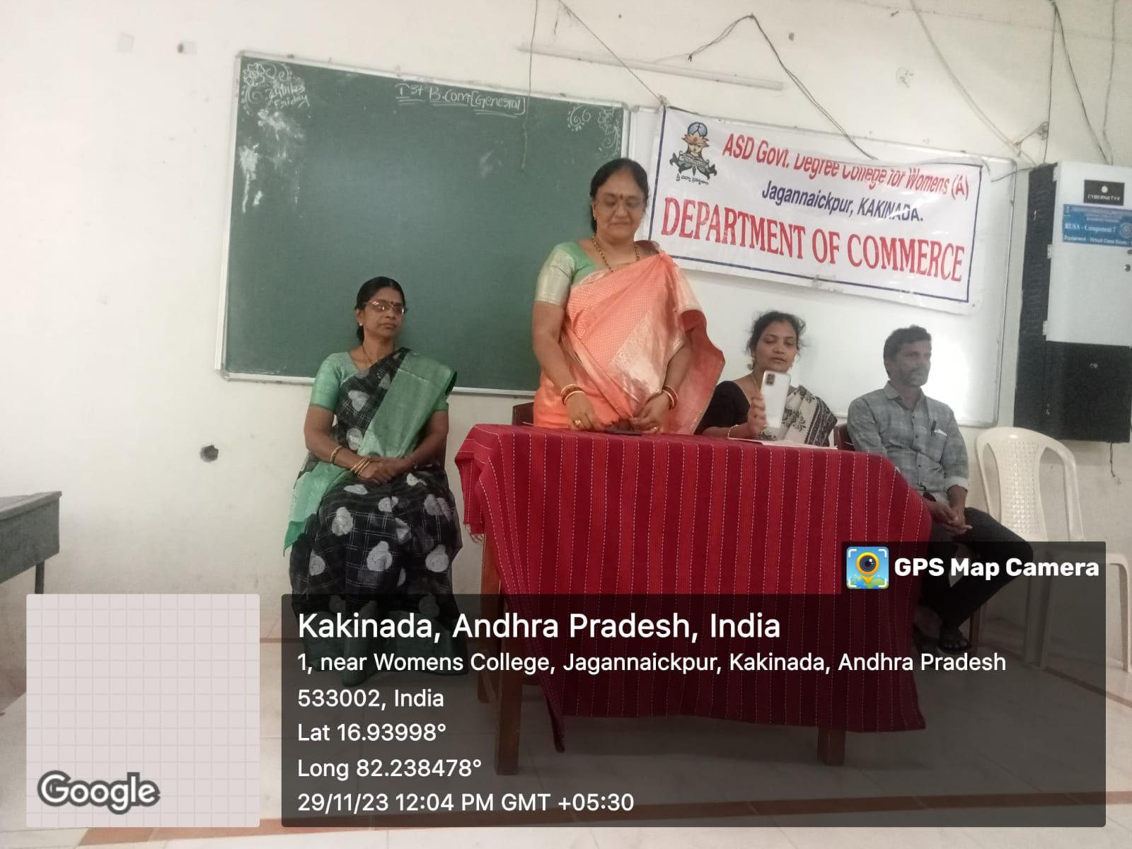
- Guest Lecture on Career as a Financial Analyst (29th November 2023) A guest lecture on "Career as a Financial Analyst" was conducted on 29th November 2023. The lecture was delivered by M. Srinivas Rao, a lecturer in Commerce at GDC, Pithapuram. The session, attended by 100 students, focused on the skills required to pursue a career in financial analysis, industry trends, and potential career growth in this field. Students were introduced to the key concepts and tools used by financial analysts, making the lecture a valuable resource for those considering a career in finance.
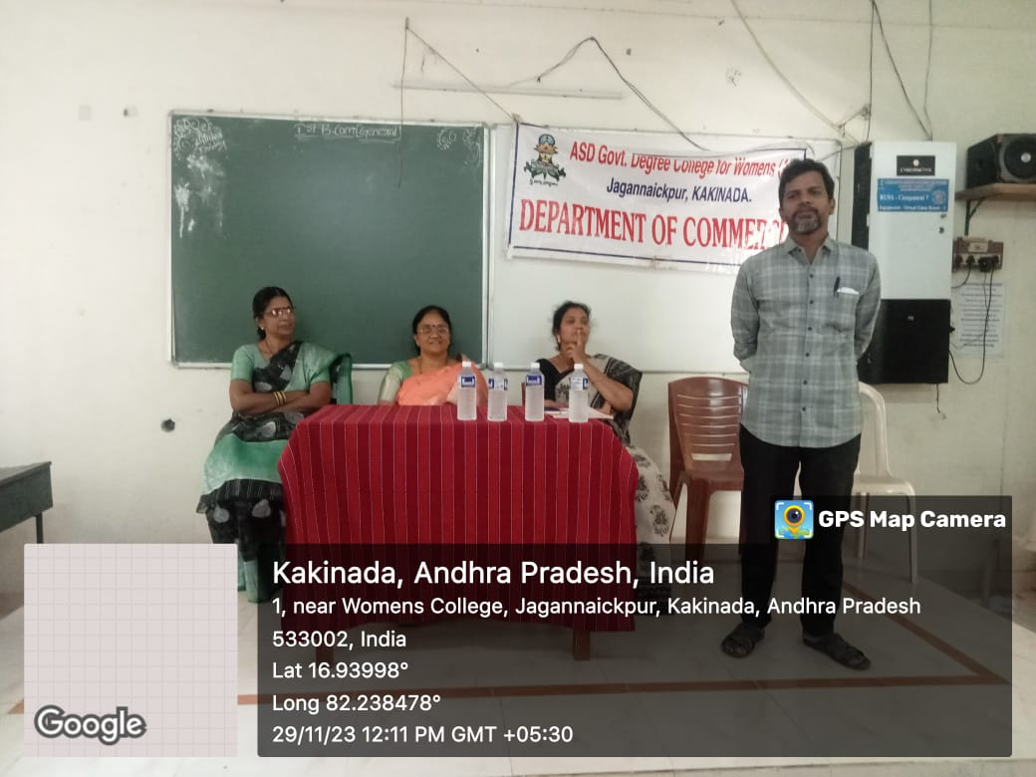
- Industrial & Environmental Tour – Rampachodavaram and Maredumilli (2nd December 2023) The Department of Commerce organized another Industrial and Environmental Tour on 2nd December 2023 to Rampachodavaram and Maredumilli. 61 students, along with 6 staff members, participated in the tour, which was aimed at providing students with insights into the functioning of industries and the importance of environmental conservation. Faculty members, including Smt. R. R. D. Sirisha and others, guided the students throughout the tour, making it an informative and practical experience. The tour highlighted the need for sustainable practices in industrial settings, encouraging students to think critically about environmental issues.
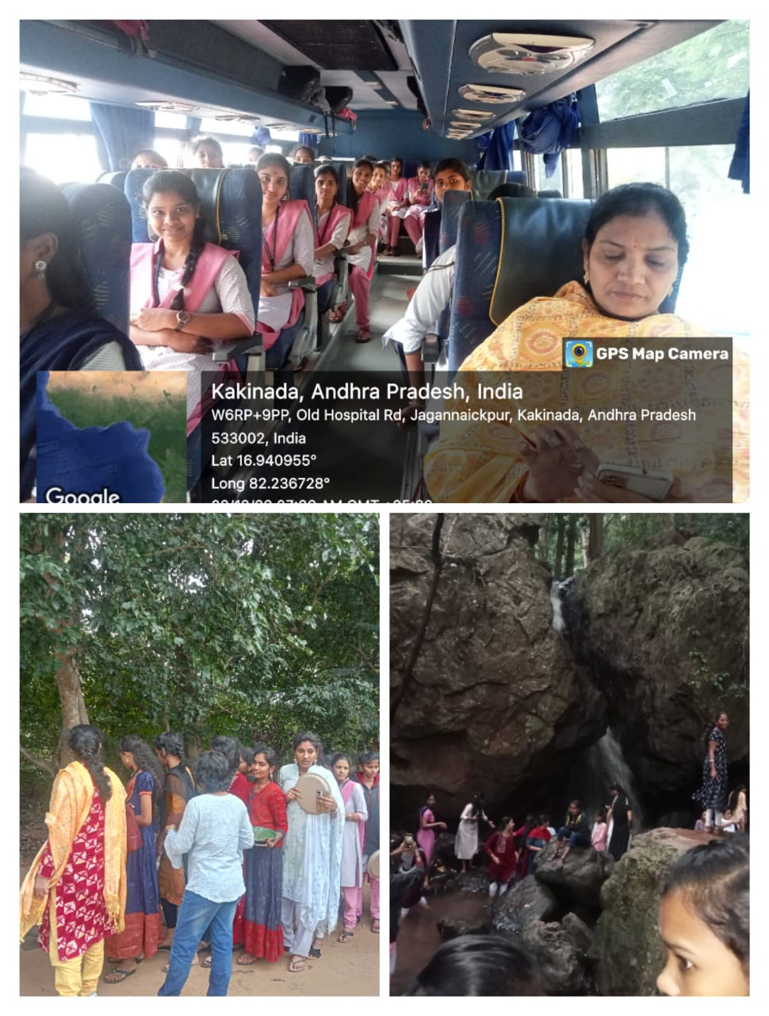
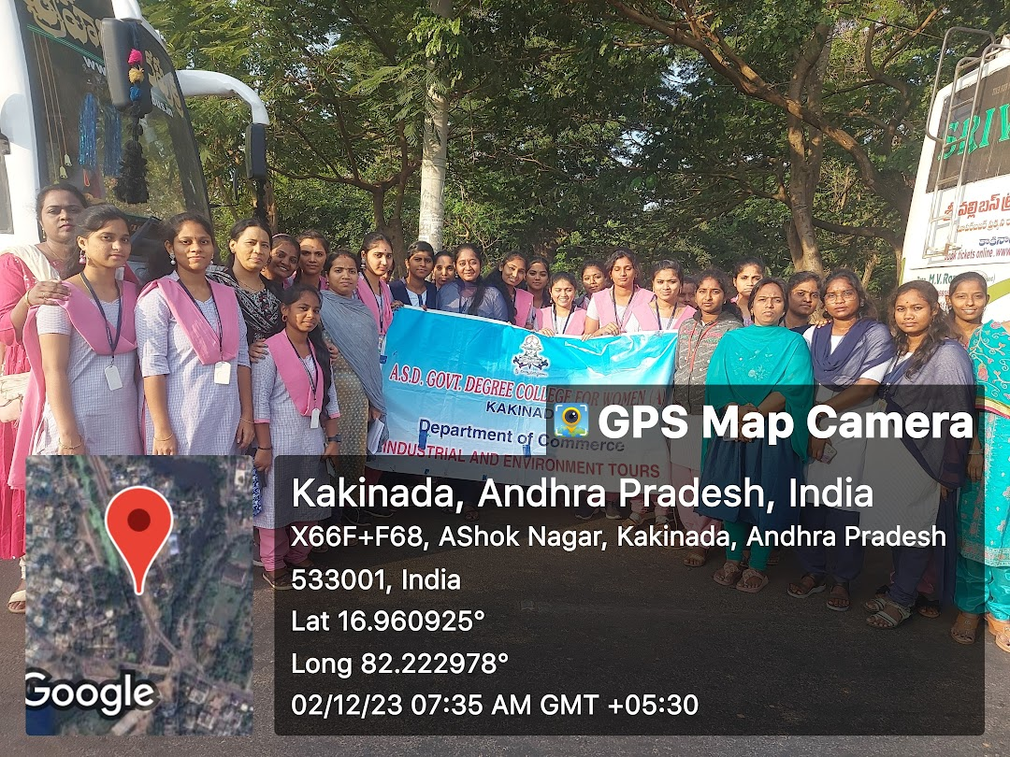
- Inauguration of Certificate course on Retailing from 08.12.2023 to 22.02.2023 under MOU Between A.S.D. Government Degree College for Women and GDC, Pithapuram: On 8th December 2023, the Department of Commerce inaugurated a Certificate Course on Retailing, under a Memorandum of Understanding (MOU) between A.S.D. Government Degree College for Women, Kakinada, and GDC, Pithapuram. The certificate course, running from 8th December 2023 to 22nd February 2024, aims to equip students with specialized knowledge and practical skills in the field of retail management. During the inauguration, faculty members from both institutions emphasized the significance of retailing in modern commerce and how this certificate course would enhance students' employability.
- Awareness Programme on CA and CMA with CA Medha Institute, Guntur Vijayawada On 15th December 2023, the Department of Commerce organized an Awareness Programme on CA (Chartered Accountancy) and CMA (Cost and Management Accountancy) in collaboration with CA Medha Institute, a reputed institute specializing in professional accountancy courses in Vijayawada and Guntur. The event aimed to inform commerce students about the career opportunities and pathways available in the fields of CA and CMA, both of which are prestigious and sought-after qualifications in the finance and accounting sector. During the program, experts from CA Medha Institute, including practicing Chartered Accountants and CMAs, provided detailed insights into the structure of both courses, the eligibility criteria, examination patterns, and the necessary skills required to succeed in these professions. They emphasized the growing demand for qualified CAs and CMAs in various industries, including auditing, taxation, financial management, and corporate governance. The session covered the scope of career opportunities after completing CA and CMA, the challenges students might face during their journey, and strategies to overcome them. Real-life examples and success stories of professionals in these fields were shared to motivate students. Additionally, participants were given information on study resources, preparation tips, and the importance of continuous learning in these dynamic fields. The awareness programme was highly interactive, with students asking questions about the differences between the CA and CMA courses, their respective job prospects, and the potential for career growth. The event provided clarity for students aspiring to pursue professional courses in accounting and finance, and the collaboration with CA Medha Institute offered students access to mentorship and further guidance on preparing for these rigorous exams. Overall, the session was informative and well-received by students, empowering them with the knowledge and motivation to consider a career in professional accountancy.
- Consumer Club Activity & Extension Activity – Awareness Programme on Consumer Rights (18th December 2023) On 18th December 2023, the Department of Commerce’s Consumer Club organized an extension activity on consumer rights awareness at Municipal Salipeta, Kakinada. The program, held just before National Consumer Day (24th December), aimed to educate the public about their rights under the Consumer Protection Act. A total of 110 participants, including students and local residents, attended the event. Faculty members from the Commerce department conducted the session, explaining the legal framework protecting consumers and providing practical advice on how to address grievances effectively. This activity played a crucial role in raising awareness about consumer rights in the community.
- Consumer Club Activity & Extension Activity – Awareness Programme on Consumer Rights and Consumer Act 1986 (19th December 2023) On 19th December 2023, the Department of Commerce’s Consumer Club conducted another awareness programme, this time at ASD Junior College for Women. The session focused on educating students about the Consumer Protection Act of 1986, with an emphasis on consumer rights, responsibilities, and the redressal mechanisms available to them. Commerce faculty members led the event, and 100 students participated. The program aimed to empower the younger generation with knowledge about their rights as consumers, thus fostering responsible consumer behaviour among students.
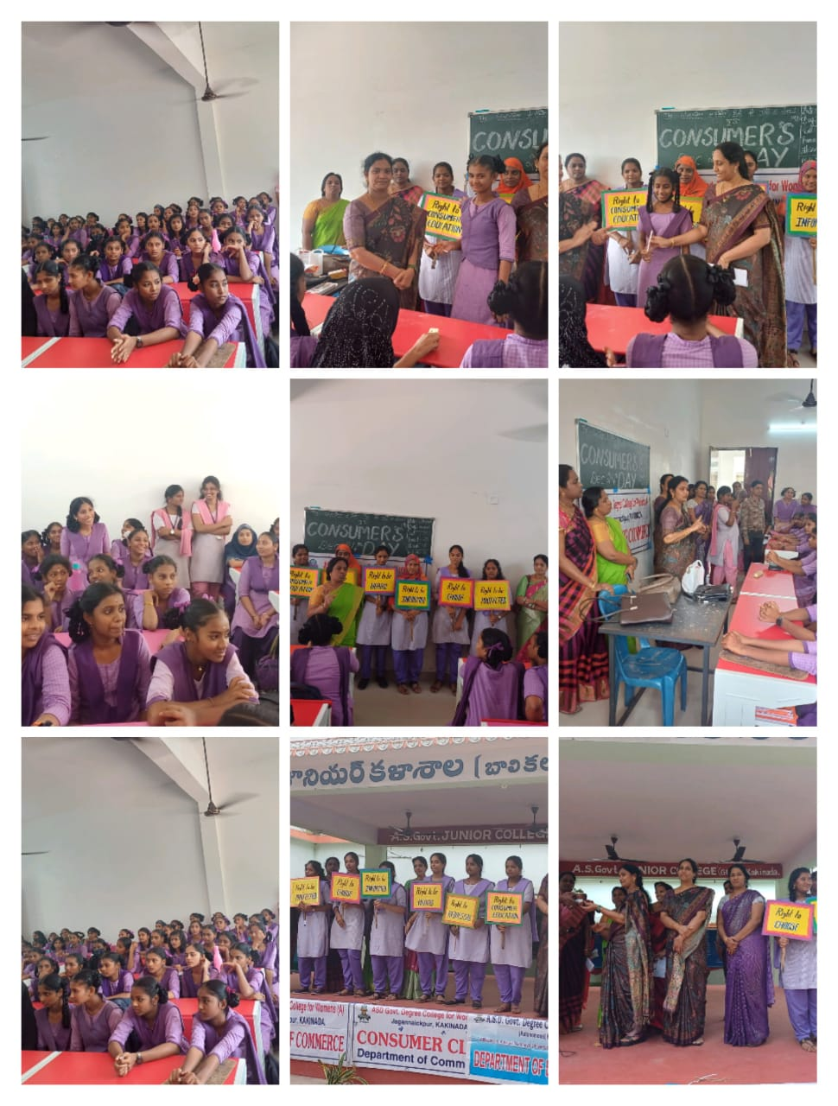
- Consumer Club Activity (20th December 2023) Awareness created to our college students and staff on consumer rights: On 20th December 2023, the Department of Commerce, through its Consumer Club, organized an Awareness Programme on Consumer Rights aimed specifically at educating students of the college. The event was part of the department’s ongoing efforts to empower students with knowledge about their rights and responsibilities as consumers in today’s marketplace. The session covered fundamental consumer rights under the Consumer Protection Act, such as the right to safety, the right to be informed, the right to choose, and the right to seek redressal. Faculty members emphasized the importance of consumer awareness in safeguarding against unfair trade practices, faulty products, and deceptive marketing. Through engaging presentations and discussions, students were educated on how to protect themselves from consumer exploitation and make informed purchasing decisions. Real-life examples were shared to demonstrate the relevance of consumer rights in everyday scenarios, including online shopping, product warranties, and fraudulent practices. Students were also informed about the process of filing complaints through consumer courts and the available legal mechanisms to address grievances. The awareness program was interactive, with students participating in discussions, asking questions, and sharing their own experiences as consumers. By the end of the session, the students gained a clearer understanding of their rights, as well as the practical steps they can take to assert them. This initiative significantly contributed to building consumer awareness among the students, equipping them with the knowledge and confidence to navigate the marketplace responsibly and protect their interests as informed consumers.
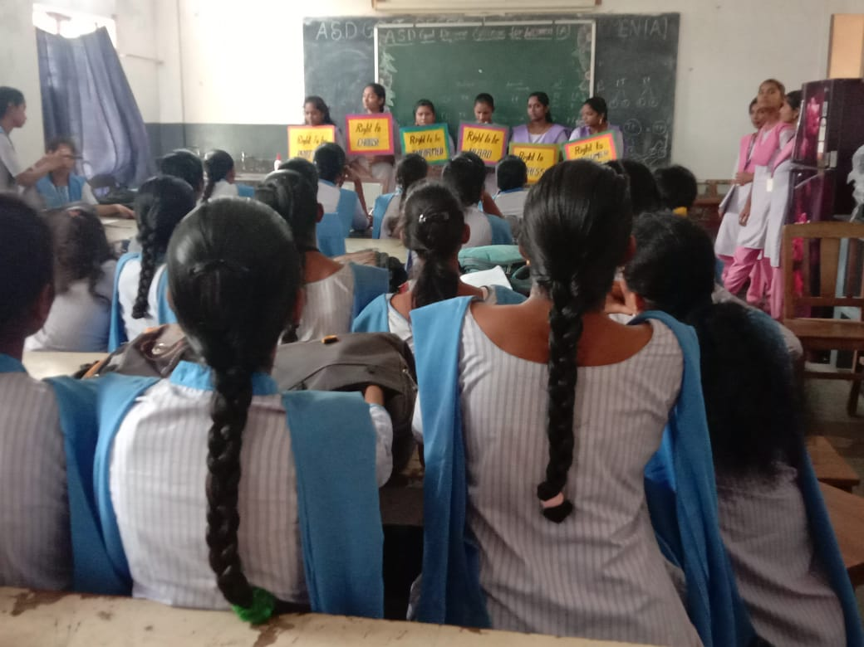
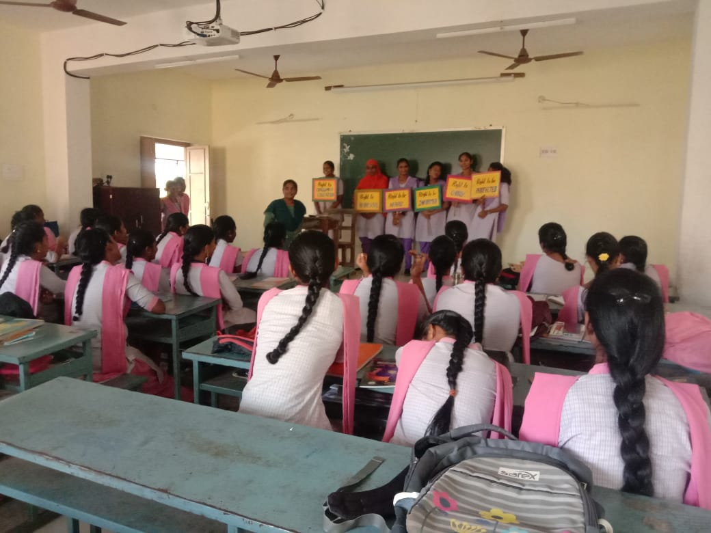
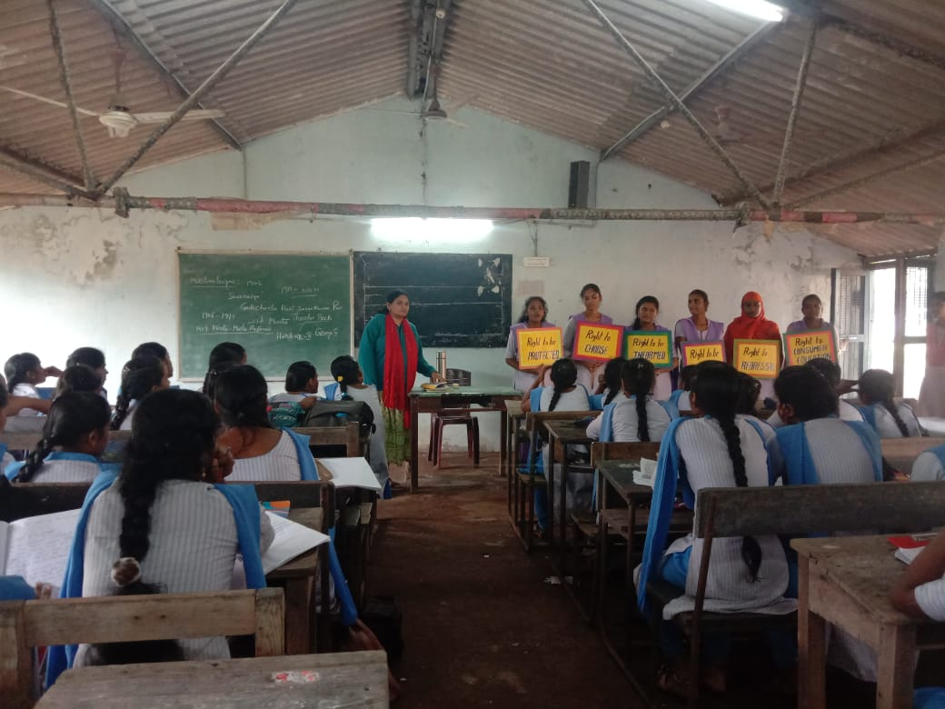
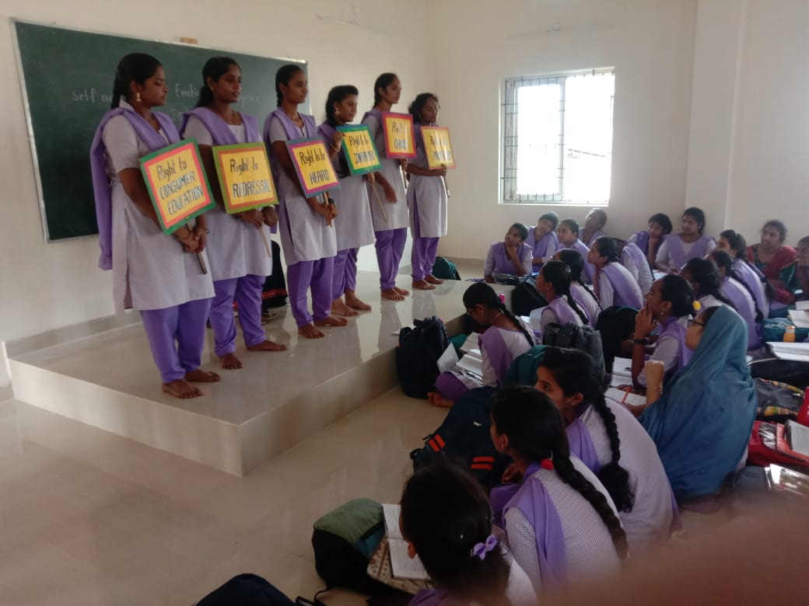
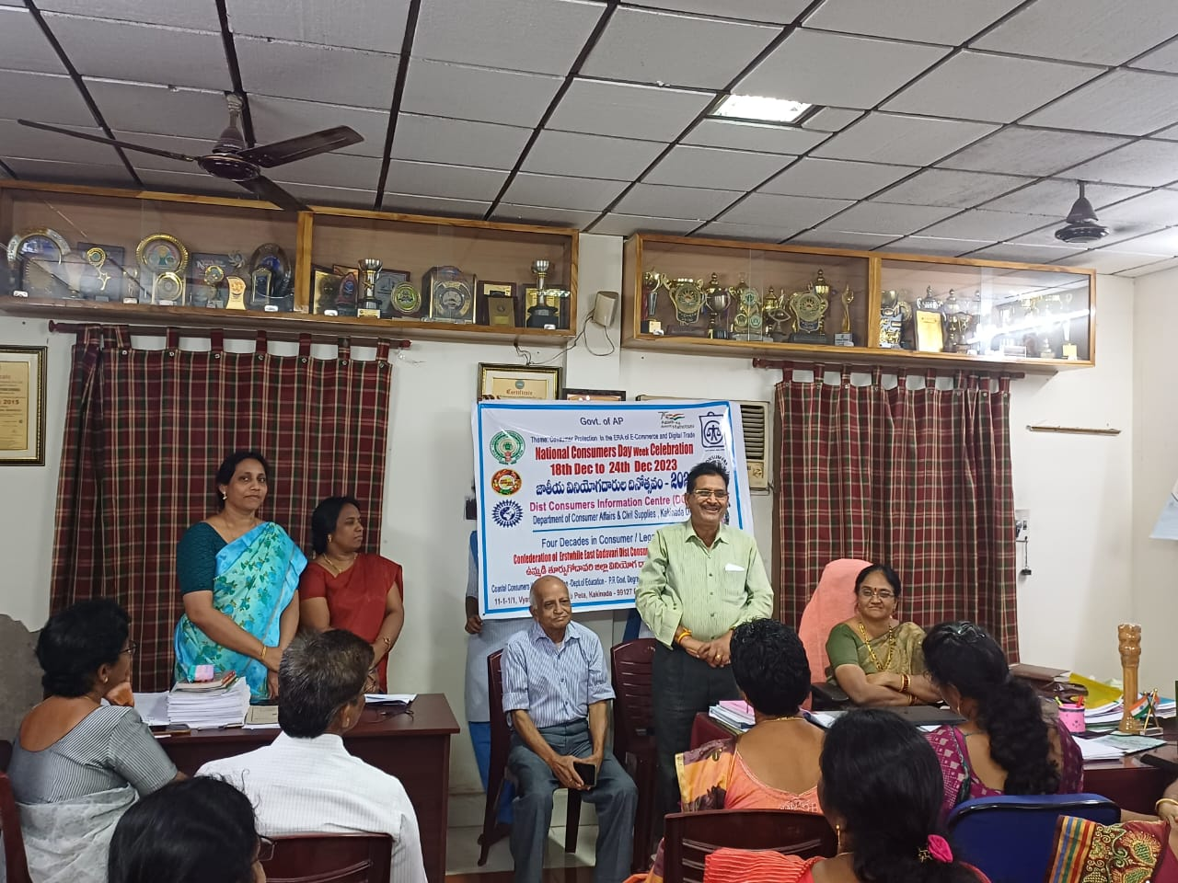
- Consumer Club Extension Activity and Community Awareness Programme: Rally on Consumer Rights and Flash Mob(20th December 2023) On 20th December 2023, the Department of Commerce organized a Rally on Consumer Rights to raise awareness about consumer rights and responsibilities. This rally, held as part of the department’s ongoing efforts under the Consumer Club initiative, was aimed at educating the public on the importance of protecting their rights as consumers. Students and faculty actively participated, carrying informative banners and slogans that highlighted key aspects of the Consumer Protection Act, such as the right to safety, information, and grievance redressal. The rally and Flash mob attracted attention from the local community, promoting a greater understanding of consumer rights and encouraging responsible consumer behavior.
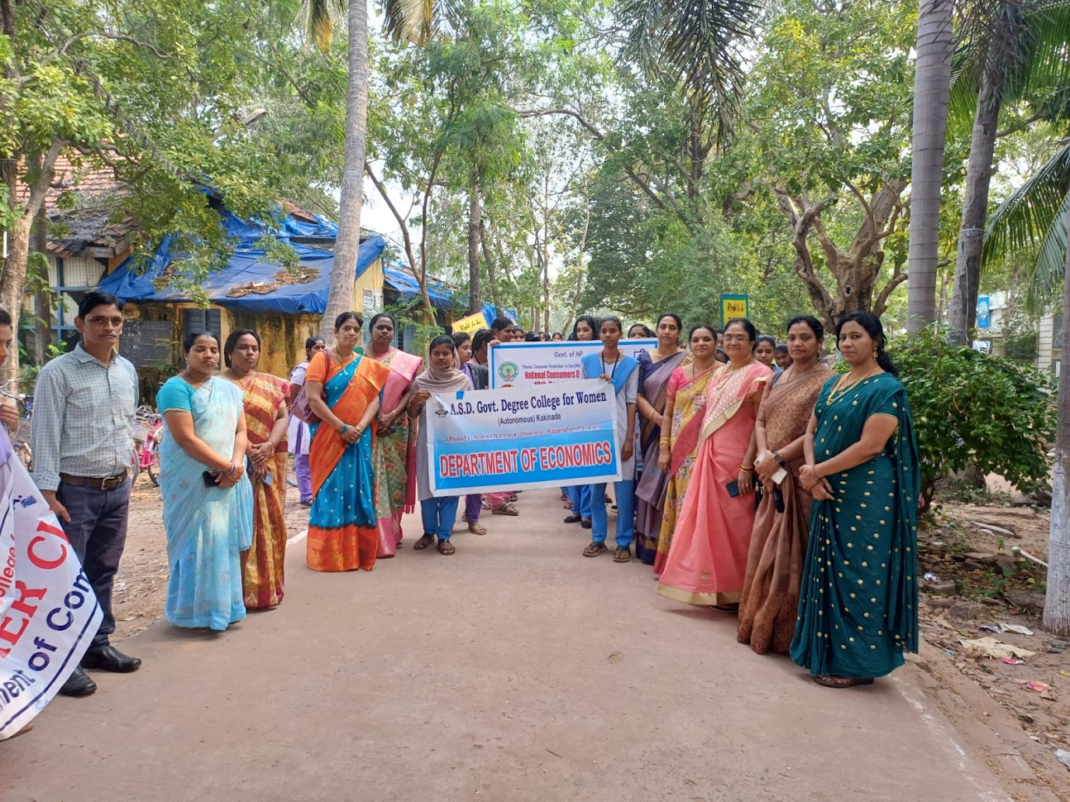
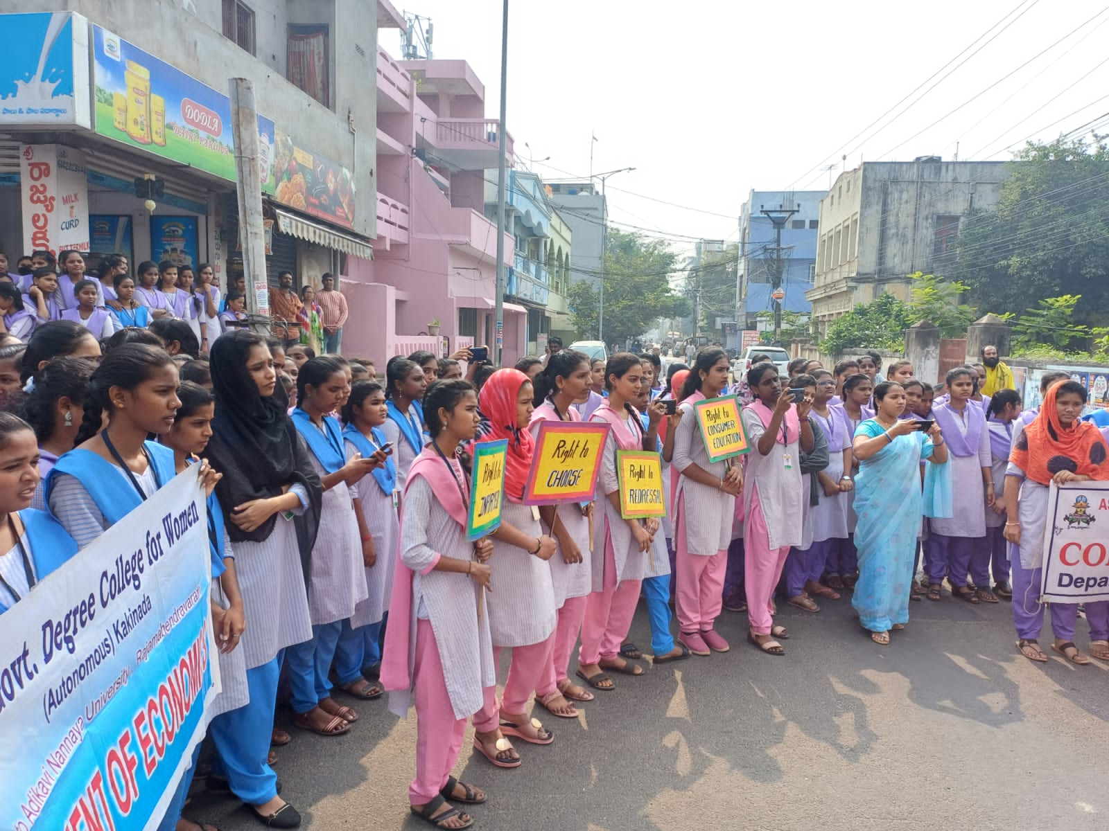
- Elocution and Essay Writing Competitions (21st December 2023) On 21st December 2023, the Department of Commerce organized Elocution and Essay Writing Competitions as part of its Consumer Rights Awareness campaign. These competitions were held to encourage students to explore and express their understanding of consumer rights and related issues. Participants delivered speeches and submitted essays on topics such as the significance of consumer awareness, the role of government regulations, and the impact of consumer rights on society. These competitions helped students enhance their public speaking and writing skills while also fostering a deeper understanding of consumer laws. The event received enthusiastic participation, reflecting the students’ commitment to learning and advocating for consumer rights.
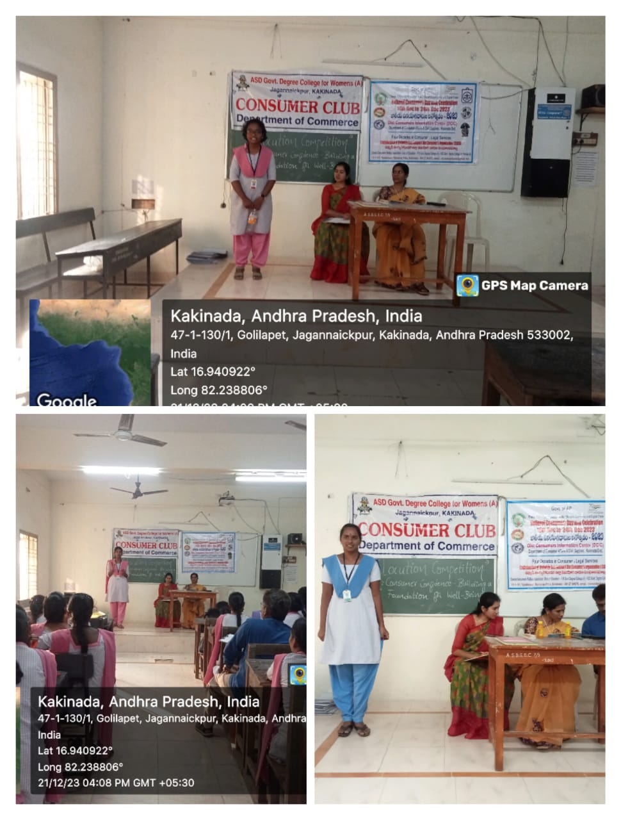
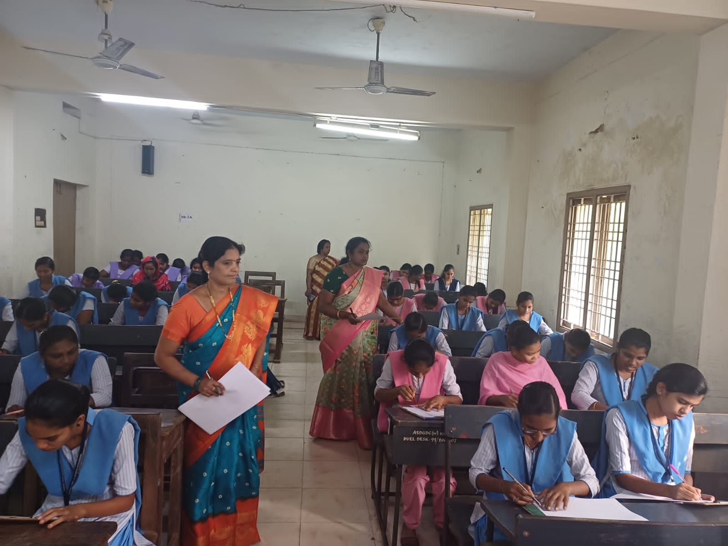
- Health Camp (21st December 2023) On 21st December 2023, the Department of Commerce, in collaboration with local healthcare providers, organized a Health Camp for students and faculty. This health initiative aimed to promote general well-being and provide basic medical check-ups, including blood pressure monitoring, blood sugar tests, and consultations with physicians. The camp emphasized the importance of preventive healthcare, educating participants about maintaining a healthy lifestyle. Students were also encouraged to take responsibility for their health, understand common health issues, and adopt wellness practices. The camp was a successful initiative that reinforced the department's commitment to holistic development, addressing both the academic and physical well-being of its community.
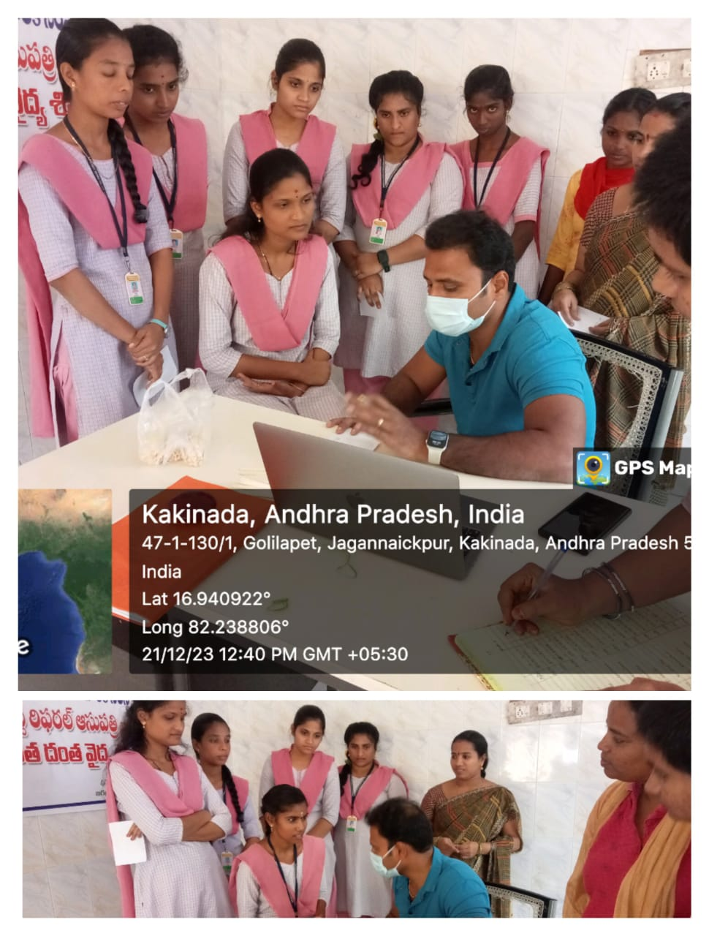
- Poster presentation (22nd December 2023) On 22nd December 2023, the Department of Commerce held a Poster Presentation as part of its series of activities centered around Consumer Rights. This event encouraged students to create visually engaging posters that communicated key messages related to consumer protection, rights, and responsibilities. Topics included consumer fraud, ethical consumption, and the importance of awareness in the digital marketplace. The students' creativity and research skills were on full display as they presented their posters to faculty and peers. This activity not only helped students develop their presentation and artistic skills but also deepened their understanding of consumer rights through visual storytelling and design.
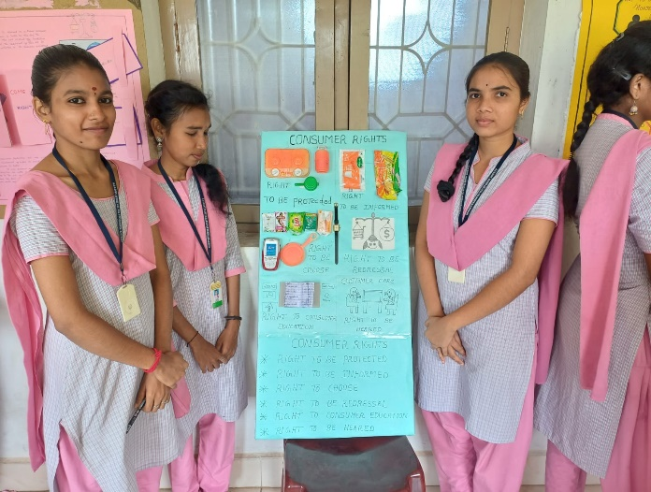
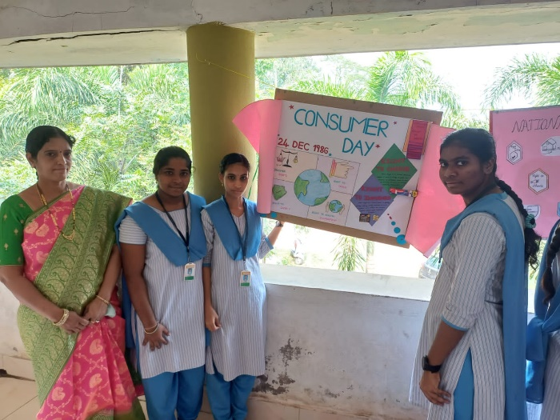
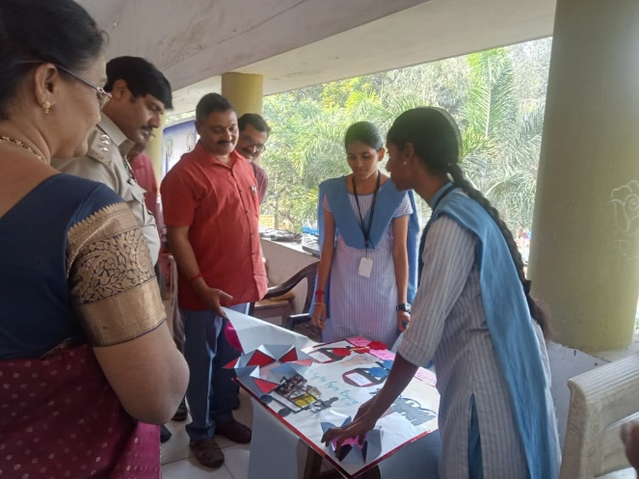
- Consumer Day Celebration (23rd December 2023) In observance of National Consumer Day, the Department of Commerce’s Consumer Club held a special event on 22nd December 2023 to celebrate the importance of consumer rights. The event was attended by 100 participants and was graced by the presence of Sri B. Bhami Siva Murthy, who delivered a lecture on consumer protection and the role of consumers in ensuring fair trade practices. The celebration served to enhance the students’ understanding of their rights as consumers and provided them with insights into how to safeguard these rights in everyday transactions.
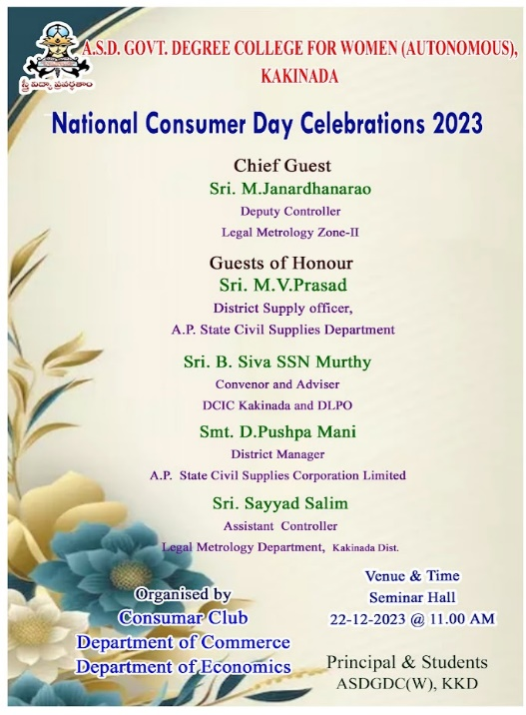
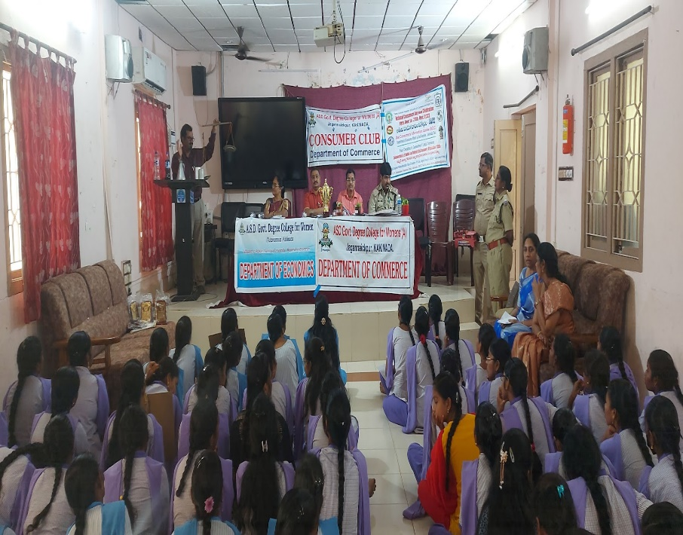
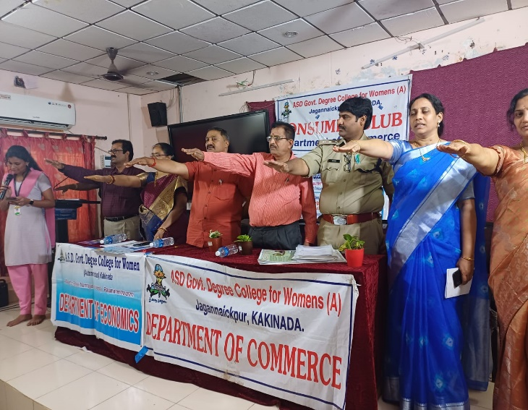
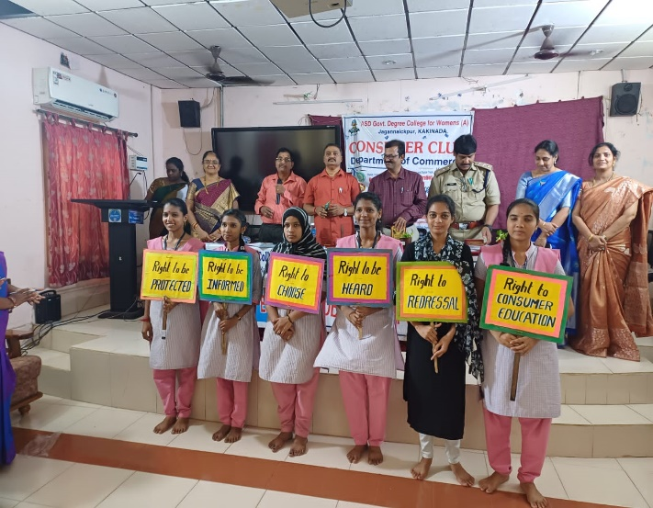
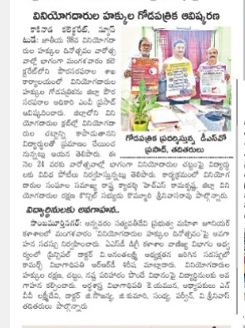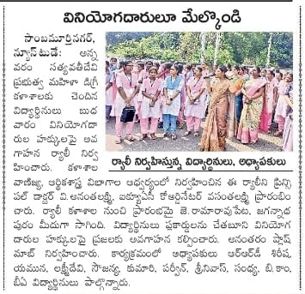
- National Integrity Festival – Sankranthi Sambaralu (11th January 2024) On 11th January 2024, the Department of Commerce celebrated the Sankranthi Sambaralu festival as part of the National Integrity Festival. This large-scale cultural event saw the participation of 800 students, reflecting the department’s commitment to fostering national unity and cultural diversity. The festival included various traditional activities, games, and performances, making it a colorful and joyous celebration. The event helped students connect with their cultural heritage and promoted a sense of togetherness within the college community.
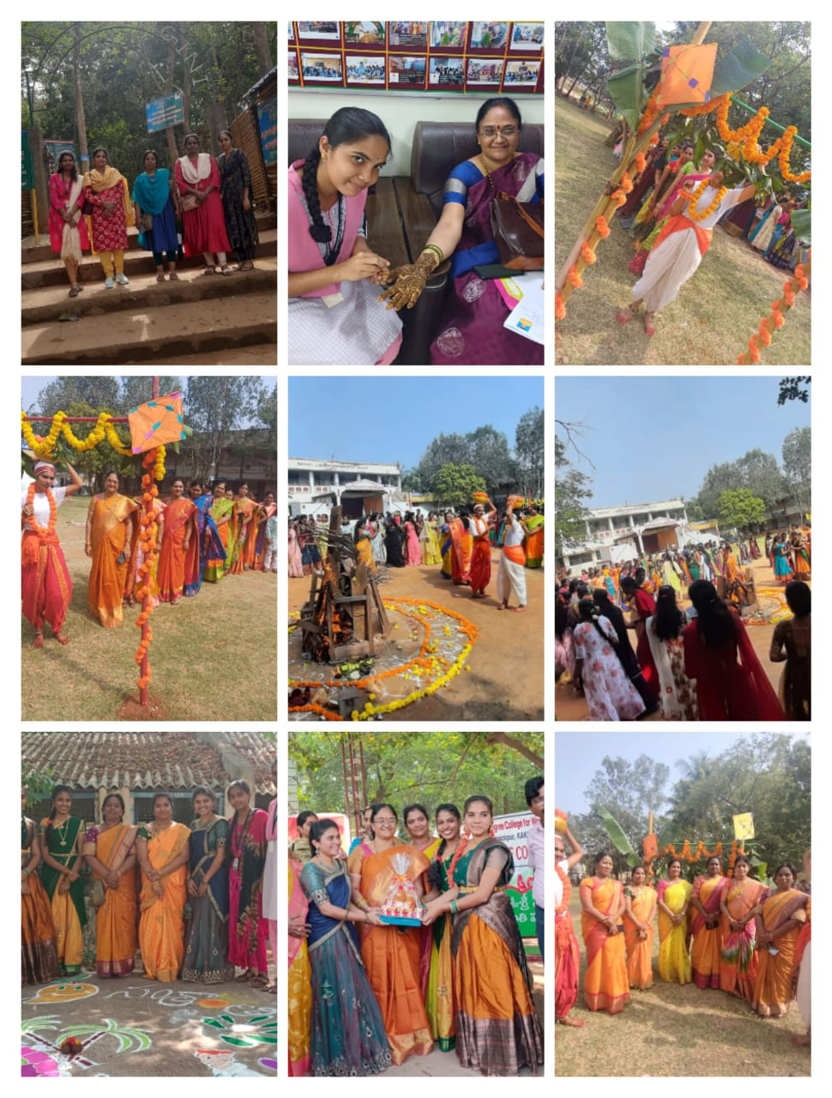
- Student Training Programme – Soft Skills Training on Goal Setting (4th & 5th March 2024) A two-day student training program on soft skills was held on 4th and 5th March 2024. The event, conducted in collaboration with the IKKA Foundation and Coromandel, focused on the crucial skill of goal setting. Trainers Srividya Konne Pudi and Y. Hari Kumar led the sessions, providing 100 students with practical techniques for setting and achieving personal and professional goals. The training was designed to enhance the students' soft skills, which are essential for both their academic and professional success. This program equipped the students with the knowledge and tools to plan their futures more effectively.
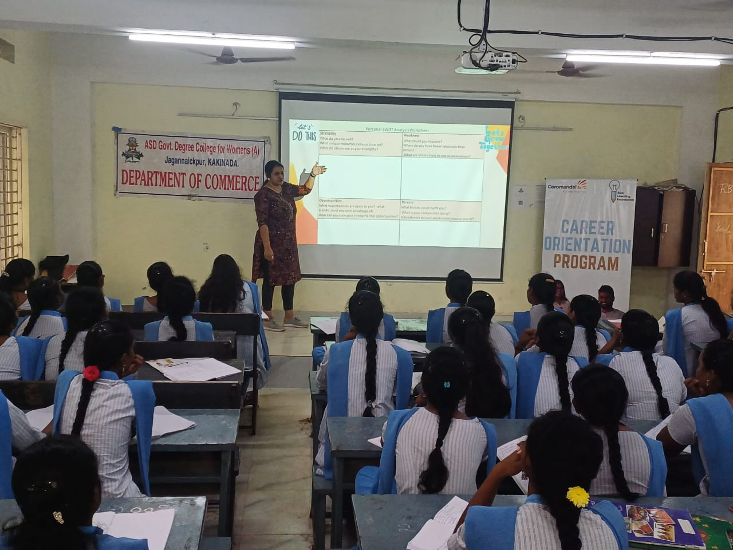
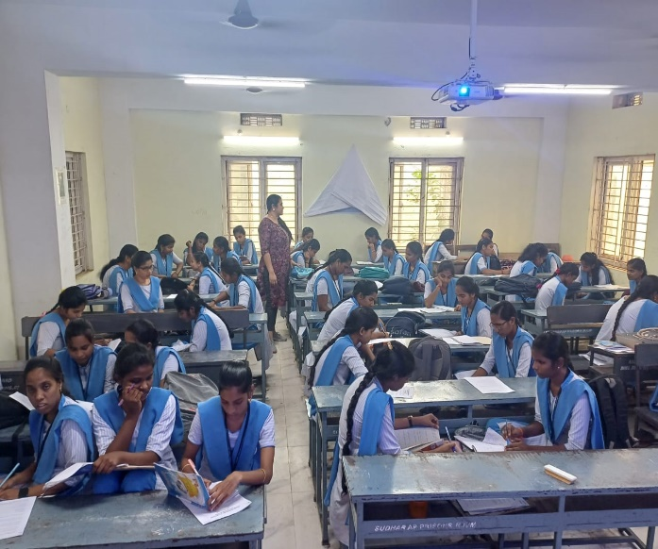
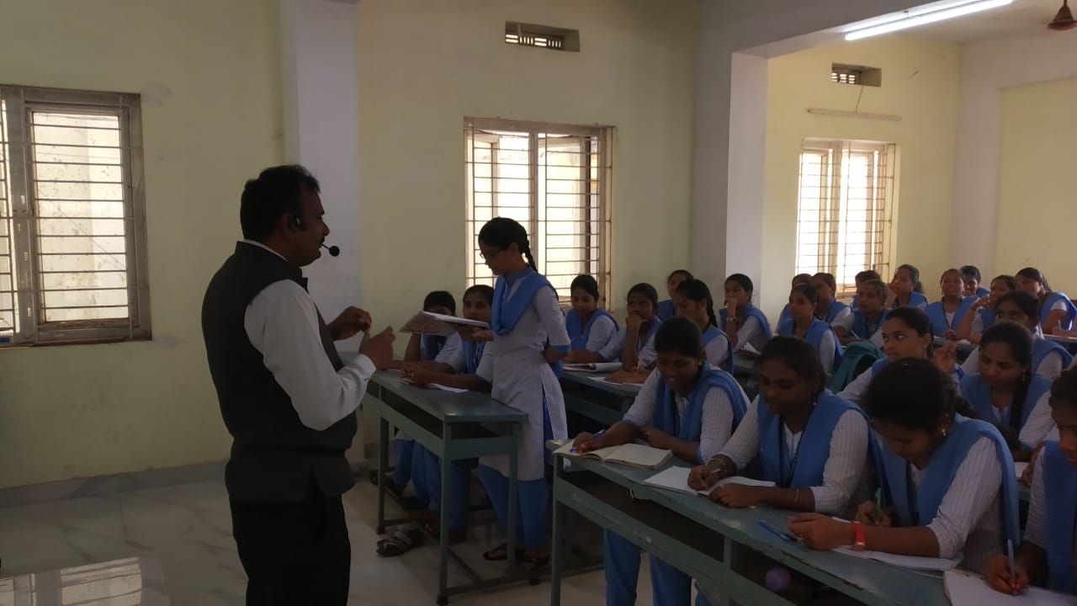
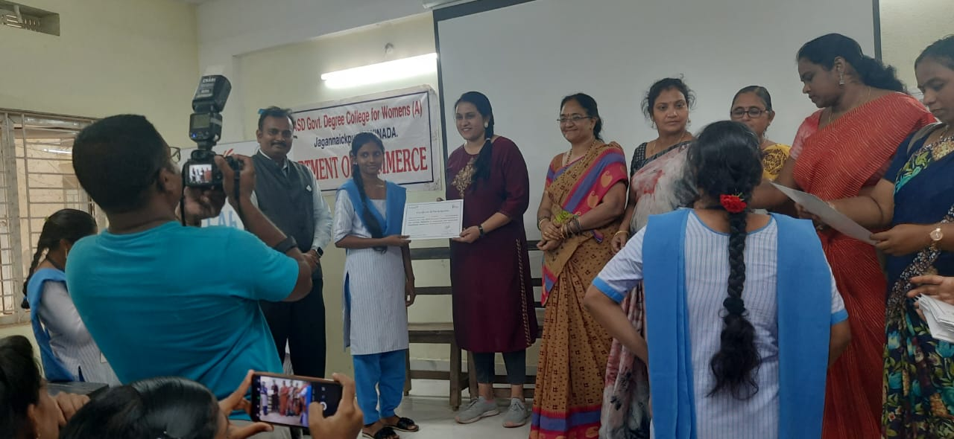
- MOU with Confederation of Women Entrepreneurs (COWE) by A.S.D. Government Degree College for Women(A), Kakinada in cooperating each party in extending cooperation in the matters of training and development of entrepreneurial skills among student community by organizing workshops, training programmes etc. the Department of Commerce facilitated the signing of a Memorandum of Understanding (MOU) between A.S.D. Government Degree College for Women, Kakinada, and COWE national President Smt. Lalitha and AP Chapter Regional President and others participated .
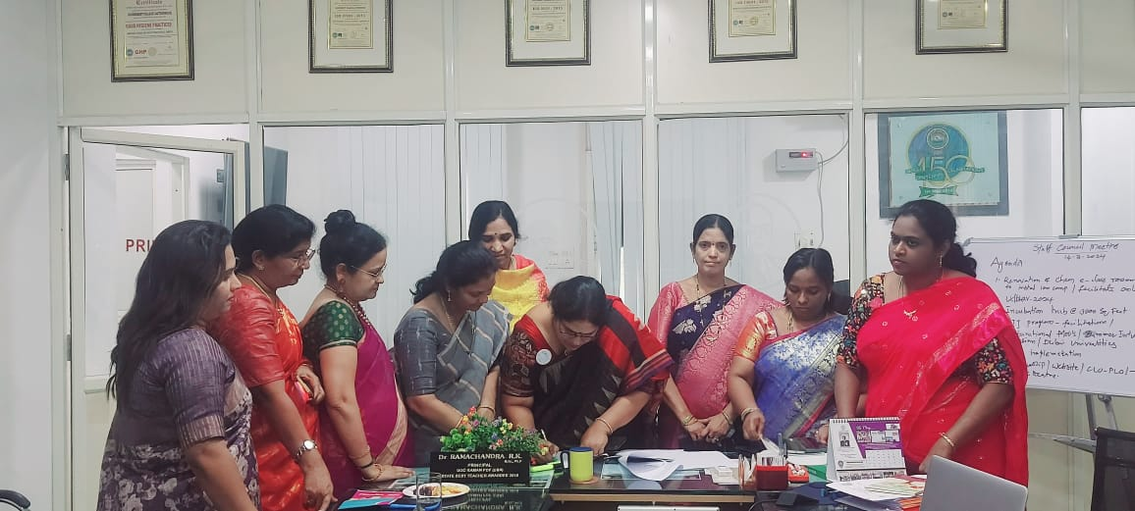
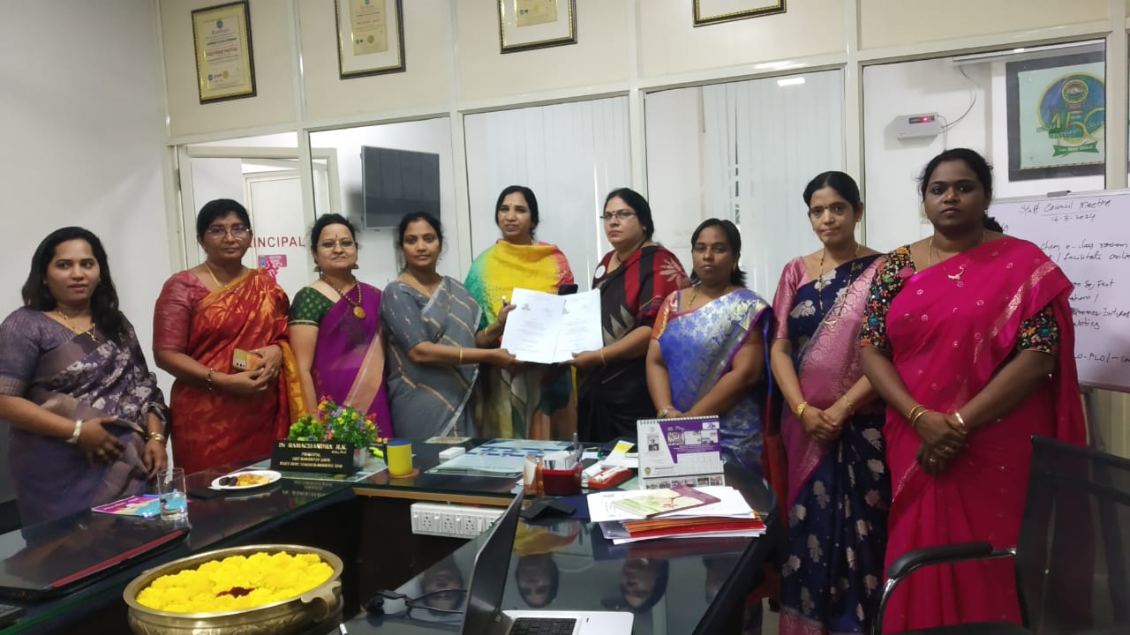
- Guest Lecture on Cybercrime and Redressal of Consumer Rights (15th March 2024) On 15th March 2024, the Department of Commerce organized a guest lecture on the topic of cybercrime and the redressal of consumer rights. Dr. J. Pandu Rango Rao, a lecturer in Commerce at P.R. Government Degree College for Women (A), Kakinada, was the key speaker. The lecture, attended by 100 students, highlighted the growing threat of cybercrime in today’s digital age and informed students about their rights as consumers in the event of cyber fraud. The session was highly informative, helping students understand the legal frameworks in place to protect consumers and how to seek redressal in case of cybercrimes.
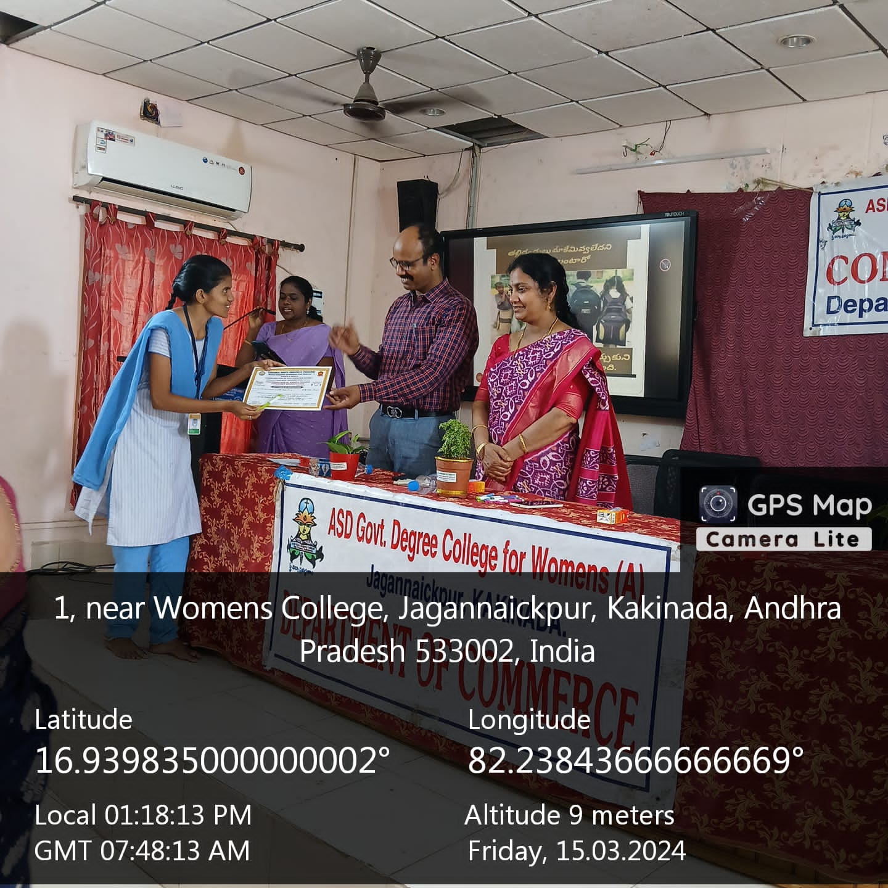
- Extension of Service as state level Master Trainer by Rama Durga Sirisha. .Reddy I/C Department of Commerce at Nodal Resource Cener, Rajahmundry 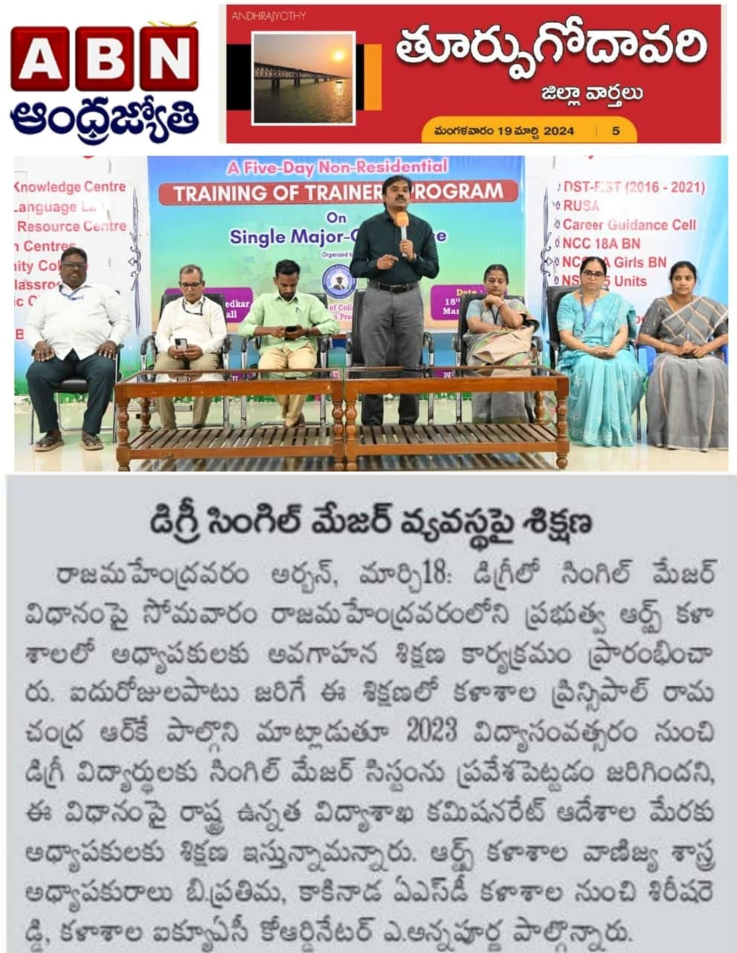
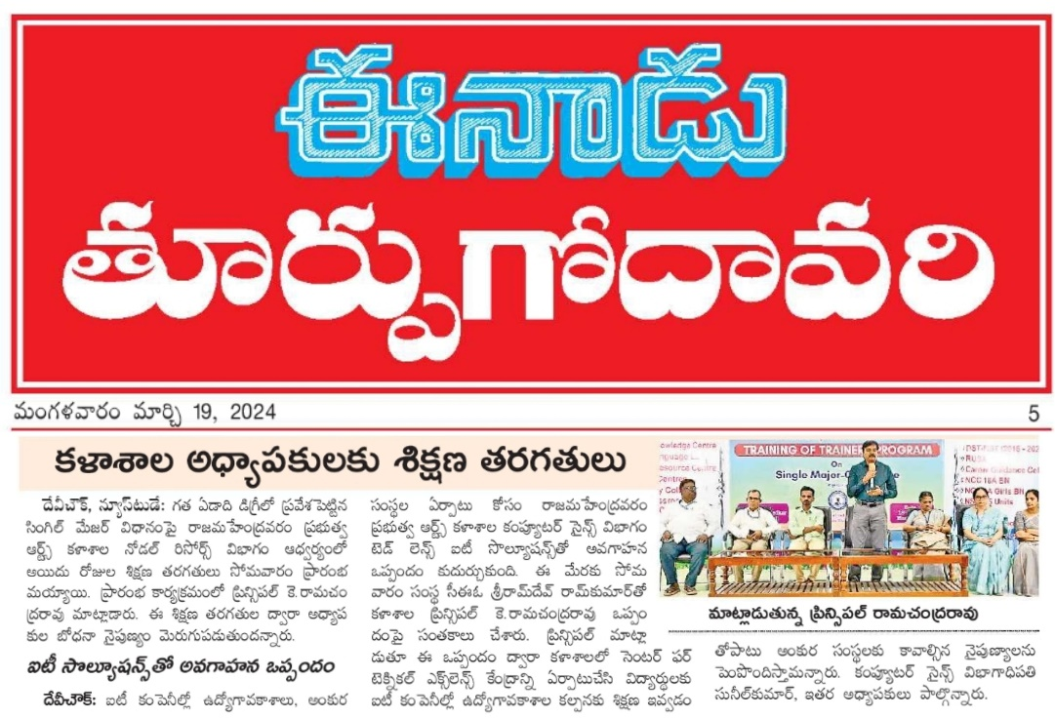

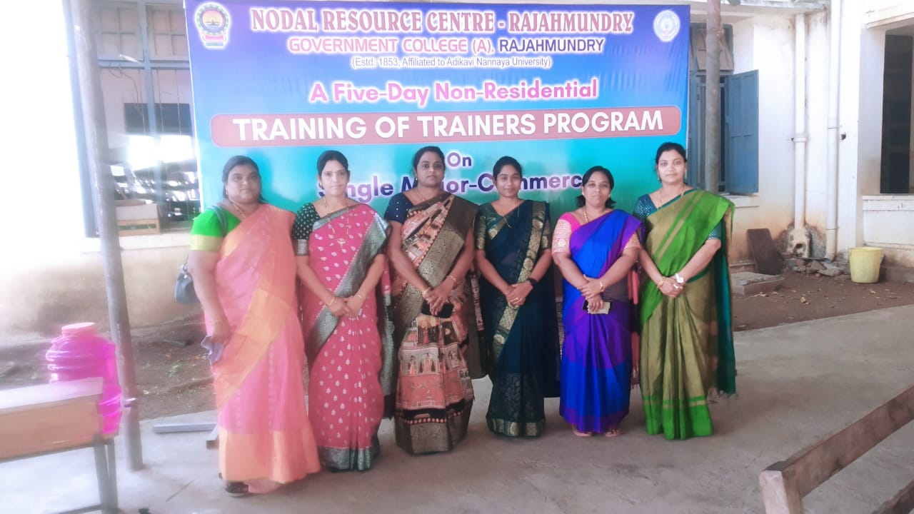
- MOU with Pithapuram College – Certificate Course Validictory on Retailing (15th June 2024) On 15th June 2024, the Department of Commerce entered into an MOU with Pithapuram College to introduce a Certificate Course on Retailing. The course aimed to provide students with practical knowledge about the retail industry, its operations, and the skills required to excel in this field. The faculty involved in this initiative included Smt. R.R.D. Sirisha, Dr. G. Sowjanya, N.P.V.L. Lakshmi Devi, and K.N.B. Kumari. A total of 100 students enrolled in this course, which is expected to significantly enhance their employability in the retail sector by providing them with both theoretical knowledge and practical exposure.
