**A.S.D GOVERNMENT DEGREE COLLEGE FOR WOMEN (A) KAKINADA**

# DEPARTMENT OF COMMERCE

**Activities 2019-20**

**Conducted by**

**Department Commerce**

**Personality Development Programme, JCI, Kakinada**

**Date: 01.08.2020**

**Purpose:**  
The personality development program, conducted by JCI, aimed to improve students’ soft skills and enhance their personal and professional growth.

**Highlights:**  
The session focused on building communication skills, boosting confidence, and improving goal-setting strategies. Students participated in interactive activities to develop their personality traits.

**Outcomes:**

1. **Skill Enhancement:** Students learned important soft skills like communication and confidence building.
2. **Personal Growth:** The program motivated students to improve their overall personality.

**Conclusion:**  
The program contributed significantly to students' personal and professional development, preparing them for future challenges.

**Guest Lecture on Inspiring Youth**

**Date:**13.09.2019  
**Purpose:**  
This motivational talk, delivered by T.V. Surya Prakash, aimed to inspire students to set personal goals and work toward achieving them.

**Highlights:**  
The lecture emphasized the importance of goal-setting, perseverance, and self-discipline. It also discussed strategies for achieving success and overcoming obstacles.

**Outcomes:**

1. **Inspiration:** Students were encouraged to set clear goals for their futures.
2. **Motivation:** The talk instilled a sense of purpose and determination among students.

**Conclusion:**  
The lecture provided students with a motivational boost and practical advice for personal growth.

Participants: 100

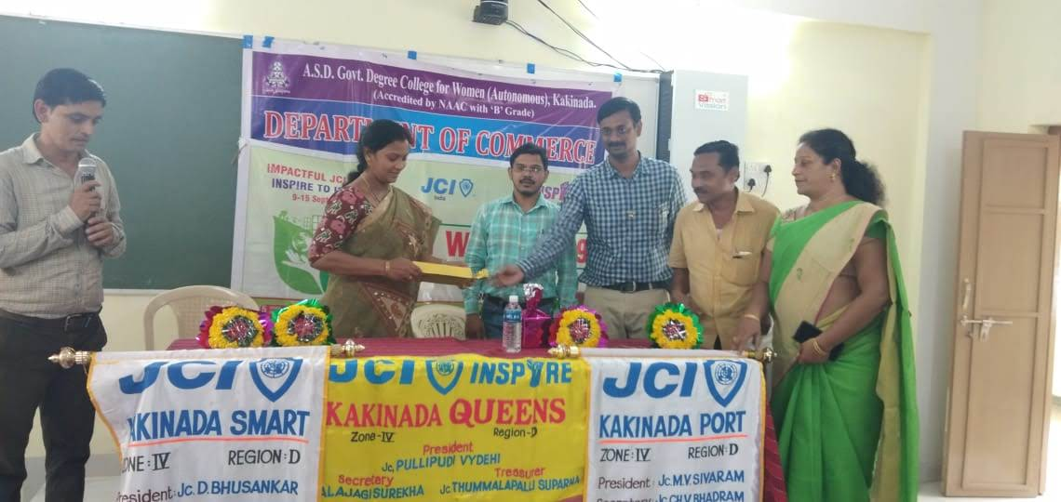

**Guest Lecture on Cyber Crimes by Smt. K. Lakshmi Naidu**

**Date: 11.12.2019**

**Purpose:**  
This lecture aimed to raise awareness among students about cybercrimes and how to protect themselves in the digital world.

**Highlights:**  
Smt. K. Lakshmi Naidu discussed common cybercrimes, their impact, and preventive measures. The session also focused on the importance of online security and privacy.

**Outcomes:**

1. **Awareness:** Students gained awareness of cyber threats and how to avoid them.
2. **Safety Knowledge:** The lecture provided practical tips on staying safe online.

**Conclusion:**  
The session helped students understand the risks of cybercrimes and the importance of digital safety.

Participants: 60

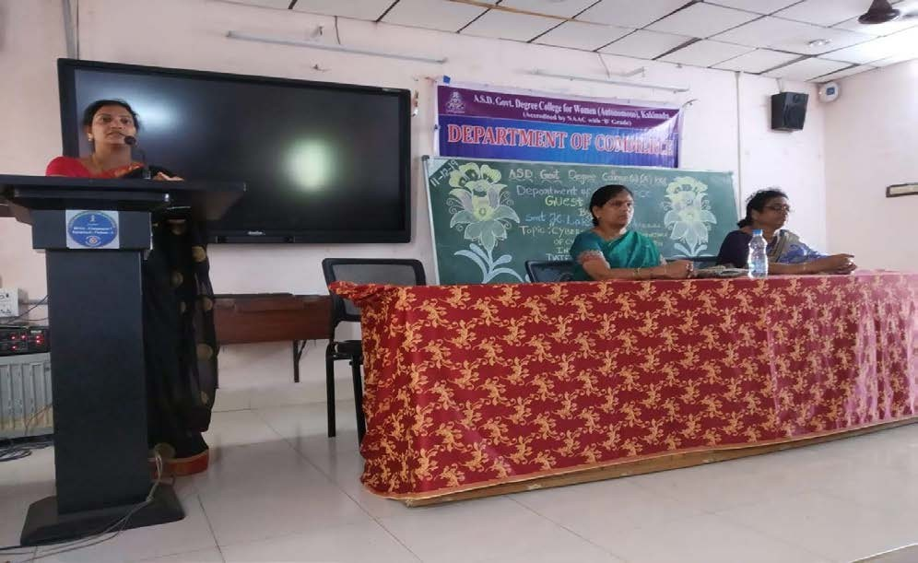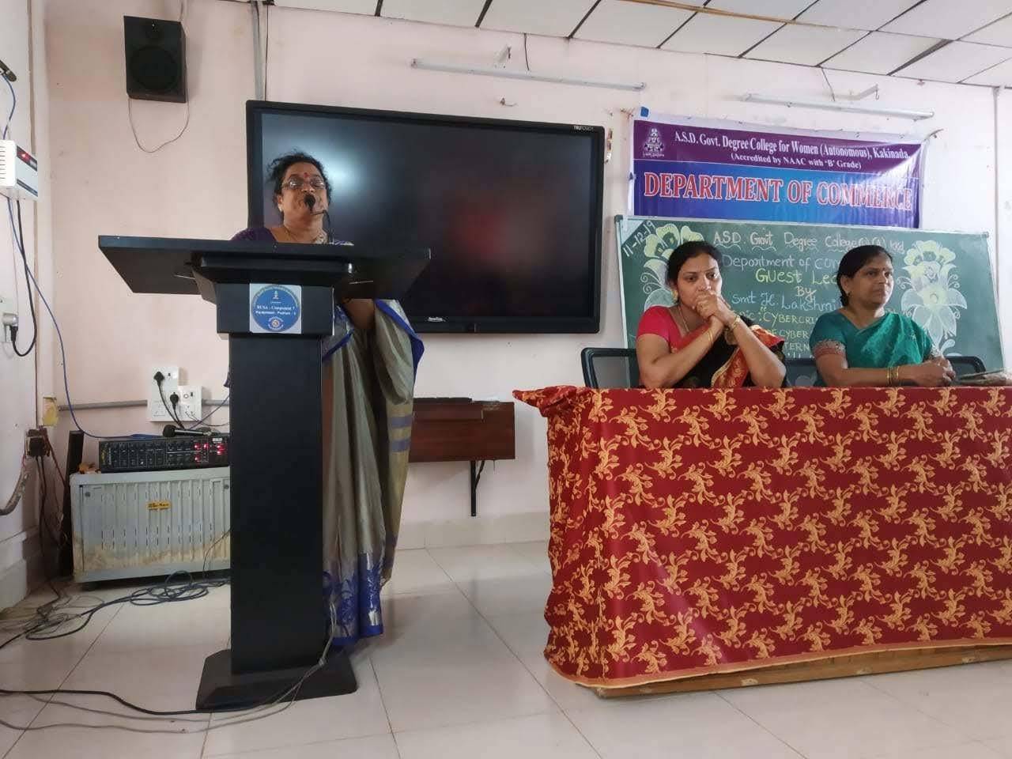

**Guest Lecture on "Consumersim- Impact of Globalisation by Sri. Y. Rajesh Kumar"**

**Date:02.01.2020**

**Purpose:**  
This session aimed to create awareness about consumerism and the impact of globalization on consumer rights and behavior.

**Lecture Highlights:**  
Sri Y. Rajesh Kumar discussed the rise of consumerism and how globalization has affected consumer choices, market dynamics, and consumer protection.

**Outcomes:**

1. **Consumer Awareness:** Students learned about their rights and responsibilities as consumers.
2. **Globalization Impact:** The lecture highlighted how globalization influences consumption patterns.

**Conclusion:**  
The lecture deepened students’ understanding of consumer rights and the evolving landscape of consumerism.

Participants: 78

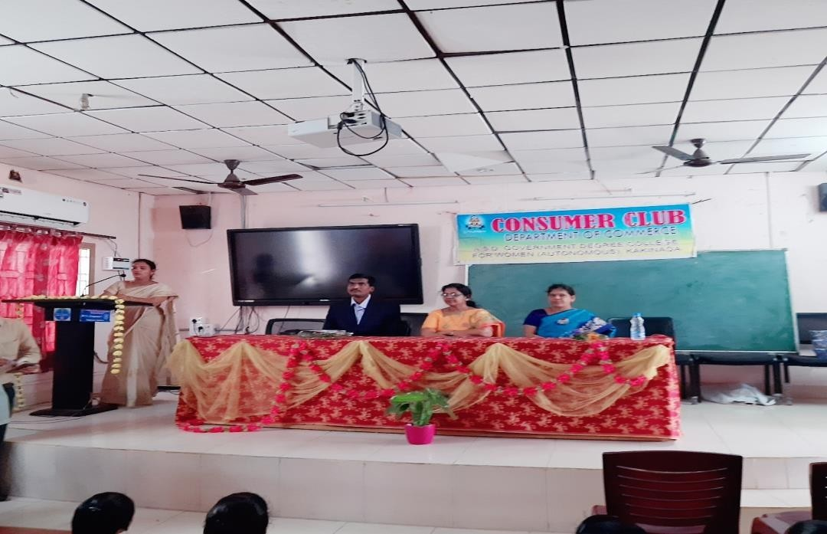

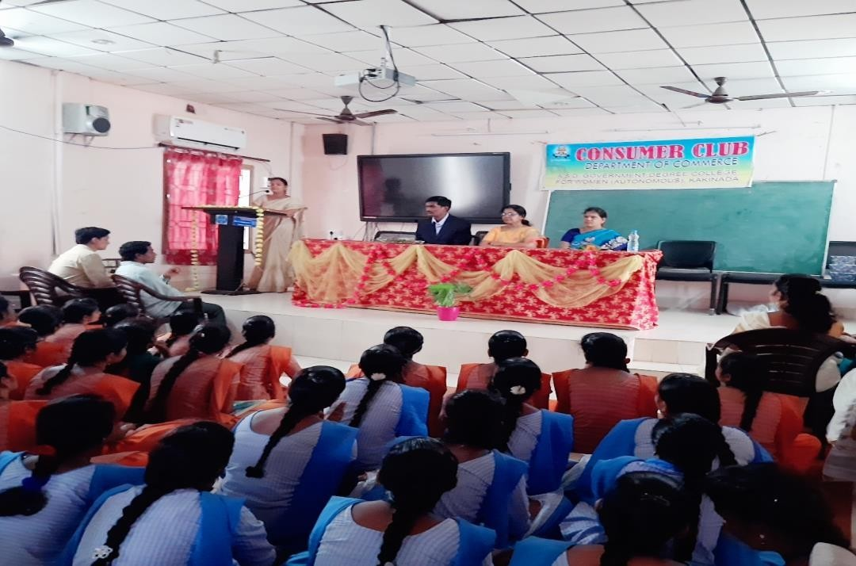

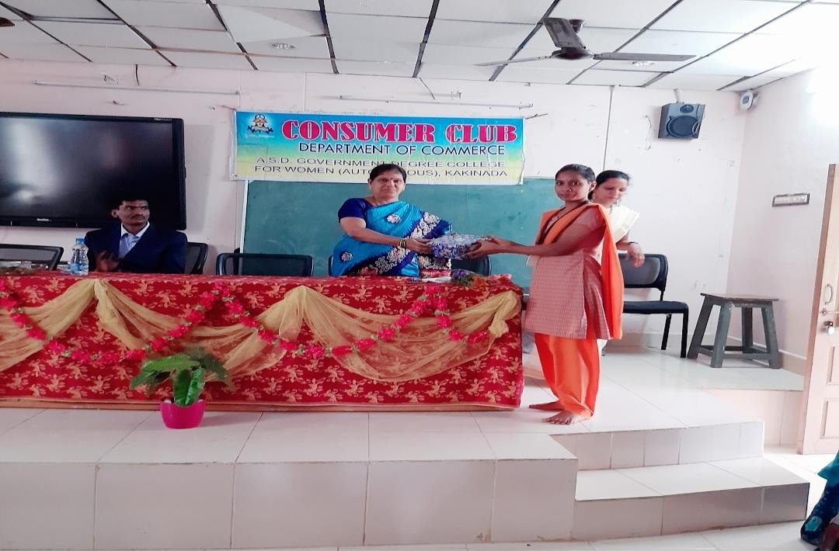

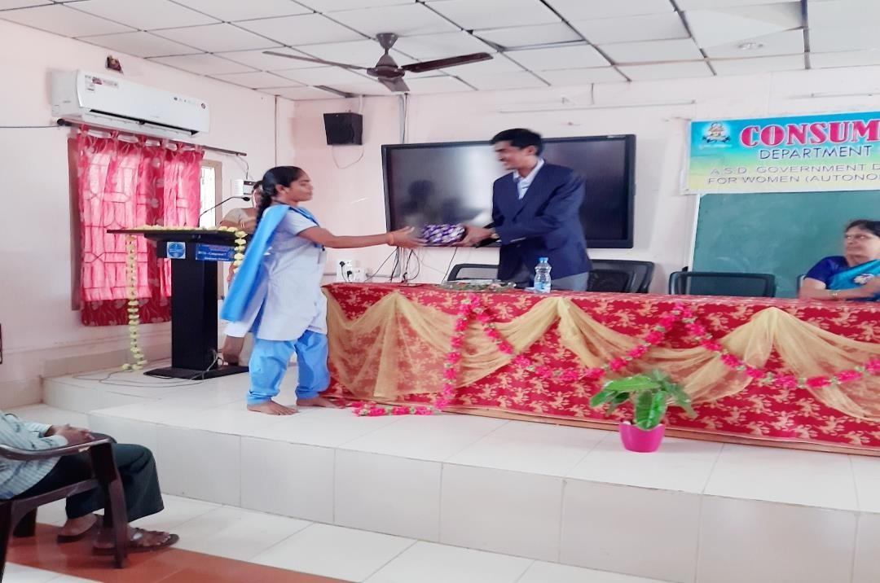

**SAMANA 2019**

**Date:21.12.2019**

**Purpose:**  
SAMANA 2019 was aimed at empowering students with entrepreneurial skills, encouraging them to think creatively and pursue business ventures.

**Highlights:**  
The event included entrepreneurial workshops, guest talks, and business-related activities to inspire students. It provided a platform for students to explore their entrepreneurial potential.

**Outcomes:**

1. **Entrepreneurial Spirit:** Students were inspired to consider entrepreneurship as a viable career option.
2. **Skill Development:** Students gained valuable insights into the fundamentals of starting and managing a business.

**Conclusion:**  
SAMANA 2019 effectively empowered students by fostering entrepreneurial thinking and equipping them with relevant skills.

Participants: Total College students & staff

**Two Day National Seminar on "India's Economic Slowdown Dynamics and Perspectives"**

**Date: 06.03.2020 to 07.03.2020**

**Purpose:**  
This seminar aimed to explore the causes and solutions to India's economic slowdown, providing a platform for students and experts to discuss potential remedies.

**Highlights:**  
Experts from various fields discussed India’s economic challenges, including issues like unemployment, inflation, and policy reforms. The seminar also examined potential strategies for revitalizing the economy.

**Outcomes:**

1. **Economic Insights:** Students learned about the economic slowdown and its causes.
2. **Critical Thinking:** The seminar encouraged students to think critically about economic policies and their implications.

**Conclusion:**  
The seminar provided students with a deep understanding of India’s economic challenges and potential solutions, enriching their knowledge of macroeconomic issues.

Participants: 127

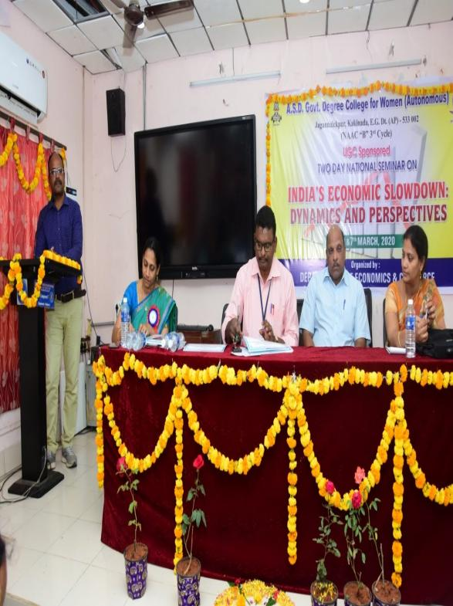 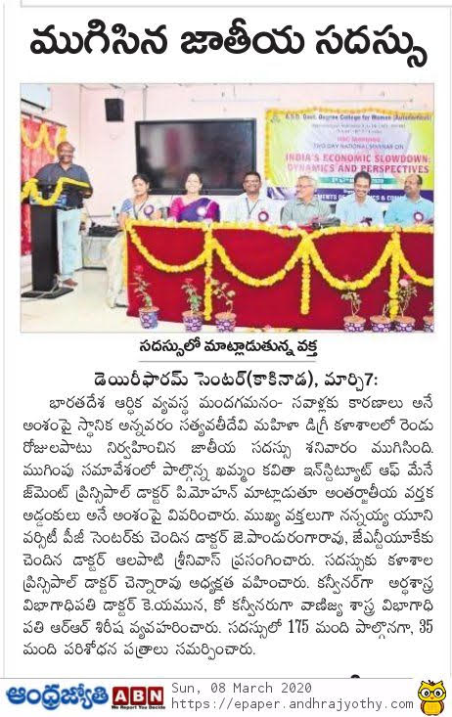

https://asdgdcw.ac.in/resource/file_attach/1714910106EconomicSlodown_06_03_2020.pdf

**Field Visit to Heritage Ltd Co. Visakhapatnam**

**Date: 26.02.2020**

**Purpose:**  
The field visit aimed to provide students with hands-on exposure to the operations of a process industry, specifically Heritage Ltd Co., a leading company in the dairy and food processing sector.

**Visit Highlights:**  
The visit allowed students to observe the production processes, quality control methods, and packaging techniques used in the dairy industry. Experts from the company explained various aspects of production, including procurement of raw materials, supply chain management, and the role of technology in ensuring product quality.

**Outcomes:**

1. **Practical Knowledge:** Students gained insights into the functioning of a process industry.
2. **Industrial Exposure:** Enhanced understanding of how industries maintain efficiency and quality.
3. **Career Awareness:** Introduced students to career opportunities in the food and beverage sector.

**Conclusion:**  
The visit bridged the gap between theoretical concepts and real-world industrial practices, enriching the students' knowledge base.

Participants: 49

