Best Practice-I
Title of the Practice: SAMANA- A STUDENT FAIR
- Objectives of the Practice:
SAMANA-A Student Fair is a fair conducted to tap the talents and potentials of the students. The objectives of the practice includes:
- To show case the latent skills of students in the institution
- To inculcate entrepreneurial skills among the students
- To create awareness on preparation of budget proposal, Banking transactions, Project proposals for start-ups
- To provide first hand experiences on consumer behaviours
- To inculcate marketing skills among students
- To empower the students on how to market their skills
- To help the students to earn while they learn
- The Context :
SAMANA-A Student Fair is an initiative by the department of Commerce which was fist started in the year 2015.In the beginning only the students of Commerce department established various stalls for the students in the institution and the students of the other departments were only the buyers. Witnessing the huge success of the programme, it was adopted as a best practice of the institution by involving all the interested students to set up stalls and convert their skills into a small scale business. The fair was initially limited to the students of the college. Later the family members of the students and the people of the nearby community were also given access and hence it is organized at a large scale
- Uniqueness in the context of India higher education: Higher education centres are usually the knowledge imparting centres. But gaining knowledge is not sufficient in the present competitive scenario and developing employment and entrepreneurship skills among the students has become need of the hour. Given the present economic situation, it is no longer sufficient for a new graduate to have knowledge of an academic subject. Increasingly, it is becoming necessary for students to gain those skills, which will enhance their prospects of employment and Entrepreneurship. Hence to inculcate skills among the students, various departments are organizing skill development courses to the students which may be directly or indirectly related to their domain of specialization.
Initially the teachers of the Commerce department invite the proposals for setting up the stalls for the fair. After finalizing the lists, the date of the fair is informed to the students for the preparation of their items. The day before the event, the concerned teachers make the necessary logistics and arrangements. Each student is charged a minimum amount to set up their stalls and are allotted the stall numbers. On the day of the event ,the concerned students arrives early and set up their stalls and be ready for the inauguration of the stalls. A locally reputed person is invited as the chief guest who along with the college principal inaugurates the stalls. They go around the stalls and interact with the students about their products and encourages them. Then the stalls will be opened for the other students and locals. After the fair is over, the students have to submit a report on the number of items sold and the gain or loss in the fair.
This Samana-A student fair provides an opportunity for the students to commercially use their skills and creativity. It is a unique practice because the students in spite of possessing skills are usually not aware how to use them commercially. In the institution when they participate in the fair under the guidance of the teachers, it provides them a right direction in planning and also the implementation of the project, budget planning and production of the items based on the demand of the other students. They also gain the skill of calculating their profit or loss and how to estimate the cost price and selling price of their produces. These skills gained in this practice especially is very much beneficial for the girl students who are not willing to work after their marriage due to family constraints and can set up their own start-up.
- Evidence of Success
Initially in 2015 when the fair was arranged for the first time the stalls set up were very few and only 50 students of commerce participated in the fair and setup their stalls. But year by year the number of stalls and also the number of participants has increased enormously. By the year 2019-20 the stalls have increased in both quantity and quality. The participants increased enormously including not only the students of the institution but also the locals , parents and also the students of the junior college .The students also earned relatively good profit for the amounts they invested.
- Problems Encountered and Resources required
The first problem encountered when the practice as initiated was the low motivation of the students. The teachers had to work had to motivate the students.
Another major problem encountered was the time to be spent by both the teachers and the students on planning and preparation of the fair due to the hectic academic schedule of the students and teachers in the semester pattern.
As the majority of the students in the institution belong to low and marginalized families, investing a small amount on setting up a stall was also a big challenge for the students
The parents of the students were sceptical about getting back the amount invested by the students and hence were very difficult to be convinced

- Notes (Optional): This practice can be adopted by any higher education institutes as it brings out the latent talents and the potentials of the students. It also provides a business environment exposure to the students. It strengthens the student’s skills in planning and implementation of the projects, gain and loss in a business and also marketing skills. Such exposure during the student days can be a stepping stone for the students interested in planning their start-ups after their education.
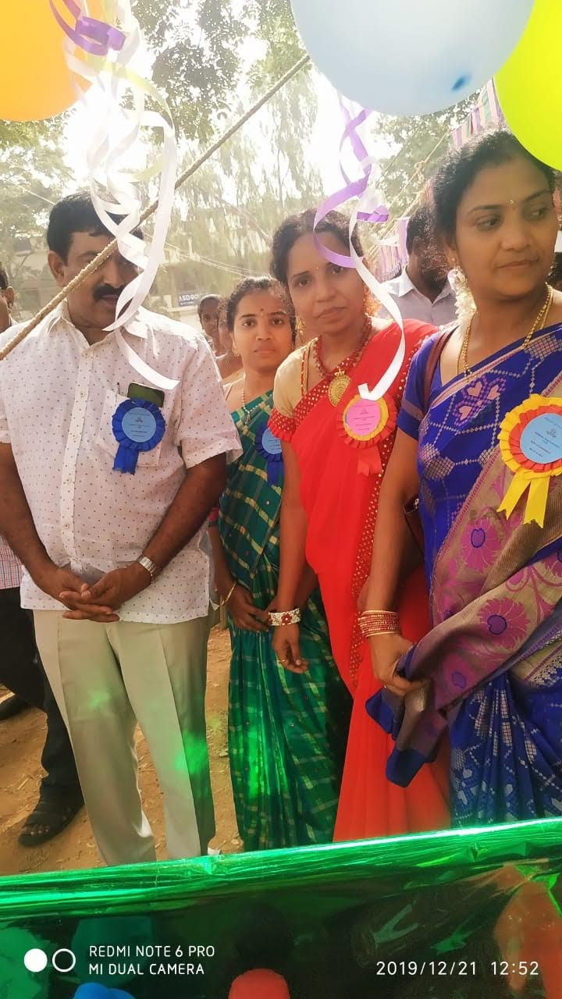
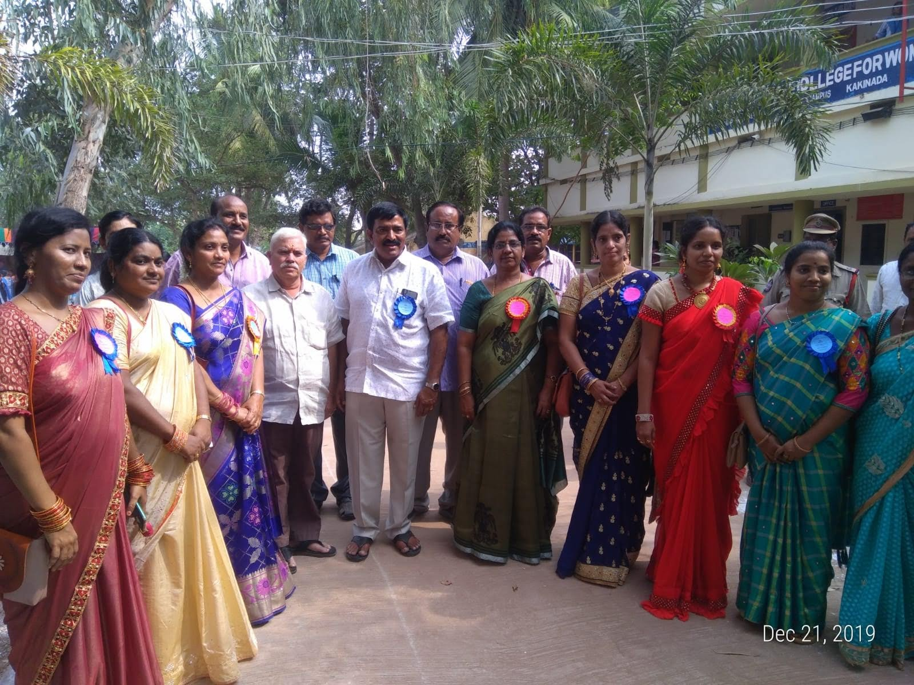
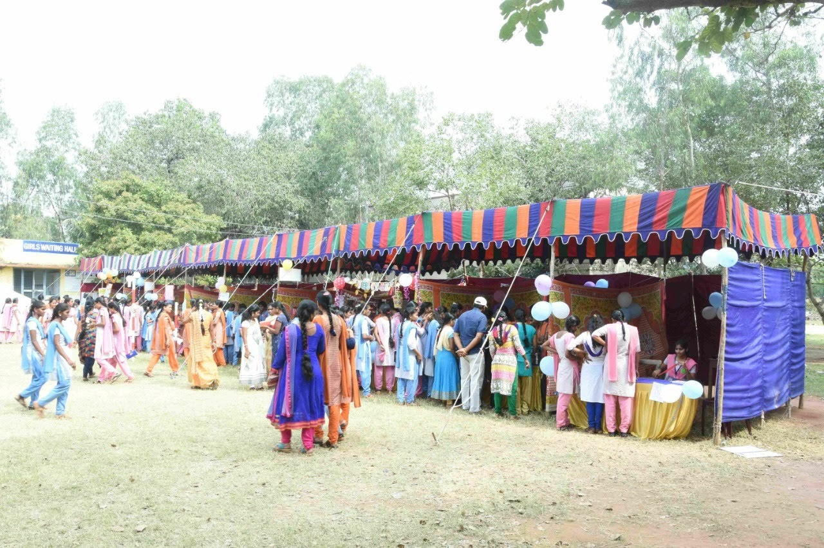
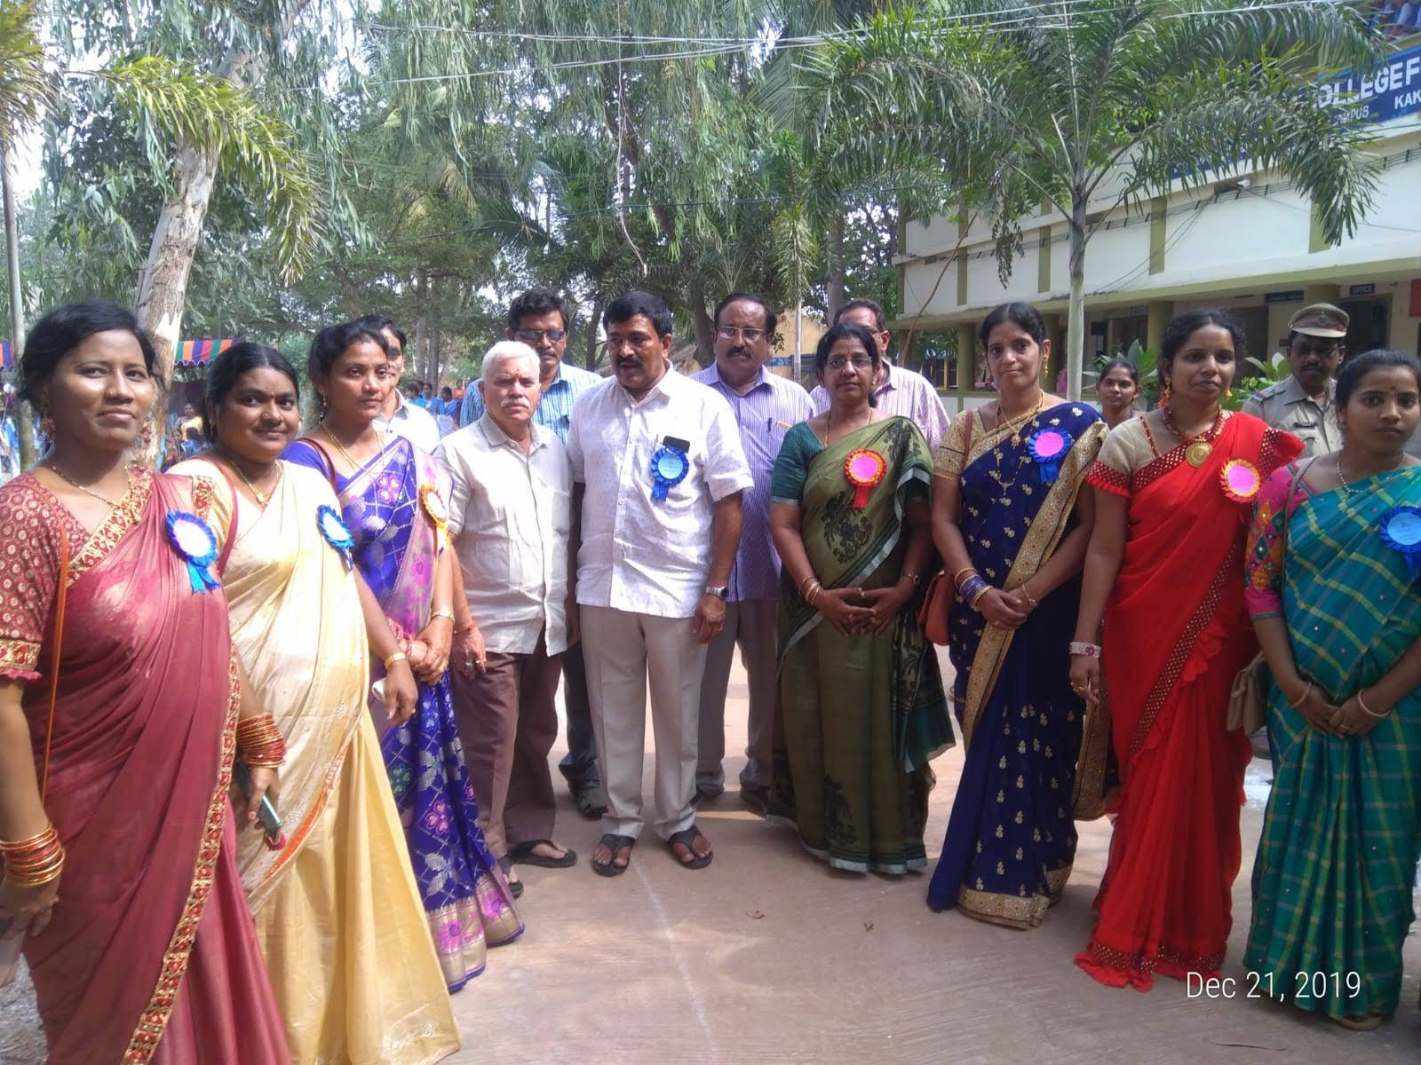
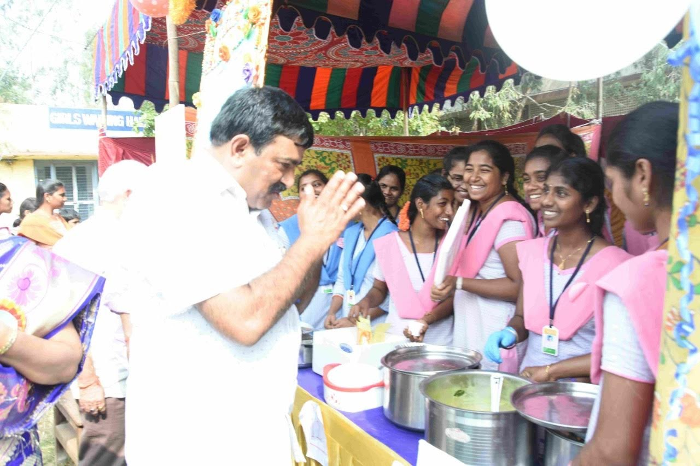

Best Practice-II
- Title of the Practice: Koushal-Skill Training for students

- Objectives of the Practice:
- To develop the general and domain specific skills among the students
- To develop job readiness among the students
- To develop employability competencies among students
- To develop entrepreneurial skills among students

- Uniqueness in the context of India higher education: Skill and knowledge are the driving forces for both the economic growth and social development of any country. India being an young country with more than 54 percent of the population below the age group of 25 years, their contribution to the society makes a huge difference to both the economy and the society. In this scenario, Higher educational Institutions have a great role to play. Along with the knowledge, if the students need to be imparted skill training. The skill training might be either in general or domain specific.

- The Context: The present job sector is emphasizing more on skills compared to the knowledge. Skill training also provides an avenue for entrepreneurship In this scenario this institution has been offering skill based certificate courses which might be their domain specific or in general domain.

- Contextual features or challenging issues that needed to be addressed in designing and implementing this practice
Offering certificate courses along with the regular busy academic schedule in the semester pattern is very demanding for the teachers. Sometimes they need to be offered during zero hours. Though the certificate courses are charged nominally or sometimes not charged at all, the students still find it difficult to spend on the material required for the courses as majority of them are from economically marginalized families. So the students have to be constantly motivated to enroll for the courses..
- Evidence of Success
In the academic year, five certificate courses were offered by the institution by the departments of English, Mathematics, Computers and Home Science. The courses were offered in communicative English, IOT applications, Digital Literacy, Handicrafts etc., Nearly 200 students were trained during the academic year.
- Problems Encountered and Resources required Please identify the problems encountered and resources required to implement the practice (in about 150 words).
Finding the skilled resource persons for some of the courses like Nursery Management ,computer courses etc especially at nominal remuneration is a herculean task for the teachers. In spite of such constraints, the institution is offering certificate courses for the benefit of the students.Regular attendance of the students to the courses is also a challenge.
- Notes (Optional) : Please add any other information that may be relevant for adopting/
This practice can be adopted by any higher education institutes as it creates an opportunity for the students to gain knowledge in various general and specific domains. It enhances the chances of job opportunities for the students. It also creates opportunities for stating their entrepreneurships.
