Best Practice I:

Parivarthana: A Participatory Learning Approach

Title of the Practice: Parivarthana is an initiative of the institution aiming towards the transformation of the students to confident individuals with good communication, presentation and interpersonal skills.
Context: In the present scenario of Higher Education, a student needs to be trained in multiple areas with special emphasis on communication and presentation skills to compete with their peers across the world. Our students especially hailing from poor economic sections have very few opportunities to hone their skills to compete in the present competitive world. Hence to address the holistic nature of the students ,they are provided with various modes of learning opportunities.
- Students are motivated to do Poster/Power Point Presentations in the seminars and conferences organized in the institution by various departments by constantly guiding, training and grooming them for the presentation

- Students are encouraged to do Oral and Poster Presentations in the events organized by the other Institutions/Organizations at District and State level

- Students are trained to invite and introduce the Resource Persons during the Seminars and Conferences to groom their presentation skills

- Students are motivated to do Poster/Power Point Presentations in the seminars and conferences organized in the institution by various departments by constantly guiding, training and grooming them for the presentation

- Students are encouraged to do Oral and Poster Presentations in the events organized by the other Institutions/Organizations at District and State level

- Students are trained to invite and introduce the Resource Persons during the Seminars and Conferences to groom their presentation skills

- Peer Teaching is adopted where selected students will teach their juniors under the guidance and supervision of the teachers

- Peer Mentoring is followed wherein the students mentor their counterparts who are slow learners and need some extra mentoring

- Group Learning is encouraged by dividing into groups with a combination of Bright, Average and Slow learners (Based on their performance in the internal examination) A monitor is appointed who acts as a mentor and offers necessary help to the other group members. The leaders of the groups obtains the required study material and guidance from the concerned teacher.

Evidence of Success:
- The practice of Participatory Learning has become a successful practice as it is received very positively both by the students and staff members.

- Many students won prizes in Poster and Power point presentations, Essay and Elocution Competitions organized within outside the institution. This has resulted in high motivation among the other students

- Remarkable improvement was observed in the communication and presentation skills of the students

- Kum.Pavithra , III CBMB won I prize in National level Workshop Poster Presentation at Government Arts College, Rajahmundry

- Kum. Keerthana ,III CBMB won II prize in Poster Presentation in National level Workshop at Govt Degree College, Rajahmundry

- Kum.Devi ,III CBZ won I prize in Poster Presenation in International Workshop on Wild Life Week Celebrations organized by the college

- K.Sandhya ,II CBZ won II prize in Poster Presenation in International Workshop on Wild Life Week Celebrations organized by the college

- Kum.Hemasri ,III B.A won I prize in Elocution competition on RTI
- Some of the students have started giving class seminars also in Power point mode which improved their skills in using ICT

- Students have started putting extra efforts in understanding and learning the subject matter as they need to act as peer teachers

- Peer mentoring also has resulted in improving the performance of the slow learners as they could easily approach their peer mentors

- Interpersonal relations among the peers also improved remarkably. Good Leadership qualities are inculcated among the students
Challenges

- Training the students in the use of technology as they are previously not exposed to web browsing and web presentations

- Sustenance of interest among the students and the staff members

- Management of time for extra mentoring for the students by the staff members as already they are overburdened with the teaching duties and also the other supporting committees

- Convincing the parents to send their wards for presentations out of station

- Teachers need to put extra time and effort along with their regular responsibilities
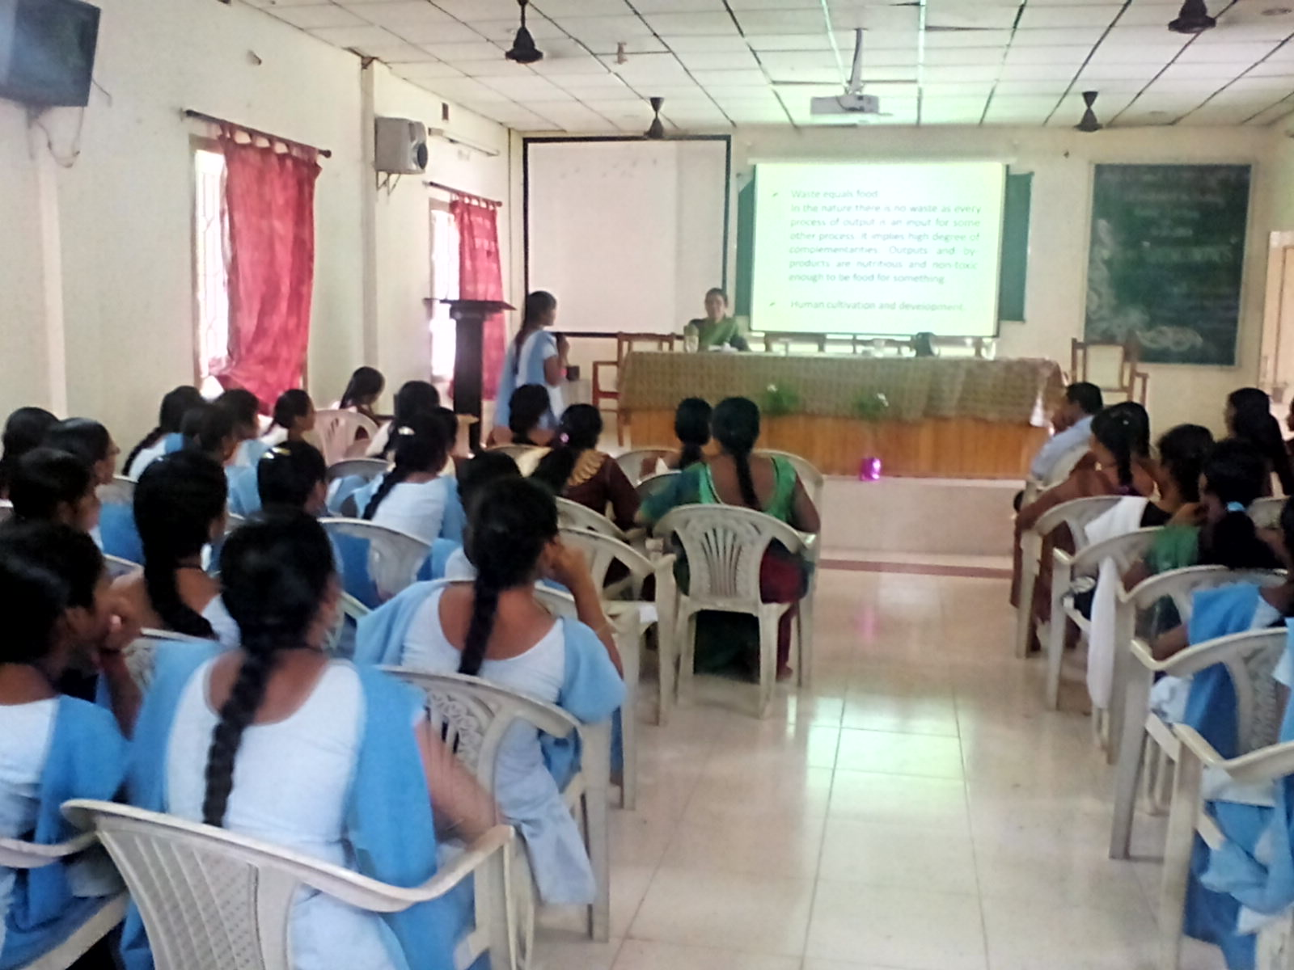
Student interacting with the Guest Speaker
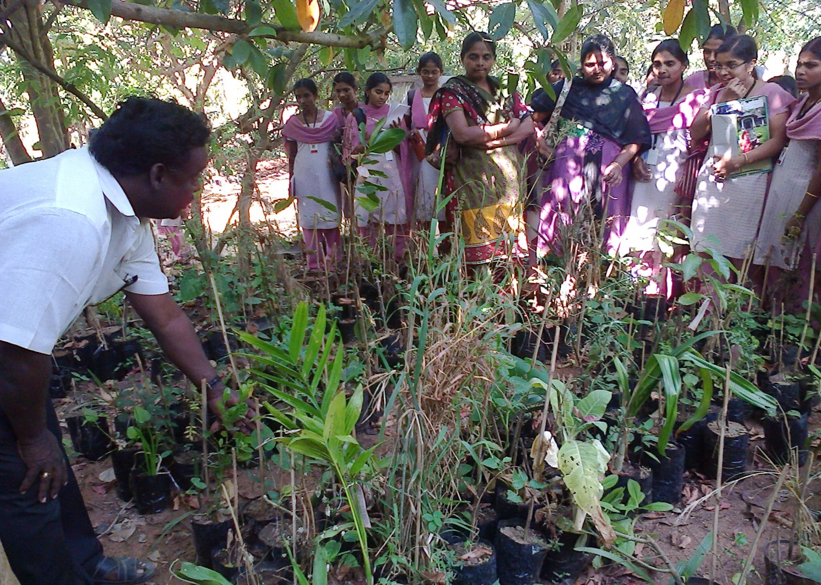
Students learning through First Hand Experiences in the filelds
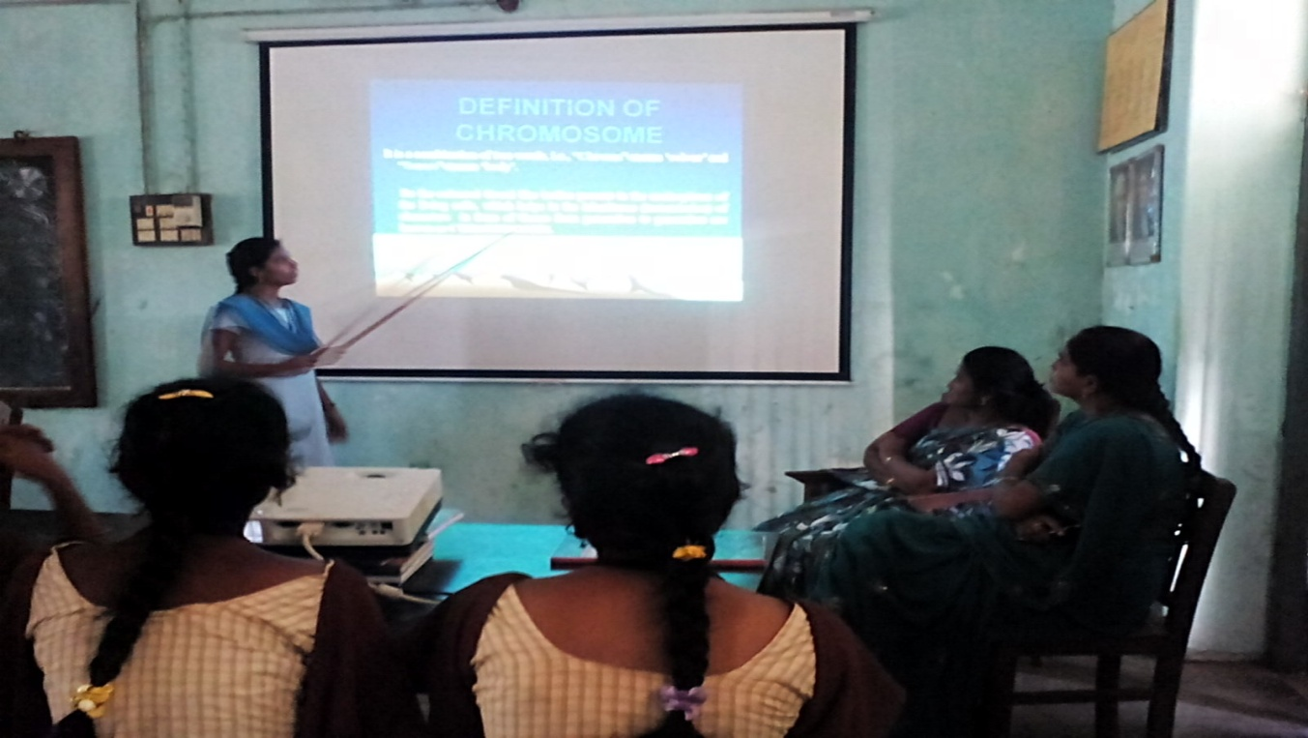
Peer Teaching through PPT Presentation
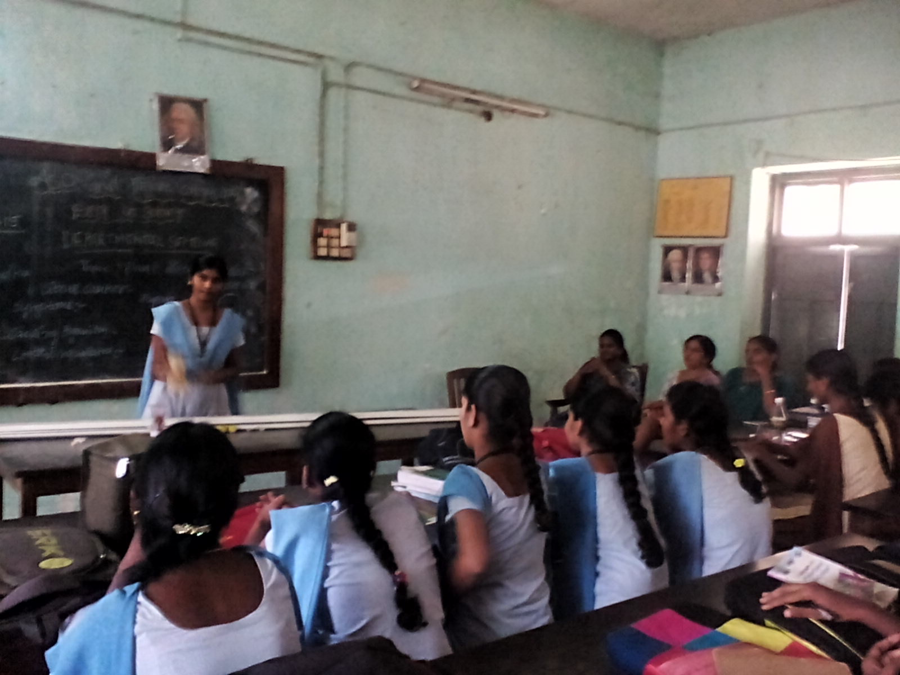
Peer Teaching Sessions

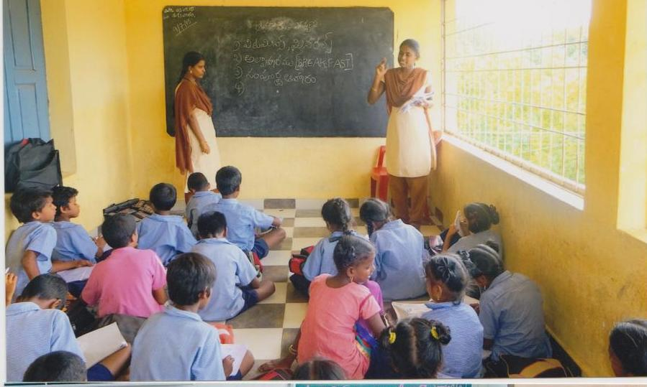
Educating the School children on Health,Hygiene and Nutrition

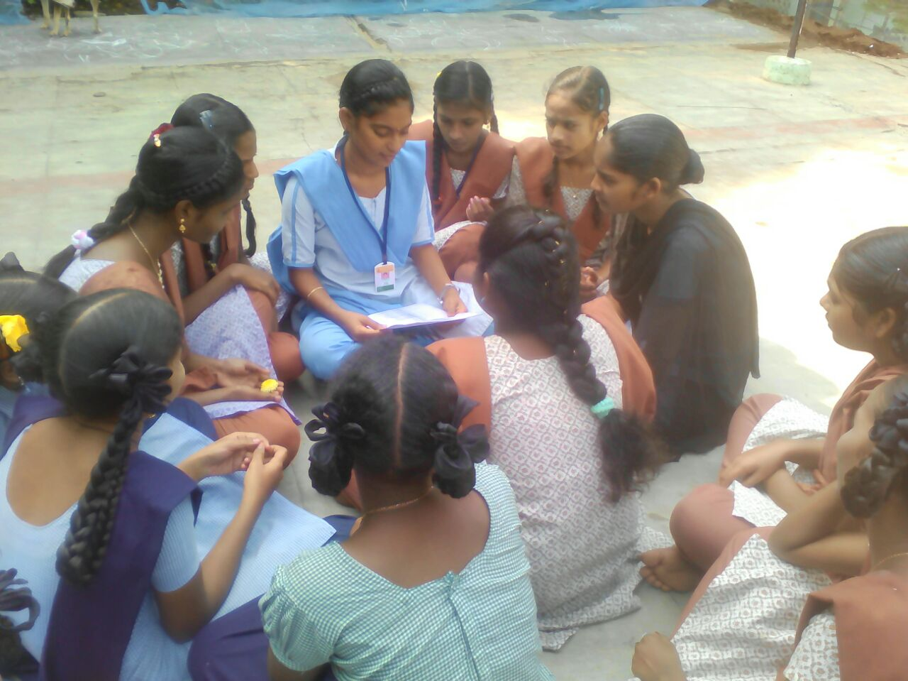
Peer Teaching to Adolescent Girls in Residential Schools
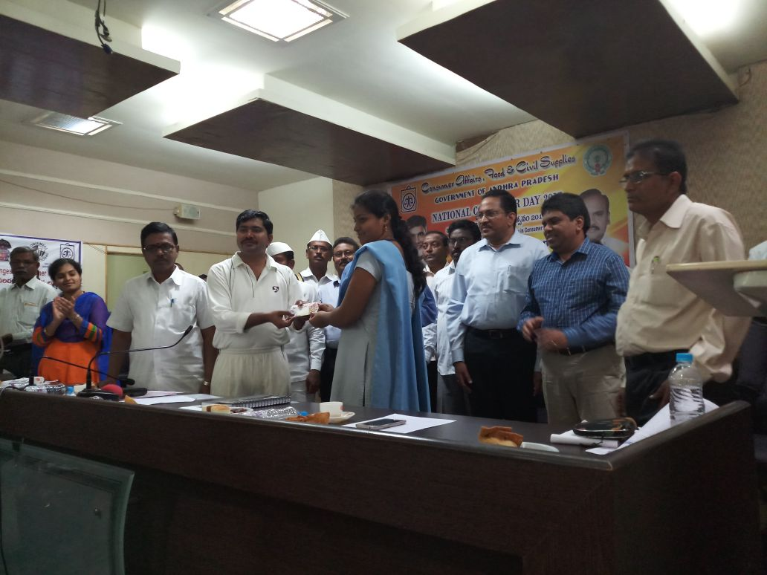
Kum.---- State Level First Prize Winner in Elocution Competition on World Consumer Day
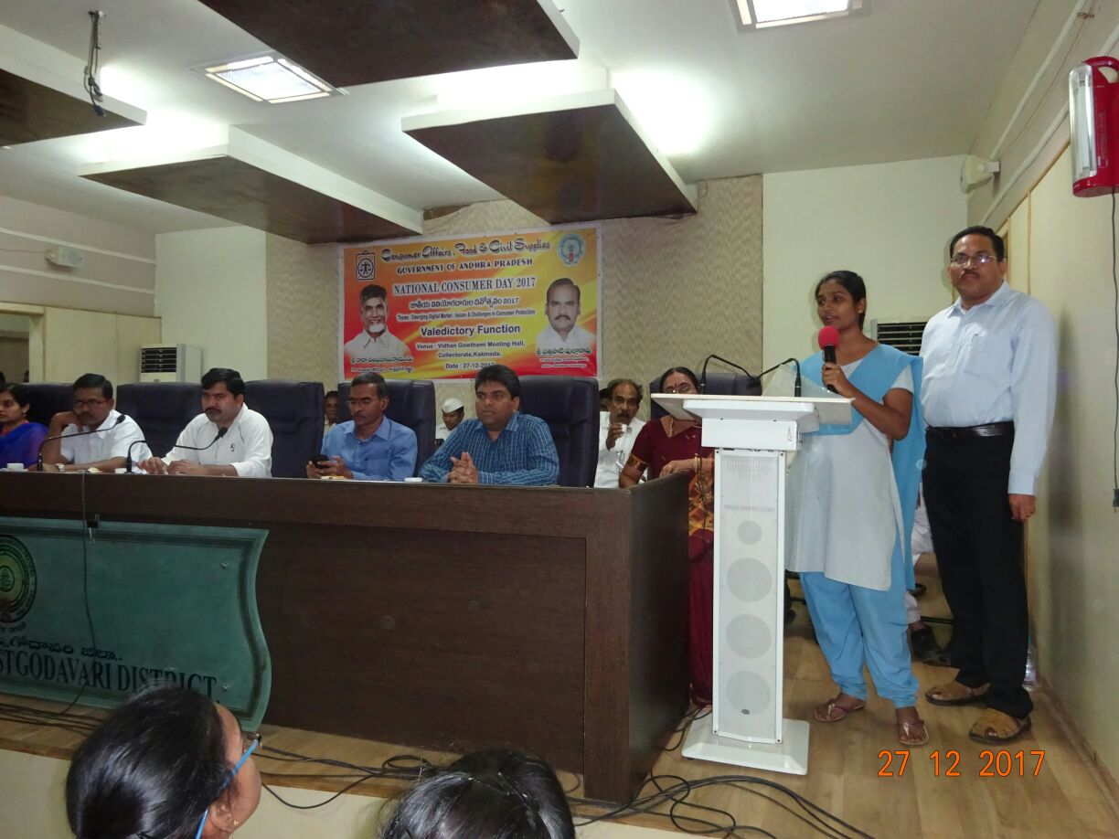
Kum.M.N.D.S.prasanna participating in Elocution Competition on World Consumer Day
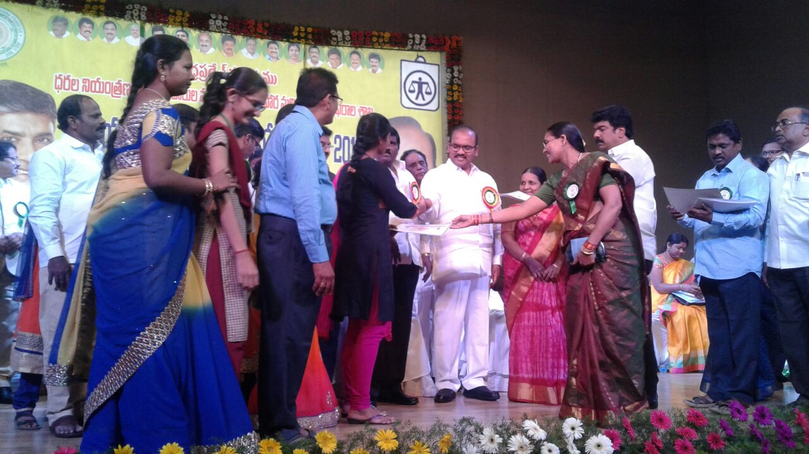
Kum.M.N.D.S.Prasanna recieving State Level prize for Elocution Competition
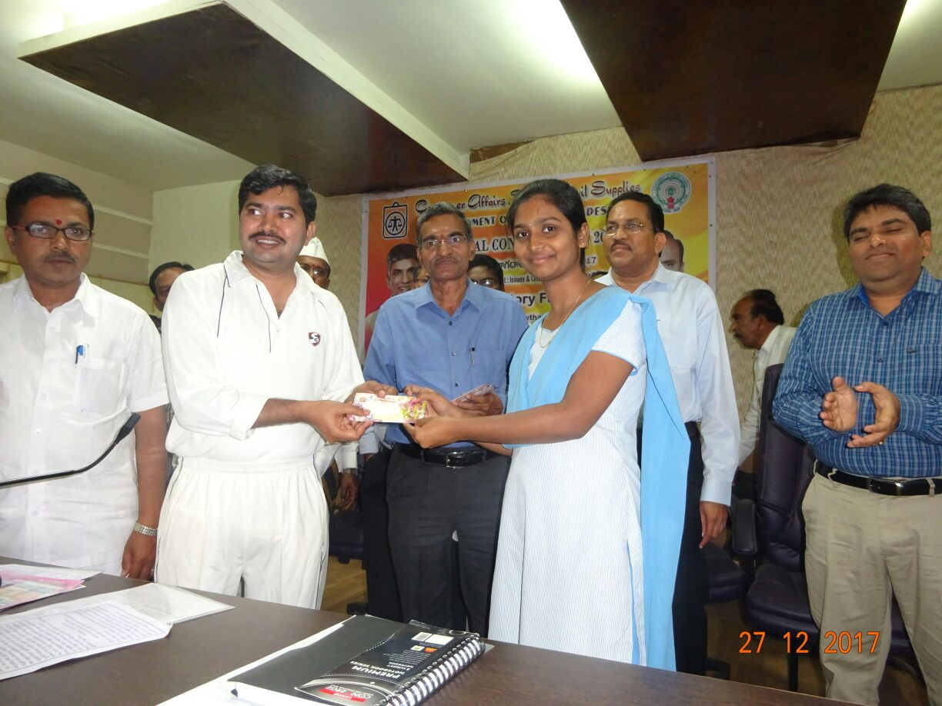Kum.M.N.D.S.prasanna , First Prize winner at District Level in Elocution Competition on World Consumer Day

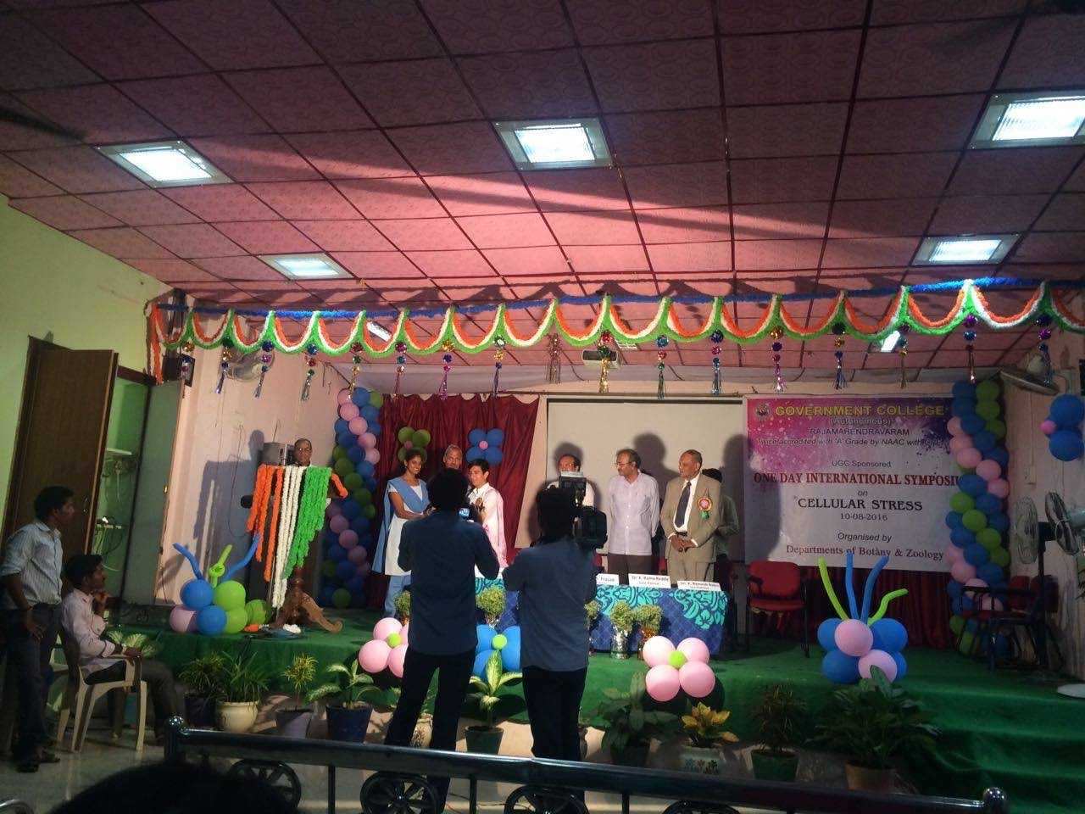
Kum Leela Pavithra First prize Winner in Poster Presentation at District Level Seminar
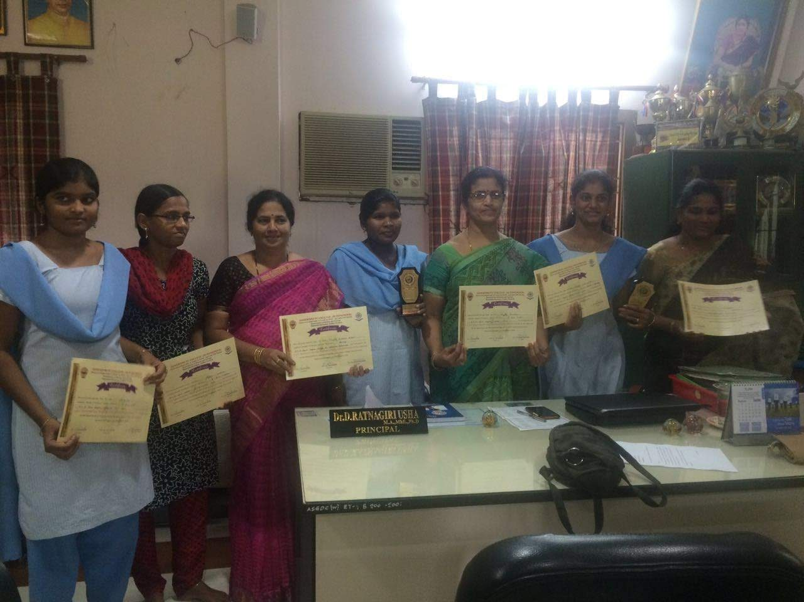
Participants in District level Poster Presentation on cellular Biology
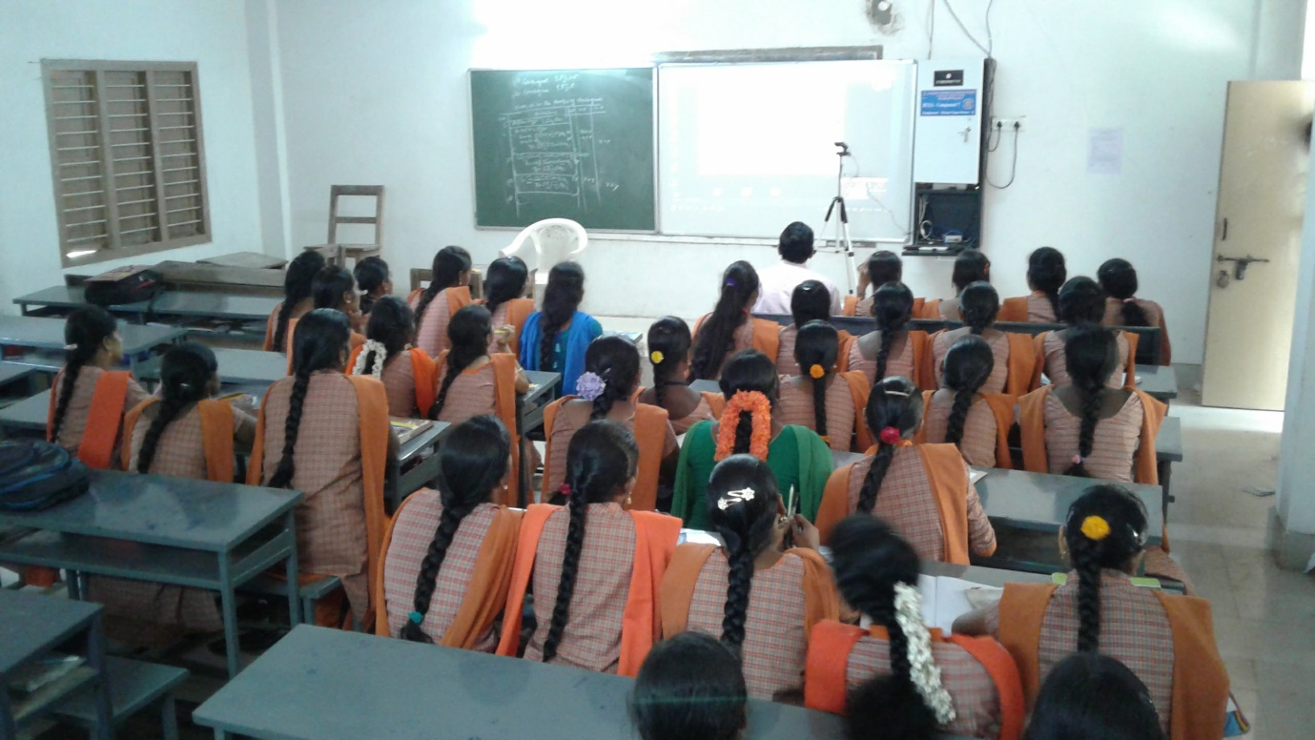
Students Learning in Virtual Classrooms
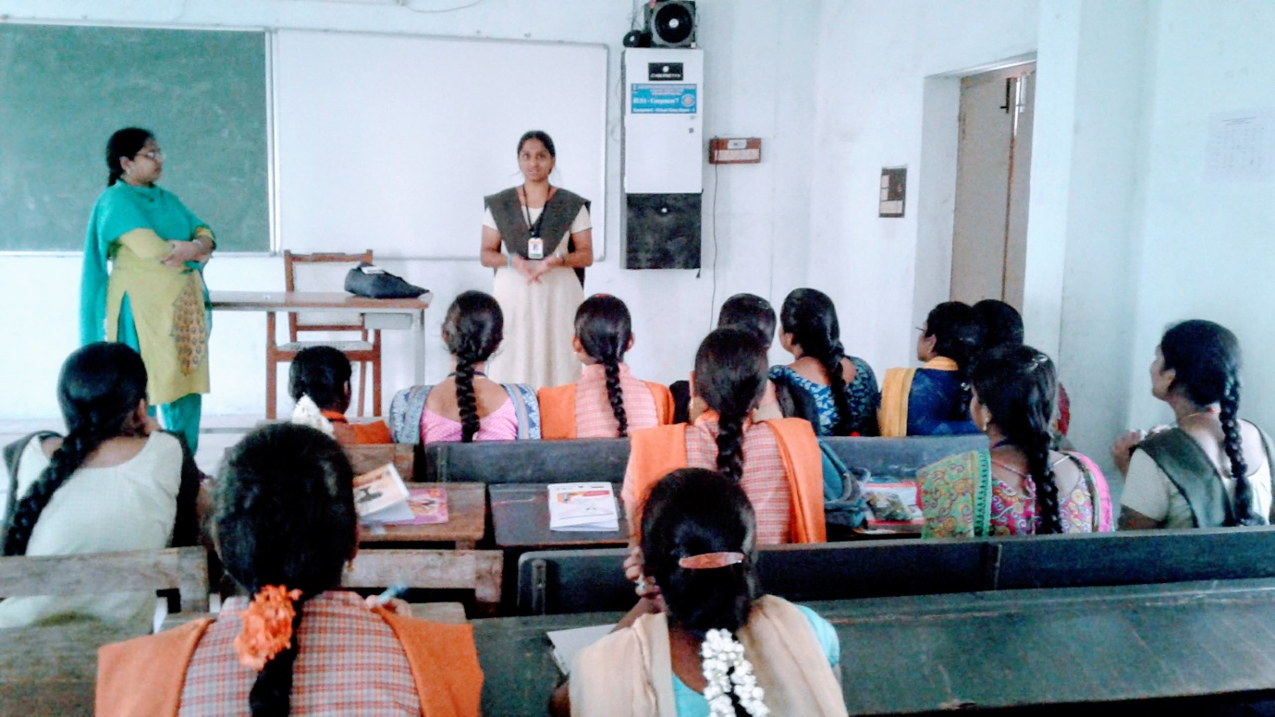
Developing Communication skills of students through JAM Sessions
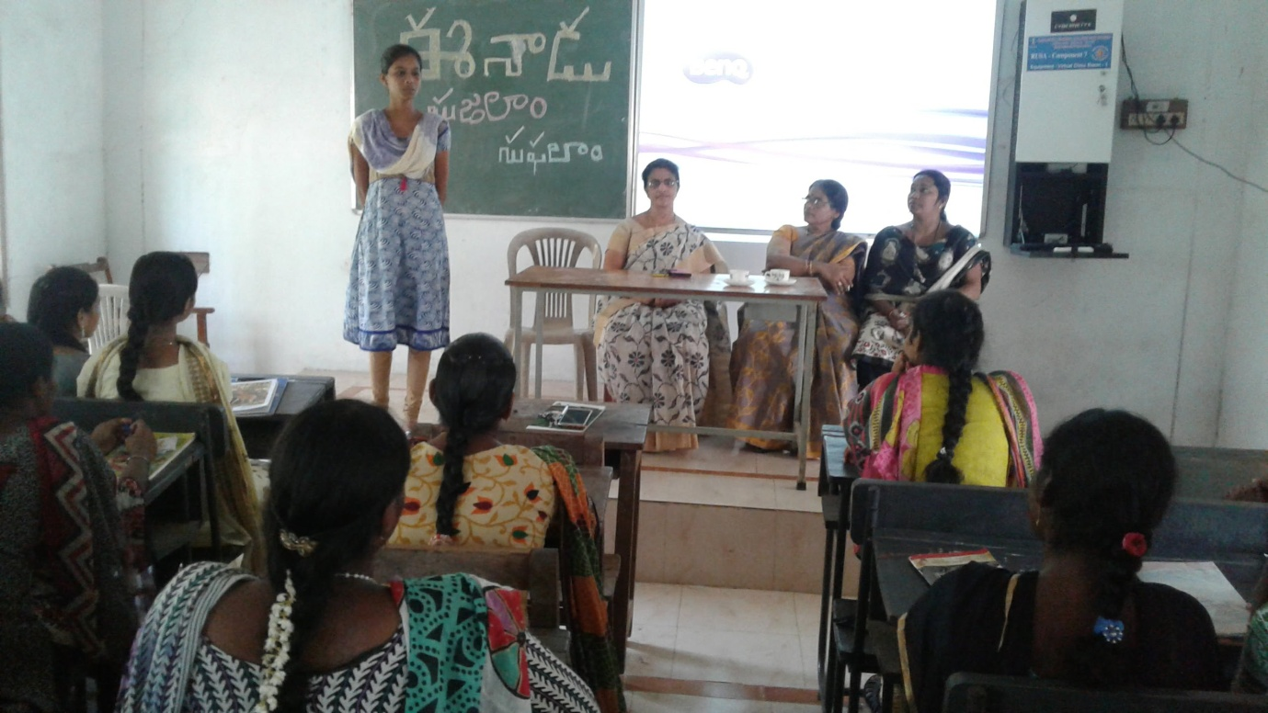
Extempore on Water Conservation

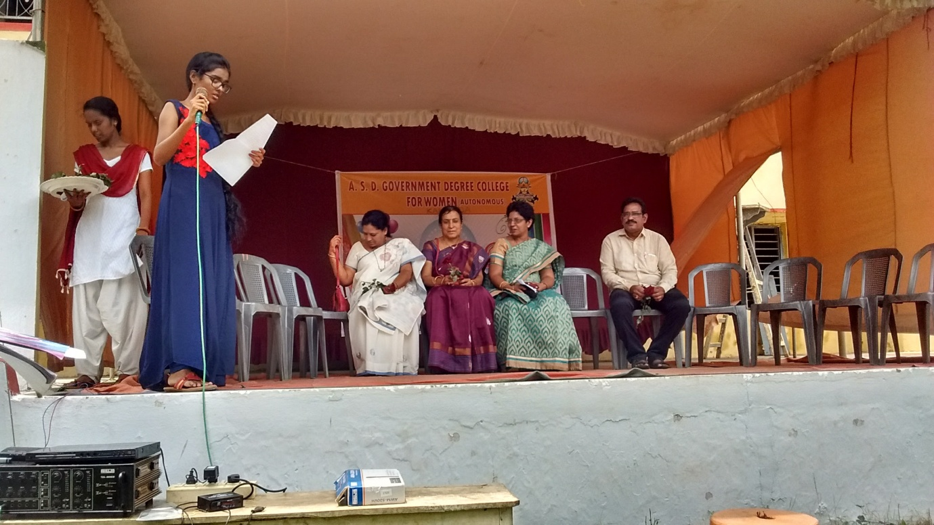
Inviting the Guests on Special occasions
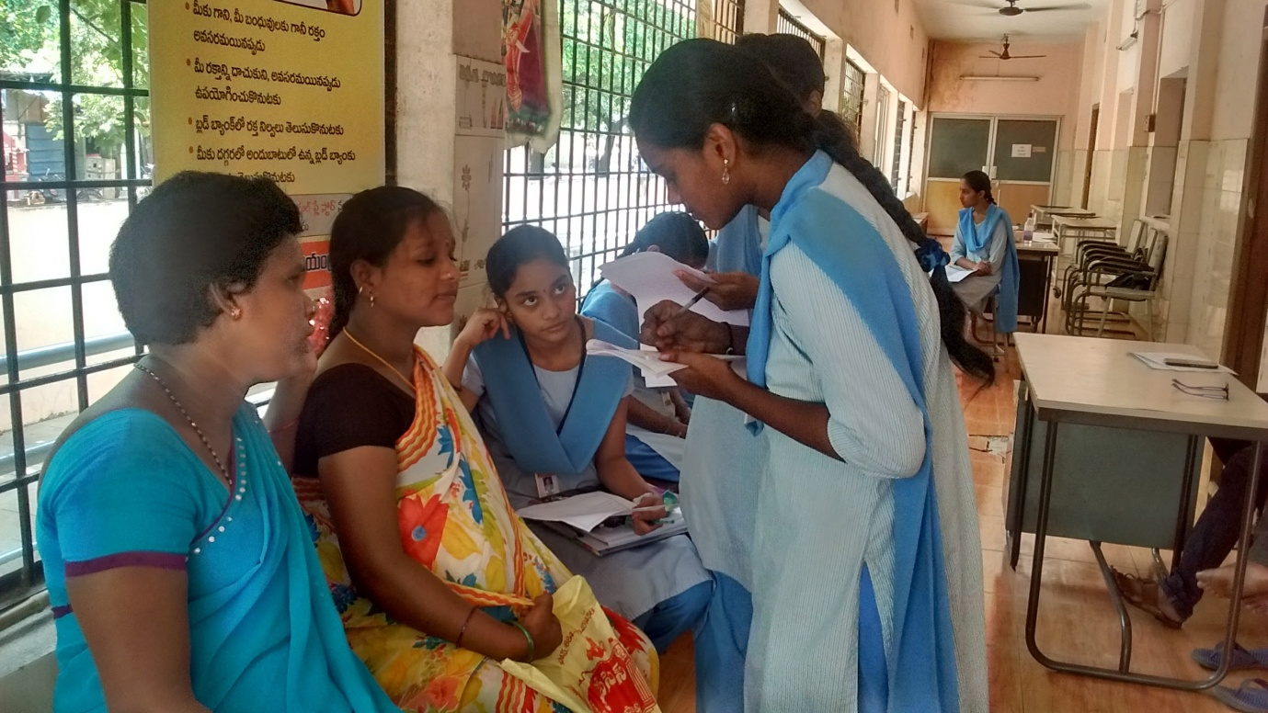
Learning through Case Study Method
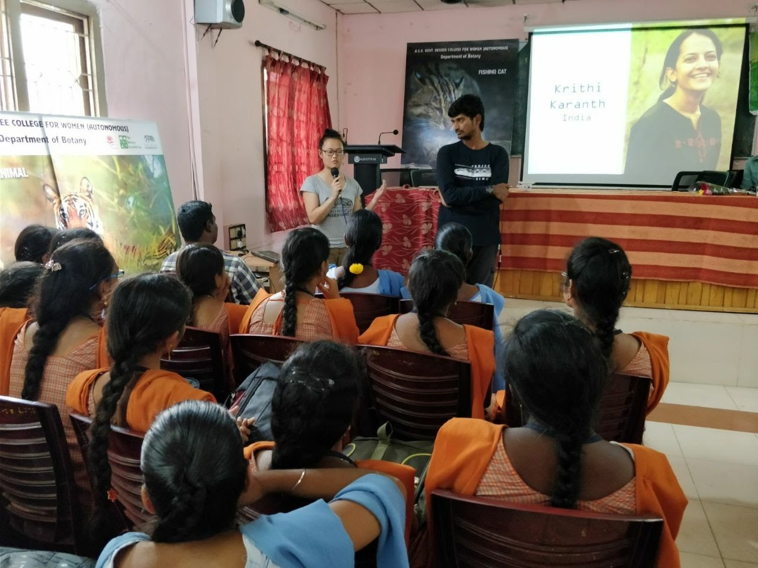
Participation in Seminars
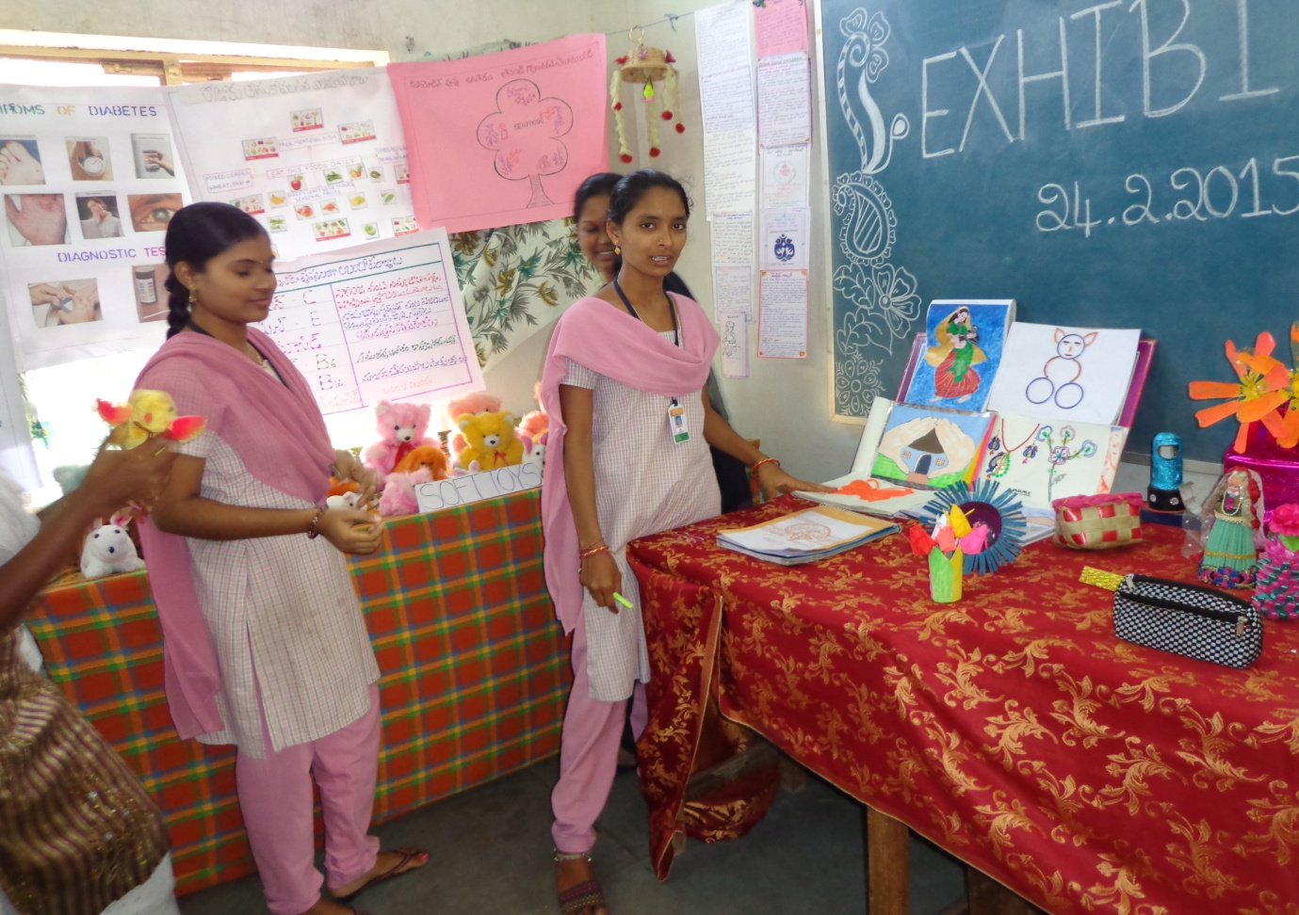
Organizing Exhibitions cum sales
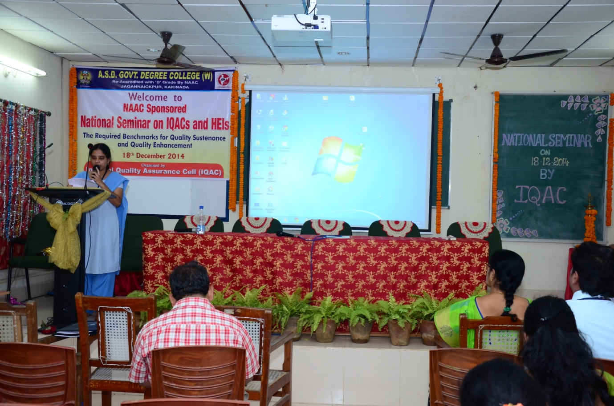
Paper Presentation in National Seminars
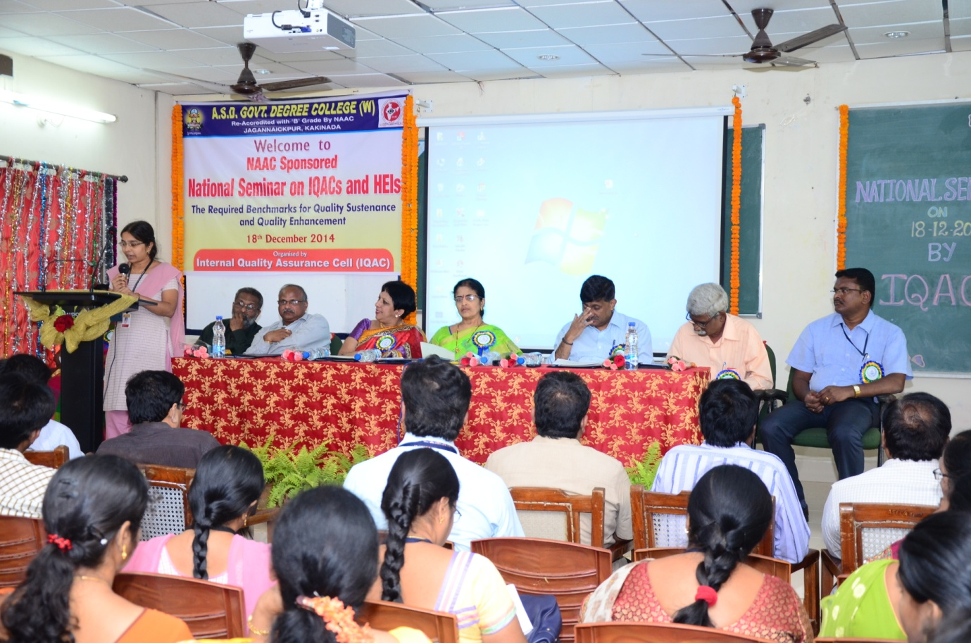
Student introducing the Resource Persons
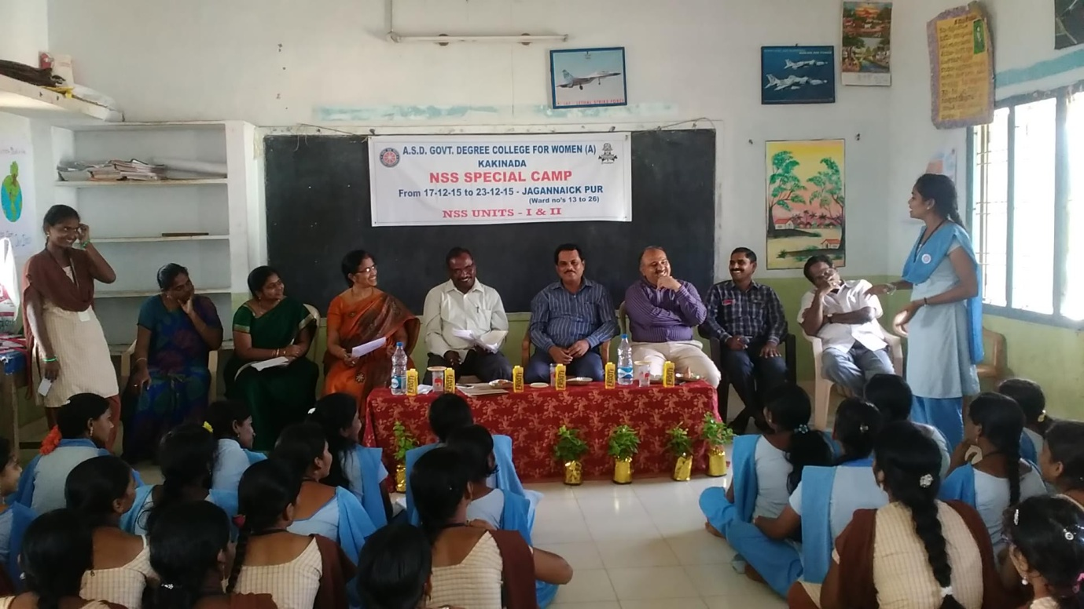
Presentation of Smart Survey Report to the Commissioner, Kakinada Municipal Corporation in NSS Special Camp
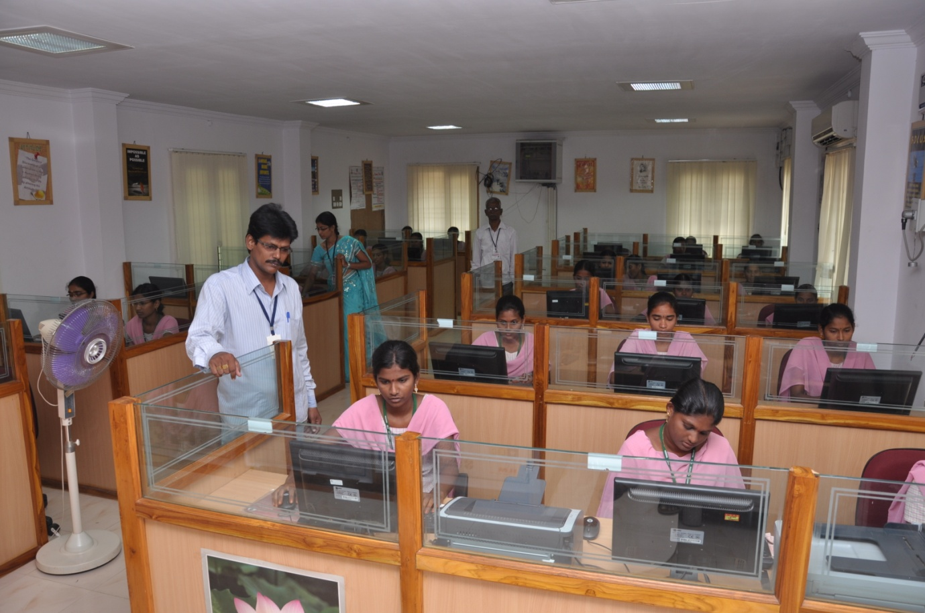
Learning through ICT
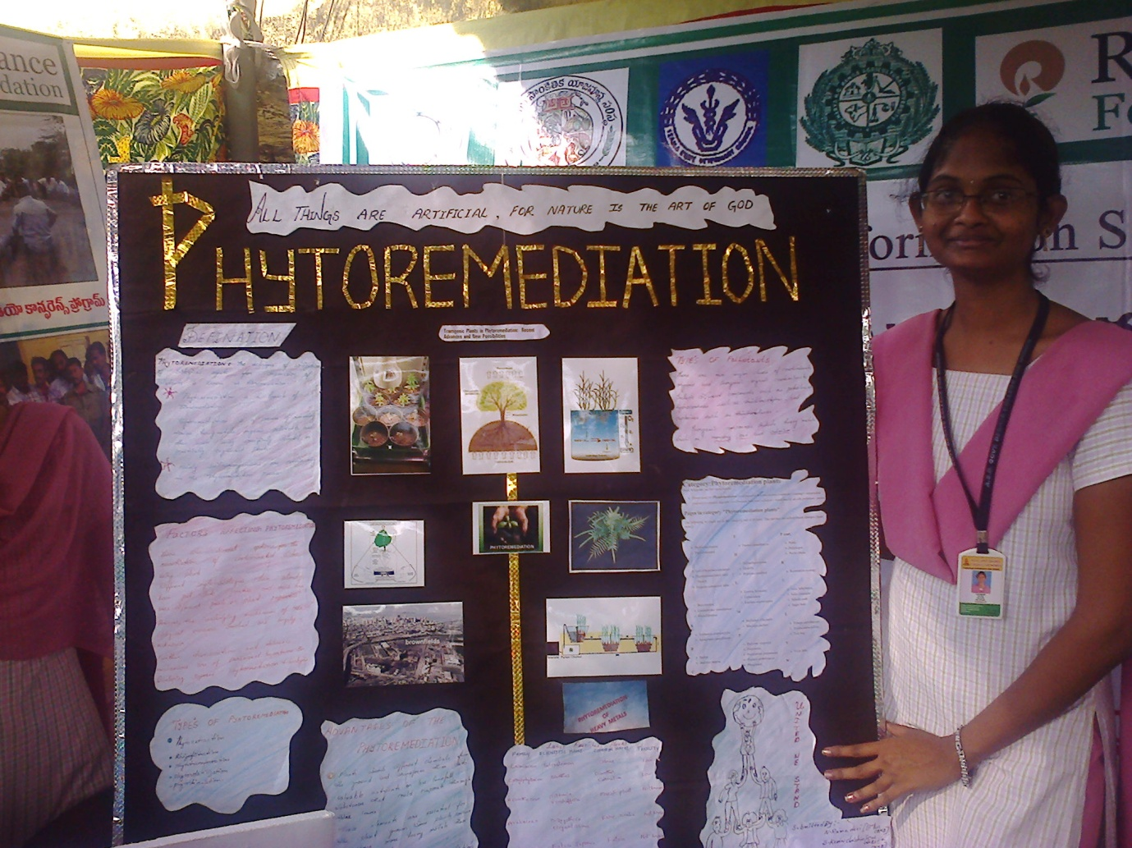
Participation in Poster Presentation
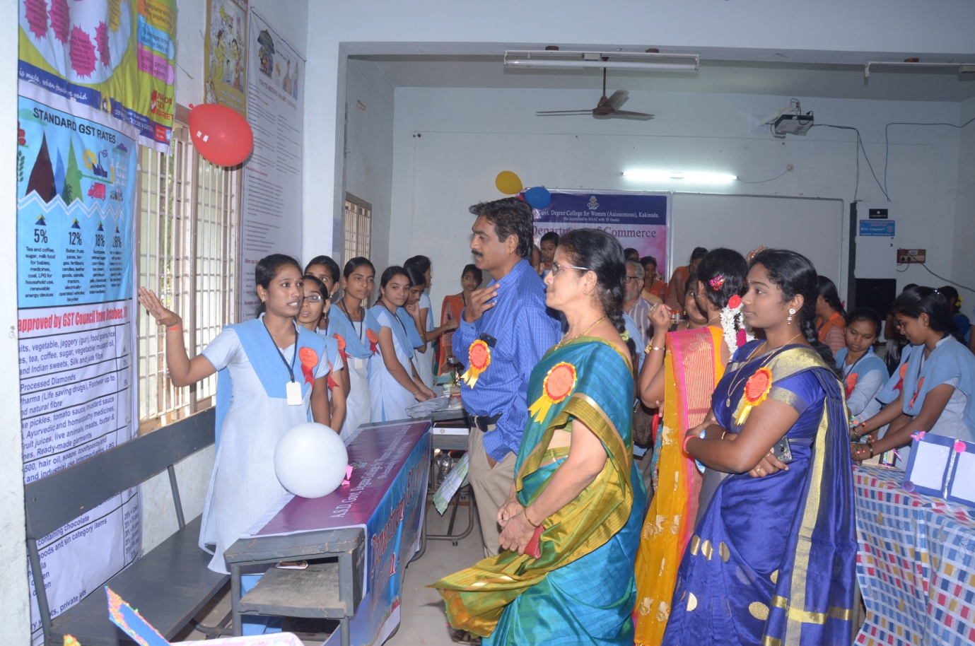
Organizing Exhibition cum Sales
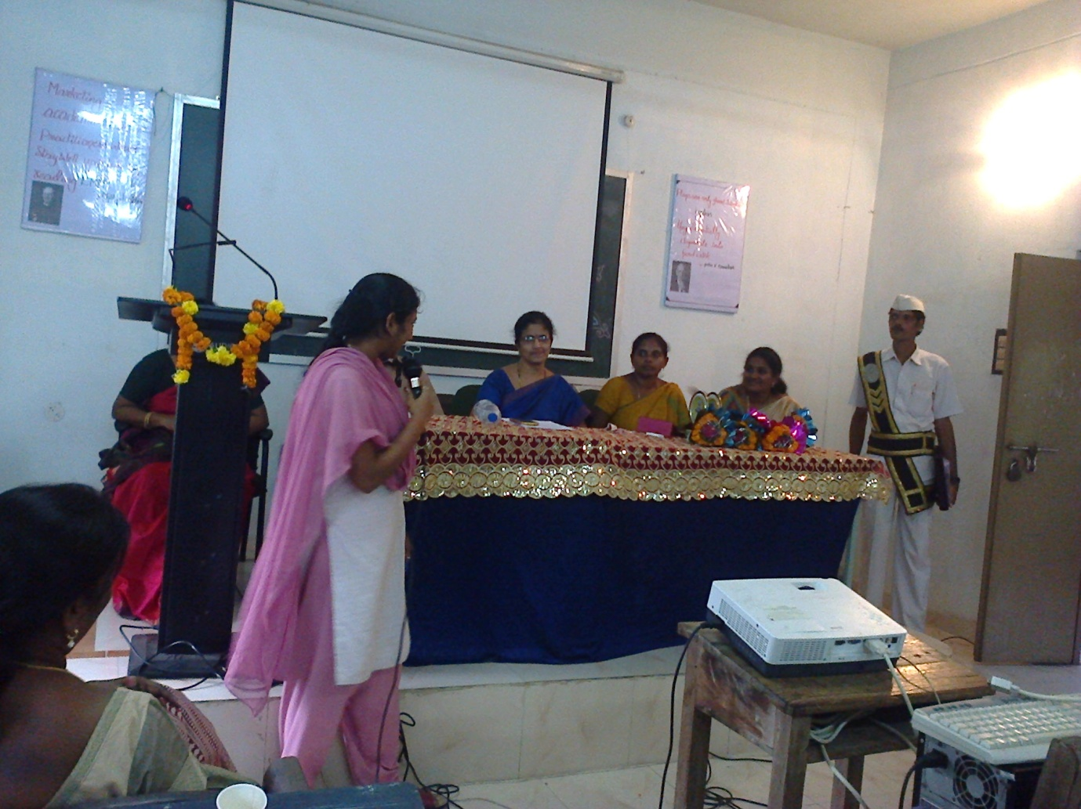
Student presenting Feedback on the workshop
Best Practice-II
- Title of the Practice: Student Empowerment through Voluntary Action(SEVA)

- Objectives of the Practice:

SEVA is an initiative of our institution to create a link between the institution and the community. The idea was conceived to inculcate civic engagement and social responsibility among the students and also help the low and marginalised communities nearby.

The objectives/expected outcomes of the programme include:
- Encourage civic engagement among the students
- Inculcating social responsibility among the student community through community participation
- Develop leadership among the students
- Linking theory and practice by designing the extension activities based on the area of study
- Transfer of knowledge and expertise to the needy in the nearby community
- Address issues such as Illiteracy, Health, Cleanliness, Taboos, Malnutrition, Food fads and fallacies etc., as per the need
- Promoting learning of the students through first hand experiences in the community
- Linking the community to the college and develop a mutual and positive relationship between the college and the community

- The Context :
One of the recommendations for The New Education Policy, 2017 is active engagement of students in Community activities. As a Higher Education Institution, it forms the responsibility of engaging the student folk in uplifting the community for inclusive growth.
In Contemporary society, the students are highly ignorant about the problems of society where they live. Therefore, it is realized that the students must be sensitized about society and extension activities are made mandatory for them.Implementation of the task is a herculean task as

- As a part of SEVA, the students and staff from all the departments were motivated to conduct activities which provides a mutual learning experience for both the students who gain practical knowledge through First hand experiences and also a learning experience for the community; educating the community on various issues to provide them with opportunities to improve their standards of life. The activities covered under the programme were :
- Department of Telugu have been conducting as Adult Education Programme titled “Each One Teach One” where the students after their working hours educate some of the local women by teaching simple reading and writing skills and raise them from Thumb print to doing their signature
- Botany Department have been conducting a drive on “Medicinal Plants available in our sorroundings” where in they educate the housewives on the local medicinal plants like Tulasi,mint,.........etc and their health benefits with an aim of prevention is better than cure. They have also educated the housewives about the ill effects of the regularly used pain killers and how the pain killers can be substituted by the local herbs
- Commerce Department have been conducting programmes to educate the local women on Cnsumer Education. They have been teaching the Rights and Responsibilities of a consumer. They have also educated the local women on Financial Management and Financial records that can be maintained at household level to check on unnecessary expenditure
- Chemistry Department have educated the women in the local community about the various apps available for protection of women and their usage. The students have installed the apps in the mobile phones of the local women
- Department of Home Science have conducted anthropometric survey of the school children and based on the results ,nutrition education was given to the mothers of school children who were malnourished
- Students of Home Science Department have been conducting “10 day Orientation cum Awareness programme for the adolescent girls in the nearby schools” where in the adolescent girls are educated about menstrual hygiene, dental health, nutritional requirements, physical and psychological changes during adolescence, problems of adolescence etc..
- Nutrition education was given to the pregnant and lactating women visiting the nearby Referral Hospital
- As a part of NSS activities NSS volunteers have been regularly educating the community on AIDS –its causes, prevention and Cure
- NSS volunteers have also educated the people in the fisherman community about the hazards of Open defecation and the importance of the Toilet Construction in their houses
- Department of History has initiated a programme entitled “Helping Hands” in which charity is collected from the staff ,students and community and the same is donated to the needy students in the college who can’t afford to pay their college fees
- NSS has initiated a programme “Donate a Handful of Rice” in which each student and staff member is required to donate a handful of rice and the accumulated rice id donated to the nearby Old Age Home
5. Evidence of Success
- SEVA practice has created a positive impact on part of the institution and also the community.
- A strong linkage between the community and the college has been formed.
- The Activities held improved the students’ confidence and personality making them more participative in various activities.
6. Problems Encountered and Resources
- Credits should be assigned to the activities or projects taken up in the community
- Financial allocations for such programmes are limited hence rendering them to only limit to the nearby communities.
- Consistent motivation to Students has been a hurdle – however once the service spirit is ignited among them, the organisation has become fairly easy.
- Community support has been hard to attain in some areas – local authorities had to be approached for assistance.

